An Assessment of INAF 201: Intro to International Affairs
Department of International Affairs
Trinity Washington University
March 2016

Introduction
This assessment is being conducted in the context of the 2016 visit from the Middle States Association accrediting body, and is an example of the periodic review of programmatic elements conducted by all departments in the College of Arts and Sciences at Trinity Washington University.
The INAF faculty, represented by Dr. Susan Farnsworth (Professor of History, INAF Department chair) and Dr. James Stocker (Assistant Professor of International Affairs), has decided to review the INAF 201: Intro to International Affairs course during this assessment cycle. INAF 201 is a requirement for international affairs majors and minors, as well as an option for fulfilling the Civic Knowledge requirement of the GenEd curriculum. It is generally offered twice a year, during the fall and spring semesters. Since Fall 2012, it has been taught by Dr. Stocker.
We chose to review INAF 201 for several reasons. First, as is discussed at length in our Spring 2015 Program Assessment, the INAF 201 course is a relatively new offering, developed about a decade ago. INAF faculty members wish to be sure that our continuation of INAF 201 adds value to the major. Second, an important agenda item facing the CAS Faculty in 2015-16 is a perceived need to reduce the number of General Education (GenEd) credit requirements for students. Among the proposals for reducing the number of required GenEd credits has been a suggestion to eliminate the Civic Knowledge requirement. Since the INAF 201 course fulfills the Civic Knowledge requirement, it makes sense to evaluate the success of the course in fulfilling this requirement, as well as the potential impact of cutting the Civic Knowledge requirement on the INAF major and on this particular course.
This review includes the following components:
- a review of International Affairs/International Studies programs at cohort and local institutions, including the collection of syllabi of comparable courses;
- an assessment of the role of INAF 201 in the INAF and CAS GenEd curricula;
- a review of the evolution of current course learning goals and assignments from 2012-2015;
- an exploration of student perspectives on INAF 201, including a review of student evaluations and interviews of recent graduates and current students about their INAF 201 experience;
- a survey of alternate possibilities for the three course credit; and
- a recommendation to keep or drop the course.
The Introductory International Affairs Course Amongst Trinity’s Peer Institutions
There are hundreds of interdisciplinary international affairs programs at universities in the United States. Generally, the most common name for such programs appears to be “international studies.” We consider this term to be interchangeable with “international affairs”, as it is referred to at Trinity. In some cases, so-called “global studies” programs see themselves as emphasizing the study of factors that are less-state based and perhaps more deeply rooted in issues of justice, but at Trinity, we do not make this distinction. In a sense, the “interdisciplinary” aspect of such programs is their primary distinguishing quality, as opposed to any distinction in emphasis between global and international. All of these programs draw on courses from a variety of disciplines and departments to provide students with many different tools (in the form of bodies of knowledge, paradigms, research methodologies, skills, etc.) to understand and interact with the world around them.
Scholarly research has only just begun to shed light on the current state of these multiform international studies programs. As a consequence, broadly recognized “best practices” do not exist for the major in the same way that they do for other social sciences and humanities disciplines. Political science departments, for instance, usually offer introductory courses, methods courses, specialized courses in one of five or so subdisciplines, a few area studies courses, and perhaps a number of special topics or applications courses. Professional associations in international affairs such as the International Studies Association do not offer recommendations on the structuring of majors.
However, this does not mean that there is a complete lack of norms regarding international studies programs. According to a survey of international studies program directors (Blanton et al, 2015), most directors believed that IS programs need three elements: 1) an introductory course, 2) a course in methods training, and 3) a senior capstone course; still, one study found that only “only one-third of IS programs in their sample of colleges and universities in the Midwest had all three elements.” That said, some two-third of directors reported that their program had an interdisciplinary introductory course (Blanton et al, 2015, 9). The existence of an interdisciplinary introductory course thus appears to be a norm amongst international affairs programs.
A look other colleges in Trinity’s region and peer group (Chart 1) suggests that relatively few have introductory courses. Of ten colleges and universities reviewed with interdisciplinary international affairs program. Of these nine, four (Notre Dame of Maryland, George Washington University, University of Maryland - Baltimore County, and American University) have required introductory courses, all of which are 100-level. Interestingly, those with specialized courses tend to be larger universities. A fifth university, Roanoke College, previously had an introductory course as a requirement, but is dropping it for majors who declare after Fall 2015.
Chart 1: The Interdisciplinary Introductory Course in INAF/IS at other colleges in Trinity’s Cohort Group and other local universities
Institution | Program Title | Interdisciplinary Introductory Course
Hood College | Global Affairs | None
Goucher College | International Relations | None
Bridgewater College | Global Studies Major | None
Roanoke College | International Relations | None (eliminated in Fall 2015)
College of New Rochelle | International Studies | None
Mount St. Mary's College | International Studies | None
Notre Dame of Maryland | International Studies | POLS- 103 Introduction to International Affairs
George Washington University | International Affairs | IAFF 1005: Introduction to International Affairs: A Washington Perspective
University of Maryland - Baltimore County | Global Studies | GLBL 101 Introduction to Global Studies
American University | International Studies | SISU-106 First Year Seminar

No course syllabi were available from these programs for the purposes of this evaluation. However, we did locate three other syllabi online that were used as a comparative basis. These vary greatly in terms of their learning goals and objectives, from the non-specific to the detailed. These are discussed in the relevant sections below.
INAF 201 at Trinity: INAF Major and CAS GenEd requirement
This section discusses INAF 201’s role in the INAF major and as a part of the General Education curriculum at Trinity, then analyzes what students are being served by the course.
The INAF Major
The interdisciplinary character of international affairs sets it apart from most other majors at Trinity. INAF Program Goal 4 states that students will be able to “explore, articulate, and understand the connections among the liberal arts disciplines that inform International Affairs and illuminate human societies.” To achieve this goal, international affairs majors take the majority of courses that count for their major in non-INAF disciplines, including history, political science, sociology and economics. In addition, some courses bear the INAF label, marking in some cases the fact that they are interdisciplinary, and in other cases serving as a holding category for courses (such as geography) that do not have their own separate department at Trinity.
One of the hallmarks of the INAF major is the introductory INAF 201 course. It is a required course for both INAF majors and minors. Its course learning goals, in large part inherited from INAF 201 courses taught prior to Dr. Stocker’s joining Trinity in 2012, currently stand as follows:
Students shall:
- Understand important issues in contemporary international affairs,
- Apply perspectives of different academic disciplines to these issues ,
- Relate contemporary international issues to their everyday lives,
- Develop and communicate their views on these issues to their classmates and the world, both orally and in writing, and
- Gain competency in basic research skills necessary to be successful in upper-level coursework.
These learning goals in various ways support all six of the main INAF program goals. Below are specific examples of the ways that these course goals help to support INAF program goals.
- Goal 1: Read and analyze professional texts, both documentary materials and disciplinary scholarship. (CAS Goal 1)
  - Students read both scholarly and popular texts from a variety of disciplinary perspectives.

- Goal 2: Communicate professional ideas effectively, both in writing and in oral presentations. (CAS Goal 2)
  - In online blogs, students learn to express views about a broad range of contemporary international issues.
- Goal 3: Conduct scholarly research that incorporates disciplinary texts, professional journals and on-line resources, reflecting the component fields of International Affairs. (CAS Goal 4)
  - Distinguish between primary and secondary sources
  - Know how to access and use major news sources and academic databases for information about the contemporary world
  - In online blog activities, students are required to use articles from specified sources such as academic journals and newspapers. They are required to find these themselves or with the help of a librarian.

- Goal 4: Explore, articulate, and understand the connections among the liberal arts disciplines that inform International Affairs and illuminate human societies. (CAS Goals 5 and 6)
  - Identify and apply key concepts from the disciplines of history, political science, economics, anthropology, and geography
  - Understand and apply interdisciplinary approaches to important subjects in contemporary international affairs

- Goal 5: Explore and explain the philosophical, ethical and moral influences on contemporary International Affairs, especially in reference to issues of human rights, environmental protection, and social equality. (CAS Goal 7)
  - Relate contemporary international issues to their everyday lives.
  - Read, critique, and incorporate academic resources emphasizing the moral, legal, and ethical dimensions of contemporary issues.
  - Appreciate the divergent ways in which global religions and cultures approach important contemporary issues.

- Goal 6: Develop capacities for responsible citizenship, active engagement and leadership in diverse communities. (CAS Goal 8)
  - Understand the relationship between contemporary international trends and their own life.
A Component of the General Education Curriculum
In addition to INAF majors and minors, the INAF 201 course also serves CAS students more broadly by fulfilling the Civic Knowledge requirement of the GenEd curriculum. At this time, the Civic Knowledge requirement is one area of the general education curriculum that is being considered for cutting by the College of Arts and Sciences Committee on Academic Policy (CAS CAP). However, as it remains a part of the GenEd curriculum, this assessment will continue to evaluate the course’s ability to fulfill this requirement in conduction with Goal 8, which reads: “Develop capacities for responsible citizenship and leadership in diverse communities.”
INAF 201 supports this goal in a variety of ways:
- Through its introduction to students of new societies and cultures, it helps them demonstrate understanding of diverse identities and cultures;
- Through the use of a blog on contemporary international affairs as a key component of the course, it helps students to develop the ability to conduct civil, respectful discourse in written form;
- Through its attention to contemporary international issues of importance, it helps to deepen understanding of social issues and social justice.
Who is being served?
Who is being served the most by this course at the moment? A look at course data can tell us. Out of 51 students enrolled in INAF 201 in SP 14, FA 14 and SP 15 (as of May 20, 2015), 11 (21%) were declared majors, 12 were undecided, and the rest had already declared another major. This data suggests that the majority of students taking INAF 201 are not INAF majors. However, there are several caveats to this analysis. First, some of the undecided majors will declare as INAF majors in the future. In addition, several other students who already have declared other majors may INAF as a second major, in part because its interdisciplinary nature tends to make it possible to double major without an unduly high number of course credits. Popular combinations of double majors with INAF include history, business and political science. Still, it is probably the case that more than 50% of students taking this course are not INAF majors or minors.
This suggests that if the course no longer counted as part of the GenEd requirement, enrollment in the course could drop by 50-75%, as it will only count as an elective requirement for students. If this occurs, it will be necessary to offer the course less often, perhaps only once per year.
Evolution of the Course from 2012 to 2015
Course Learning Goals
This assessment uses the six learning goals of Fink’s Taxonomy of Significant Learning to evaluate the learning goals of the INAF 201 course and counterparts at other institutions. These goals are as follows: Foundational Knowledge, Application, Integration, Human Dimension, Caring, and Learning How to Learn. Fink’s Taxonomy presumes that while not all of these goals may be present in every course, including more of them in course design will enhance student learning. Moreover, Fink’s Integrated Course Design methodology argues that learning goals should be carefully aligned with evaluation mechanisms and learning activities, and that any break in the relationship between these three areas can be detrimental to student success and satisfaction.
Amongst other syllabi surveyed, most seemed to have a limited number of course goals:
- At IUPUI, for instance, the syllabus’ course objective section consisted of four paragraphs. The first stated simply that the course aimed to “introduce you to International Studies.” The rest of the statement proceeded to describe international studies as an interdisciplinary major, to discuss the course readings, and to re-emphasize that the course also had the college’s broader “Principles of Undergraduate Learning” in mind.
- At Radford College, the course syllabus consisted of three goals: “1. Participants will acquire the foundational knowledge in the field of International Studies. 2. They will be able to apply some basic concepts, theories and tools to global phenomena. 3. Students will learn to use select multi-disciplinary perspectives to analyze world events.” These only include three of the six areas (Foundational Knowledge, Application, Integration) of Fink’s Taxonomy of Learning.
- At Boston College, the course syllabus provided the following objectives: “This course lays the theoretical groundwork for describing and explaining the ways in which international influences shape the world's economies, polities, and societies, and their consequences for global conflict and cooperation. Students will learn to distinguish among different theoretical explanations for understanding international politics, think critically about their strengths and weaknesses, and apply them to a range of historical and contemporary issues.” Here, again, only three areas of Fink’s Taxonomy (areas (Foundational Knowledge, Application, Integration) are being employed.
Trinity’s INAF 201 course at Trinity features learning goals that are more detailed and encompass more aspects of Fink’s taxonomy of significant learning, but these have been reached only after a significant amount of trial, error, and reflection. In Spring 2012, INAF 201 only had three course-specific learning goals:
1. Understand and apply basic theories of international relations;
2. Know and use key terms and concepts from political economy;
3. Be familiar with contemporary international issues.
This reflected the fact that the course was primarily designed to impart foundational knowledge amongst students, rather than to achieve other goals. In a sense, it resembled courses taught at other institutions, focusing on foundational knowledge, application, and (to a certain extent) Integration. At this point, the goals had not been intentionally aligned with the broader learning goals of the INAF major.
In the spring of 2014, the course-specific learning goals were adapted to the following:
1. Be familiar with the different disciplines that compose the interdisciplinary international affairs major (including history, geography, anthropology, sociology, economics and political science), and be able to analyze international issues from the perspectives of these disciplines.
2. Relate contemporary international issues to their everyday lives.
3. Distinguish between primary and secondary sources.
4. Create and maintain a blog on contemporary international issues.
5. Know how to access and use major news sources and databases for information about the contemporary world.
This new set of goals represented a shift from the knowledge-delivery approach of previous semesters to imparting a set of skills that reflected higher levels of thought according to Bloom’s Taxonomy. Not only were students required to have foundational knowledge of particular disciplines and issues, but they had to have skills that related what they learned to other disciplines. The course also now intended to help students to conduct self-reflective learning by relating contemporary international affairs issues to their own lives. Finally, a writing component had been highlighted as important. Students would gain skills writing about contemporary international issues in a blog format. In the mind of this instructor, these goals represented a qualitative improvement over the previous ones.
These goals were revised following the instructor’s attendance at a workshop by L. Dee Fink that encouraged the reconceptualization of learning goals according to a six-part set of characteristics. While the instructor left most of the existing learning goals, he added two and revised several of them. In Fall 2015, course goals were as follows:
1. Be familiar with the different disciplines that compose the interdisciplinary international affairs major, and be able to analyze international issues from the perspectives of these disciplines.
2. Relate contemporary international issues to their everyday lives.
3. Know the characteristics of major regions of the world
4. Create and maintain a well-written blog on issues that affect a particular country.
5. Access and use major news sources and academic databases for information about issues in international affairs.
6. Critically evaluate texts and use evidence in support of arguments.
7. Be informed citizens of the world.
For Spring 2016, the course goals were once again condensed. Several were removed that mentioned learning activities such as blogs and skills like the ability to access news sources, while others were rewritten in simpler language. The current goals are more concise and easier to understand:
- Understand important issues in contemporary international affairs,
- Apply perspectives of different academic disciplines to these issues ,
- Relate contemporary international issues to their everyday lives,
- Develop and communicate their views on these issues to their classmates and the world, both orally and in writing, and
- Gain competency in basic research skills to be necessary successful in upper-level coursework.
These correspond to all six areas of Fink’s Taxonomy, as follows:
INAF 201 Learning Goal | Areas of Fink’s Taxonomy
Understand important issues in contemporary international affairs. | Foundational knowledge
Apply perspectives of different academic disciplines to these issues. | Application, Integration
Relate contemporary international issues to their everyday lives, | Application, Integration, Caring
Develop and communicate their views on these issues to their classmates and the world, both orally and in writing, and | Integration, Caring, Human Dimension
Gain competency in basic research skills to be necessary successful in upper-level coursework. | Learning How to Learn

As shown above, the arc of the development of the course’s learning goals demonstrates that it has become increasingly aligned with the philosophy of integrative course development.
Course Format and Learning Activities
This section will assess the course format in terms of reading requirements, learning assessments and significant learning activities. It will compare these with similar introductory courses at three other institutions, and evaluate how they align with course learning goals.
Trinity’s INAF 201 course appears to have a somewhat lower level of reading requirements than courses at some other universities, at least in terms of page count. For this course, two textbooks are required: International Studies by Anderson et. al (approximately 470 pages) and The Travels of a T-Shirt in the Global Economy by Rivoli (approximately 285 pages). There are a few additional articles on the syllabus, and students are required to find articles for a series of blog posts that they write throughout the semester. On average, there are about 30-35 pages of reading per class session. By contrast, the Boston College syllabus requires around 45-50 or more pages per class session, the IUPUI course requires between 50 and 100 per class session. The Radford College course requires one chapter per class session, which is between 30 and 40 pages, approximately the same level as Trinity’s INAF 201.
The introductory interdisciplinary courses at other universities varied greatly in their choice of learning activities, such as assignments and tests. However, they appear to be mostly test-based. At IUPUI, 30% of the students’ grade came from two written assignments (a 300 word article abstract and a 1200 word book review), while 60% came from two tests and 10% for participation. At Radford, 70% came from two exams and two quizzes, 15 percent came from two brief activities, and 15% from participation (there were no obvious writing activities). At Boston College, 60% came from two tests, 25% from a paper, 5% from a writing assignment, and 10% from participation. All of these courses therefore emphasize testing over other forms of learning and assessment activities.
At Trinity, by contrast, a much smaller portion of the grade comes from tests. For the Spring 2016 semester, only 30% came from tests. The other 70% is composed as follows: In-Class Map Quizzes (5%), Class Participation (15%), Homework (10%), Study Guide Assignments (two, 5% each), and a Country Blog (30%).
In part, this reflects the different emphasis in learning goals discussed above. Tests and exams are ideal ways of assessing the acquisition of foundational knowledge through memorization, as well as in some instances the application of this knowledge to practical examples. However, they are less able to measure other learning goals.
Since 2012, a main activity in the course is a weekly blog, which is designed to enhance learning in all six areas of Fink’s Taxonomy of Significant Learning. The goals of the blogging assignment are improve writing and research skills (Foundational Knowledge and Applications), and to help students relate contemporary international affairs to their own lives (Integration, Caring and the Human Dimension). Throughout various iterations of the course, the assignment has required students to find sources about a subject related to their readings, and to incorporate this material into a blog post. Students repeat the assignment between six and ten times in order to gain mastery of this form of writing. They are required to find their own sources in order to help students to work independently (Learning How to Learn).
Nonetheless, there have been a number of changes to the assignment over time to optimize this assignment. In Spring 2012, the instructor gave no precise written instructions regarding sources to be used, except that the class readings should be used, and any other outside sources should be properly cited. By 2014, the instructor had modified the assignment to draw on a specific set of sources each week. In the first week, for instance, the students would use articles from the journal Foreign Affairs; in the next week, they were to use the Economist magazine; etc. No precise instructions were given on how to find each source; in-class, the instructor conducted a set of teaching activities to inform students about how to find these sources using the Trinity library website, and reminded students to register their student IDs at the library front desk so that they could see use these resources from off-campus. After the second week, students had significantly less trouble finding the sources.
In regards to the assessment of blogs, the instructor’s grading criteria have evolved over time. In Fall 2012, the instructor simply gave the students a grade and written feedback. In Spring 2012, this evolved to a loose rubric as follows:
- Relevance (20%): The blog post is relevant to the week’s course material.
- Perspective (20%): The blog post represents the student’s own perspective.
- Use of sources (30%): The student has selected at least one article from a reputable source, and has cited it correctly.
- Depth of analysis (20%): The blog post explores the subject in sufficient depth to justify the argument.
- Mechanics (10%): Correct spelling and grammar, as well as appropriate style.
By Fall 2015, the rubric remained similar, with a few minor changes and more detail provided:
- Perspective (20%): The blog post represents the student’s own perspective.
- Use of sources (20%): The student has selected at least one article from the correct source, and has cited it correctly.
- Depth of analysis (40%): The blog post makes a clear argument that demonstrates the student’s own point of view, and explores the subject in sufficient depth to justify the argument.
- Mechanics (10%): Correct spelling and grammar, as well as appropriate style. Mistakes will result in deductions of points.
- Formatting (10%): The blog displays correctly on the screen. Hyperlinks must only cover single words or short phrases, not entire sentences or paragraphs.
Additionally, the instructor now provides students with a detailed rubric for the assignment (current iteration in Appendix 1). It offers a series of questions that can be asked by the student and the instructor to help align expectations. When the instructor grades the blogs using the rubric, he provides some commentary, as well as suggested edits and comments in the text itself.
In addition to the blog, tests have at times been a major component of the student grades. The number of tests has varied from two to four. In Fall 2015, there were three tests; however, in the Spring 2016, only two tests are foreseen. Tests serve to measure students’ understanding of foundational concepts that are taught in the course, and ability to apply this knowledge to real world scenarios. In course evaluations, students have often complained about the sheer quantity of material that they need to learn for the course. Indeed, the reading covers a variety of different academic disciplines and regions of the world, which does pose a challenge for students, particularly those with little background in international affairs-related disciplines.
For these reasons, in the Spring 2016 iteration of the course, the emphasis will be on testing understanding of the foundational knowledge of the core disciplines of international affairs, rather than regional knowledge. One test will be administered after the completion of the first section of the textbook. Another will be at the end of the class. In response to student requests for a study guide, the instructor has created an activity that requires students in groups to put together their own study guides using “wiki” pages that are editable by other students in the class. This is worth 10% of the student’s overall grade (5% each, one for each of the two exams).
INAF 201: Student Perspectives
To gauge student views of INAF 201, we looked to two sources of data: course evaluations and a set of unstructured discussions with five recent INAF graduates at a luncheon in early May 2015. Both of these types of data are problematic, but each may be useful at pointing to general trends in the course.
First, in terms of student course evaluations, we used student evaluation data from four of the five previous times that the course was taught: Fall 2012, Spring 2014, Fall 2014, Spring 2015 and Fall 2015. Although the course was also taught in Spring 2013, no student evaluation data is available from that instance of the course, because the instructor did not require students to fill out evaluations during the final class session. No students filled out the evaluation on their own (reinforcing the instructor’s own adherence to the good practice of providing time during class for students to fill out the course evaluations on their own).
Overall student satisfaction with the course seems to be increasing. Students were asked whether they agreed with the statement “The course as a whole was worth taking”; strongly agree was rated a 5, strongly disagree was rated a 1, neutral was a 3. In Fall 2012, students rated the course as a 3.6, meaning that they were on the whole only slightly of the opinion that the course was worth taking. In Spring and Fall 2015, students rated the course a 4.2 and 4.08 respectively, suggesting that they generally agreed that the course was worth taking.

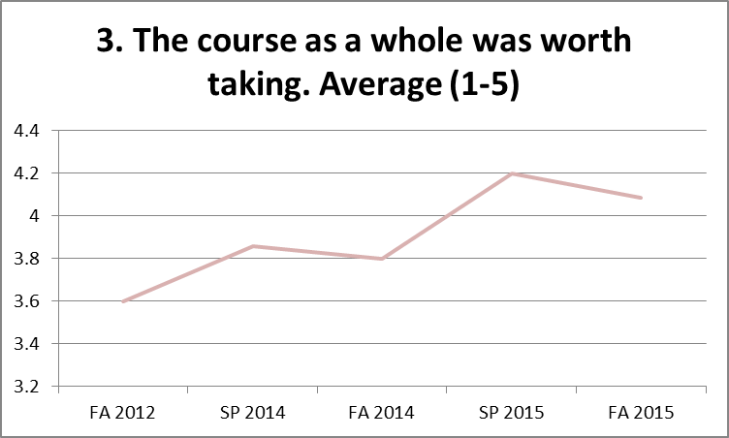
By contrast, since the beginning of the course, it has rated highly as a valuable learning experience. Using the same response criteria as before, when asked to respond to the question of whether the course was a “valuable learning experience”, all five sessions of the courses rated above 4 on average, suggesting that students learned from the course content and structure.

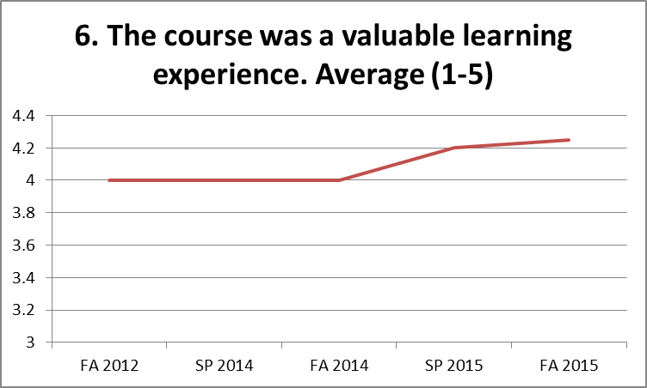
In each semester, over 70% of students strongly agreed or agreed that the course helped them to “Act as a more effective citizen, locally or globally.” In Fall 2015, 92% strongly agreed or agreed that the course had helped them do this, suggesting that the course was achieving this goal.

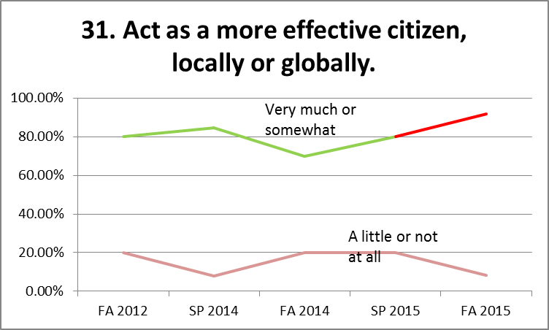
In addition to this student course evaluation data, the INAF faculty also explored the views of graduating international affairs seniors in May 2015 during a graduation luncheon with five students. During this event, the students indicated a generally high level of satisfaction with the course as it existed at the time they took it. Several students had difficulty remember the course, but others recalled that it gave them a good sense of the discipline. However, many of them took this course before its present iteration. It would be a good idea to continue discussions with graduating seniors to get a sense of their views of the role that this course played in their academic experience, even if this data will not likely prove decisive in affecting the course’s future.
Alternate Possibilities
The overall value of any course has to be considered in terms of its opportunity cost. In other words, if a course takes up three credits, it is not only important to ask whether that course offer a positive learning experience; it should also be asked whether that those three credits (in terms of both INAF curricula and instructor teaching loads) could be used for other purposes, and if so, how those would stack up against the current course offering. Alternately, the course could also simply be eliminated to reduce the number of credits that the INAF major requires.
As discussed above, the INAF 201 course instills an understanding of multiple academic disciplines in students. For instance, students who have taken INAF 201 should, throughout the rest of their college career and beyond, be able to distinguish between an economic analysis of an international affairs issue and a political one. This sort of multi-disciplinary thinking is an implicit part of many other courses at Trinity, but may not be explicitly taught at a basic foundational level. Therefore, the course serves a unique purpose that is not duplicated by other course offerings.
It might be possible to cut INAF 201 without replacing it in order to reduce the credit load of the major. Currently, the INAF major has a relatively large number of credit requirements. There are 27 credits of core courses, six additional credits of second languages and cultural competency beyond the Gen Ed requirements, and 18 credits of concentration courses, bringing the total to 51 credits. That said, some INAF core courses also fulfill CAS General Education requirements, and many of our students use placement exams for the language requirement. Indeed, many if not most choose to double major or minor in another discipline, suggesting that they do not find the course requirements onerous. Eliminating INAF 201 for the purposes of reducing the number of credit requirements for the major would therefore not appear to be worthwhile.
Alternatively, the INAF 201 course could be replaced by an alternative required course that would serve a different purpose. As noted above, the INAF major lacks one of the three broadly accepted elements of a successful international studies program (Blanton et. al., 2015), a methods course. There is no INAF specific method course, and none is currently required or even envisioned within the course major requirements. Should a change to the GenEd curriculum threaten enrollment in the INAF 201 course, it might make sense to consider whether a research methods course should be taught instead of, or even alongside it (e.g., instead of offering two INAF 201 courses per year, one INAF 201 course and one INAF research methods course). It might also be possible to require an experiential learning component such as an internship or study abroad instead of the introductory course.
Thus, for the time being, continuing the INAF 201 course in its current embodiment appears to be the best option. Should the Civic Knowledge requirement be removed from the GenEd curriculum, the INAF department may reevaluate whether or not to continue to offer this course, including whether to offer a research methods course instead of or alongside a less frequently offered introductory interdisciplinary course.

Conclusions
This assessment has provided a valuable opportunity for faculty members to reflect upon the purpose of INAF 201 in the context of the INAF major and Trinity’s broader mission, as well as to evaluate its fulfillment of these objectives. Our conclusion is that it currently seems to do so. Although it is clear that not all interdisciplinary international affairs programs around the country have such courses, a good number do require them. The course effectively supports the goals of both the INAF major and the CAS GenEd program, and equally serves INAF majors/minors and the broader CAS population. Student course evaluation ratings are higher than they were several years ago, even as the reading and workload has remained relatively consistent. A course that at one point lacked direction now has a number of clear learning goals that are aligned with recent trends in the philosophy of education, including Fink’s Taxonomy of Significant Learning. For all of these reasons, the INAF faculty supports the continuation of INAF 201 in its current form.

Reference
Robert G. Blanton and Marijke Breuning, “What Makes International Studies Programs Successful? A Survey-Based Assessment”, International Studies Perspectives (2009) 10, pp. 224–240.
Appendix 1: Rubric for Grading Blogs
Category and Grading Criteria | Max Points | Pts Earned | Comments
Perspective  - Does the blog contain the student’s own views, or is it simply a summary of the text? | 20
Use of sources:  - Has the student has selected at least one article from the correct source, and cited it correctly?  - Has the student incorporated an idea from the weekly reading into the blog? | 20
Depth of analysis:  - Does the blog make a clear argument?  - Does it incorporate evidence from the reading to support the argument?  - Are all points logical?  - Are there appropriate transitions between points? | 40
Mechanics:  - Does the student use correct spelling and grammar?  - Is the style appropriate? | 10
Formatting:  - Does the blog display correctly on the user screen?  - Are hyperlinks used to reference sources, or is the link simply pasted into the text?  - Do hyperlinks must only cover single words or short phrases, not entire sentences or paragraphs?  GOOD: The Greek debt crisis was caused by the size of the country’s international debt and its shrinking economy.  BAD: This article explains the Greek debt crisis:www.nytimes.com/interactive/2015/ business/international/greece-debt-crisis-euro.html | 10
Special Considerations  - Not writing about an international affairs issue: -30%  - “Blobbing”: submitting a disorganized single paragraph of text that does not contain any structure: -20% | n/a

For instance, the University of Maryland – Baltimore County’s Global Studies program’s website explicitly states that “While states and markets continue to be central features of international affairs, the rapid pace of globalization—political, economic, social, cultural, and environmental—suggests that our graduates need a more expansive understanding of the world.” http://globalstudies.umbc.edu/, accessed on Jan. 8, 2016.
Other professional associations, such as the American Political Science Association and the American Psychological Association, do so. See, e.g., American Political Science Association, Report of the Task Force on Political Science in the 20th century, October 2011, available at this link; APA Guidelines for the Undergraduate Major, available, Version 2.0, August 2013, available at this link.
The following is based on INAF faculty review of the webpages for international affairs, international studies, global studies, and international relations majors at ten local colleges: Hood College, Goucher College, Bridgewater College, Roanoke College, College of New Rochelle, Mount St. Mary’s College, Notre Dame of Maryland, UMBC, Georgetown University, George Washington University, and American University. Amongst local universities, Marymount University, Catholic University and Howard University do not offer undergraduate-level interdisciplinary international affairs programs.
These sample syllabi were found doing a web search. They are from Indiana University – Purdue University Indianapolis, Radford College, and Boston College (all should be accessible via the hyperlink).
A description of Fink’s Taxonomy can be found at http://www.byui.edu/outcomes-and-assessment/the-basics/step-1-articulate-outcomes/dee-finks-taxonomy-of-significant-learning.
See L. Dee Fink, “A Self-Directed Guide to Designing Courses for Significant Learning”, Director, Instructional Development Program, University of Oklahoma, Undated [Handout distributed via email, May 2015].
These sample syllabi were found via web search. They are from Indiana University – Purdue University Indianapolis, Radford College, and Boston College (all should be accessible via the hyperlink).

