It’s Not the Curriculum; It’s the Paradigm
Diana Watts, Ph.D.
Trinity Washington University

Society for Advancement of Management
International Business Conference
March 31-April 2, 2011

Abstract
Recent evaluations of business curricula and core MBA programs at leading universities, critique the limits of the quantitative, case-based analysis that proceeds to a solution-based outcome, predicated on functional expertise. (Datar, Garvin & Cullen, 2010; Minztberg, 2004) A contrasting approach could be based on developing business programs that are predicated on an open systems orientation. This alternative approach to educating future business leaders could be seen as a call for a paradigm shift that moves beyond tinkering with current course curriculum design and instead moves the dialogue towards determining a changed set of critical premises to be embedded in a systemic, ethically developed approach to business education.
Keywords: business curriculum, ethical reasoning, open systems perspective.

It’s Not the Curriculum, It’s the Paradigm
In recent evaluations of degree programs at leading universities, the current critique explores the limits of the quantitative, case-based analysis that proceeds to a solution-based outcome, predicated on functional expertise. Critiques of the business administration degree approach it from the perspective of improving the MBA curriculum model through a) additional courses or b) integrating a greater emphasis on moral reasoning. (Mintzberg, 2004; Datar, Garvin & Cullen 2010) Both are respectable alternatives and provide the basis for rethinking the collection of courses that constitute business administration programs at the graduate, and by extension the undergraduate, degree programs level. A contrasting approach could be based on developing business programs which encourage an open systems orientation and provide the basis for questioning 1st as well as 2nd order consequences. This alternative approach to educating future business leaders could be seen as a call for a paradigm shift that moves beyond tinkering with current course curricula and instead moves the dialogue towards determining a changed set of critical premises to be embedded in a systemic, ethically developed approach to business education.
Critiques:
The focus on business school curricula can be seen as a pressing issue from a variety of constituent perspectives. Business school deans are worried about competition and commoditization; (Bradshaw, 2009) b) public voices have questioned if the recent recession can been attributed to the education of MBA students who have later become business leaders; (Hickman, 2010; Gentile, 2009) and c) business professors have also noted the longstanding critique of the “dysfunctions resulting from the ranking system”; (DeAngelo, 2005:11) Even the historical conversation concerning the appropriate role of business education in its applied versus theoretical purpose and the research that supports it has resurfaced.(Shapinker, 2011; Mintzberg, 2004) What are these arguments that are being articulated in the both academic and public press specific to the business curriculum design? Those that reappear include, concern that the business degree offerings are too narrow, too applied, not sufficiently reflective of a global environment, not based on scientific theory, taught by academics without sufficient “real world” experience, lacking in coherent ethical development and perhaps most damaging based on models with limited explanatory value. (Ghoshal, 2005) This range can be clustered in terms of knowledge base, core values, scope of content and critical reasoning abilities. In the selective review that follows, a recent program review carried on by (Datar et al., 2010) and program descriptions of the three top ranked MBA programs by US News and World Report Best Business Schools (2011) provide the basis for this discussion.
Consistencies Across the Program Design:
A primary discussion concerns that of the theoretical knowledge that underpins the business school model. The first issue to be addressed here then concerns framework of analytic specialization that underpins the program design. Functional expertise provides a core foundation of all three top ranked MBA programs. (“Harvard Year 1” n.d.;“MIT:Sloan” n.d.; “Stanford MBA” n.d.) These include specific expertise sets such as finance/ accounting, marketing, operations management and human resource management. These are typically taught in separate courses with specialized faculty and from gauging the top three MBA programs, this occurs during the initial first or second semester. Analytic specialization is encouraged applying specific models relevant to the discipline. This has been termed the “home depot” approach with students focused on marketing, operations, or finance but not synthetically (Datar et al., 2010: 90). Analytic specialization stems from the respective discipline.
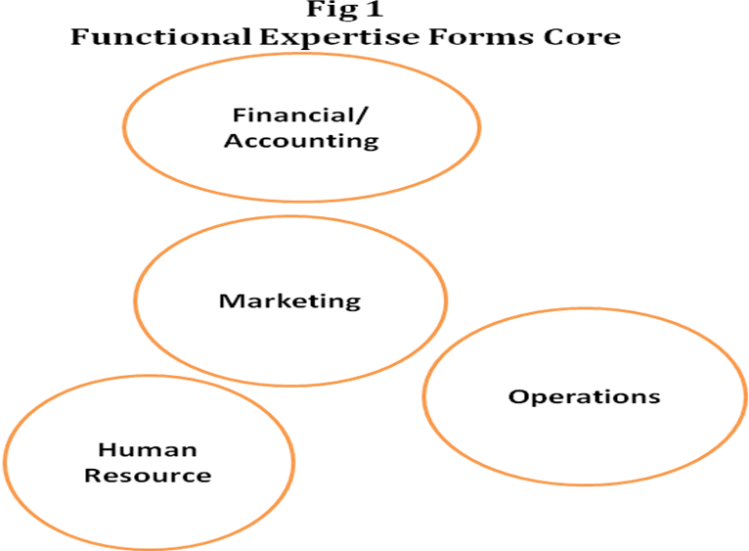
A second set of issues can be seen in the manner that the “human element” is designed into the program. This can be divided into the macro level strategy (leading) and micro-level (managing). Both dimensions are represented in the curricula. (“Harvard Year 1” n.d.;“MIT:Sloan” n.d.; “Stanford MBA” n.d.) The courses devoted to “managing” discuss organizational behavior models, focusing on topics such as teams, communication, motivation, cultural and performance. Leading aims at a number of related issues but from the strategic perspective. These models encourage students to think in terms of the critical problem to be solved is that of achieving performance in well buffered, predictable environments in which structures are relatively stable and authority structures transparent and culturally consistent. (Datar et al., 2010). Emphasis on flattened authority relationships that may limit or severally constrain hierarchical fiat are not reflected in course descriptions.
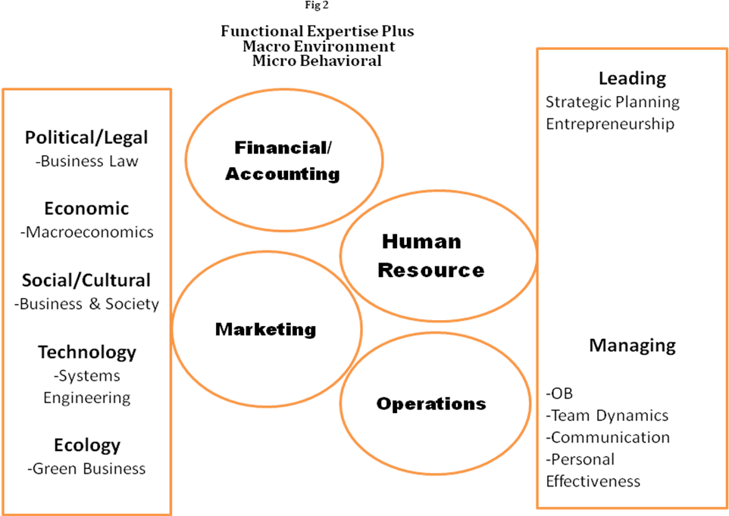
A third set of issues stem from the modeling of the environmental factors. There does appear to be a growing recognition of the range of environmental elements, including political, economic, social/cultural, technological and ecological impacts and growing list of actors (Guillen, 2001; Steger: 2009) with courses to match these. However, even given this long acknowledged list of factors, students may not be provided sufficient insight into the complexities of organizational environments where unpredictability and increasingly vocal environmental stakeholders (activist shareholders, NGO’s, informed customers) are part of the competitive landscape. (Datar et al., 2010) It may not be the number or range factors that prove to be significant, but the turbulence of this environment (complexity and speed of change) that will present challenges. (Scott, 2007)
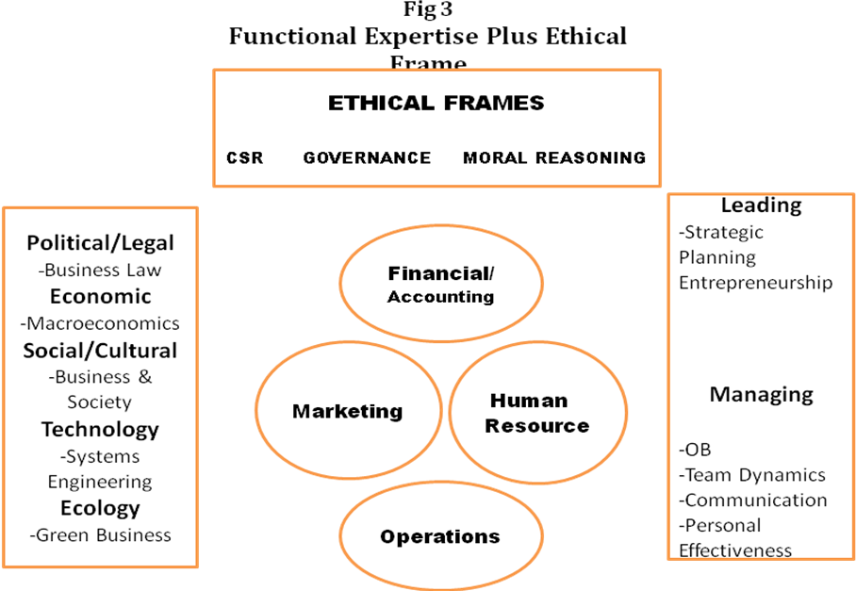
The final set of issues relates to this environmental complexity but in terms of the ethical concerns that flow from them. At the corporate level, theses have emerged in courses focused on corporate social responsibility and at the decision maker level, a renewal of concern for moral reasoning. This is certainly a significant starting point in terms of addressing the discussion of institutional and individual responsibility but is remains to be seen if a “new” set of value premises have sufficiently solidified to provide frameworks for businesses as well as business students. (Mackey, 2005)

Going Forward:
These critiques are not unknown or surprising to business school deans and business leaders. (Datar et al., 2010) But, the mainstream program continues to be comprised primarily of functional expertise models (finance, operations, marketing, human resource management). Strategic leadership and management have provided greater behavioral focus. To this, have been added additional components--- namely a greater appreciation for the macro-environment (globalization) in which organizations must compete; and a recognition that individual decisions taken inside organizations do matter at the micro-level. (ethical reasoning) Additionally, course design continues to experiment with issues of pedagogy (case-based, action learning, experiential, small group and simulated activities). This would seem to add up to a number of significant developments. However, without minimizing these changes, these can be viewed more in terms of a continued “tinkering” approach that leaves the core functional expertise in place and adds on courses “as needed”. There is the suggestion that greater integration is desirable but “not at the expense of deep knowledge”. (Datar et al., 2010: 90) The model remains largely intact if modified by a growing awareness of the urgency of capturing and explaining additional “pieces” of reality that do not comfortably reside in the existing conceptual frameworks but a fundamental question of the basis of the business curriculum design does not appear to be a central discussion. ( Fleisher, 2001; Senge, 2008 )
Thinking in Open Systems:
Open system thinking has a rich legacy in theorizing about organizations and their environments. (Scott: 2007) However, this systemic perspective does not yet appear to have permeated the business educational curriculum. Opens systems perspective encompasses in fact, a wide range of theories. For purposes of this discussion three specific concepts are relevant. These include a) defining the system in relation to the parts; b) describing boundaries and c)describing the exchange relationship of the organization to the environment. The first element, was discussed by Bertalanffy in his discussion of general systems theory, and describes the focus on “wholes” or “wholeness”. (1972) The key idea is that a system is not made of discrete parts that can be taken apart and analyzed but must understood in its entirety. This is an organic image. This contrasts with the approach taken in the business curriculum to divide an organizational into functional disciplines, encourage specialization in marketing, operational management or finance and then through “more integration” that may refer to small group work, or business simulations, understand the business organization. This analytic approach of separating “pieces” and then inferring the behavior of the whole from the respective parts, privileges the expert knowledge over the systems understanding without clarity of the interrelationships. (Mitchell, 2009)
This brings us to a related issue. The typical business model maintains divisions along structural as well as functional lines, and possibly, product, process or even a couple of additional variations. In practice, it is intuitively understood that these relationships are not neutral. Open systems theory provides here significant insight, for this conceptual perspective teaches that these relationships are not static but changing and dependent on both individual actors and subgroups. There may be differences in the “looseness or tightness” of the coupling that cannot be predicted from the organizational flow charts. Unpredictable behaviors result in autonomous actions that contradict expectations of managers. (Scott, 2007: ) This “whole” and “piece” discussion is central to the rethinking the design approach for core business courses in that integration, across disciplines may not be sufficient. Open systems thinking raises the prospect of understanding, or at least being prepared to ask intelligent questions when confronted by a range of outcomes that cannot be neatly captured when functional knowledge and models provide the primary expertise set.
The second significant insight from system theorists concerns the identification of boundaries with the environment. The current design of most business programs teaches from the perspective that a business organization resides in an environment but is separate from this environment. (“Harvard Year 1” n.d.;“MIT:Sloan” n.d.; “Stanford MBA” n.d.) Business structures assume a certain degree of fixity and separation. System theorists would encourage an alternative perspective, namely that boundaries are both fluid, transitory and may depend on the activities, actors or outcomes that are relevant. (Scott, 2007) At the national level, we could note the rise of public/private entities, corporate social foundations, other civil society actors and even government regulatory agencies, that make the definition of “inside” and “outside” shifting or at least not, patently obvious.
Finally, if the boundaries between the business enterprise and the environment are considered to be more tenuous than previously modeled, then this perspective begins to move away from a linear relationship in which the environment is primarily valued for the provision of inputs and the purchase of outputs as typically described in a cybernetic model. (Scott, 2007) An open systems theory perspective posits interdependency with the environment(s) that is crucial to the survival of the system. Rather than to be protected from the confusing array of stimuli, adaptive behaviors following an evolutionary model, may depend on a rich exchange. Scott states:
In this way and other ways, the interdependence of the organization and its environment receives primary attention in the open systems perspective. Rather than overlooking the environment…or viewing it as alien or hostile, as is true of some early theories, the open systems perspective stresses the reciprocal ties that bind and tie the organization with those elements that and flows that surround and penetrate it. The environment is perceived to be the ultimate source of materials, energy, and information, all of which are vital to the continuation of the system. Indeed, the environment is seen to be the source of order itself. (Scott. 200: 106)
We have here then three key ideas, namely, that a system is not reducible to its parts; that boundaries are not static; and that the environment is the source adaptive change. Together these concepts, drawing from open systems thinking present a very different starting point to consider the design of business curricula. To round off this discussion, it is also worthwhile to consider the core value premise which underpins the functional business design model, that of profit maximization. This is certainly not a new discussion, but one that is worth considering as we reflect on alternative design. The argument here is that increasing the courses required of managers on ethics or CSR will have limited impact, if the organizing value remains that of shareholder value. This discussion richly argued by Ghoshal claims that a particular variant of liberal ideology, represented by Milton Friedman has come to form the behavioral touchstone for the dominant academic models. (2005)
Combine agency theory with transaction costs economics, add in standard versions of game theory and negotiation analysis, and the picture of the manager that emerges is one that is now very familiar in practice: the ruthlessly hard-driving, strictly top-down, command-and control focused, shareholder-value obsesses, win-at-any-cost business leader. (Ghoshal, 2005: 85)
But it should be noted here that Ghoshal, argues this not from a value proposition position; his point is a different one. He states that business researchers, in their rush towards positivism and that “which can be modeled” have ignored the richness of the empirical reality. (2005) Ghoshal argues that we have studied only a very small slice of the behavioral possibilities that transpire in the business setting. (2005) These ideas are a direct appeal to the business academic community, and therefore of high relevance to those responsible for developing business programs, to permit greater plurality of thinking. The summary of these comments is to suggest that the current design of most business programs is predicated on a conceptual framework of disciplinary expertise, quantitative analysis and solution-centered outcomes that will rub up against the more fluid, complex and emergent set of institutional, social, economic, political and cultural institutional outcomes in which future business leaders, our students, are expected to perform. (Steger: 2009) Having critiqued the existing course offerings, the question remains, do we see innovative new approaches in curriculum design? Are there educational offerings that would support perspectives on business, management, and organizational engagement that may differ from the existing approach?
Emerging Ideas:
The following discussion represents essentially “notes from the field”. It is premature to argue that this collection of emerging courses, commitments, institutes, principles framework and conferences represent a new paradigm; however, it can be said, without overstating, that there appears to be a collective search for new strategies and approaches. Two initiatives stand out in terms of supporting a redirection of focus towards enriching the business school course offerings. The first to be noted is Principles for Responsible Management Education (PRME), a United Nations supported initiative that provides an ambitious agenda through its statement of mission
“ to inspire and champion responsible management education, research and thought leadership globally.” (“PRME: Principles,” n.d.) Their primary initiative focuses on implementing a Six Step Principles framework that moves institutions towards “corporate responsibility and sustainability in a gradual but systemic manner”. (“PRME”) The PRME approach is primarily one of support and recognition. The engagement model offered to academic institutions is through a)a continuous improvement strategy that is intended to engage the entire institution (not only the business school); b)the establishment of a Learning Network to report best practices and develop networks among members; and c) through an annual reporting of the institutional experience and progress that encourages dialogue. (“PRME”)
The Aspen Institute Center for Business Education (CBE) has also developed a number of initiatives for engaging a range of constituencies, including business leaders, faculty and business students. (“Aspen Institute Center,” n.d.) The one initiative of particular relevance to this discussion is their annual ranking of MBA programs. This alternative ranking system has been described by the Bradshaw of the Financial Times in glowing terms. (Their) “work on corporate responsibility and environmental issues on MBA programmes is arguably the gold standard on the subject.” (Bradshaw, 2008) Through a clear focus on the work of faculty in terms of both cutting edge research and curricula development, the Institute has created a context for new initiatives to be highlighted, discussed shared and compared. Similarly, the CBE provides a channel to disseminate developments that otherwise might remain inaccessible to a broader public remaining within the department or institution. It may also be argued that by using the “ranking system” based on alternative criteria, the business student has been provided a clearer understanding in the type of educational programs on offer. Taken together, these two initiatives provide the opportunity for networking and exchange of thinking that extends across the professional lines of business educators and institutions as well as providing an opportunity for institutions to gauge and evaluate their own research and programmatic developments in a public arena. This could be seen as potentially an “incubator” effect on the marketplace.
Finally, to highlight one particular initiative, that may be representative of a new approach to design in a degree program, The University of Exeter in conjunction with the World Wildlife Federation will admit their first cohort to the One Planet MBA in Fall 2011 (“University of Exeter,” n.d.). The focus of the program is sustainability. This topic has been already added on in a number of business programs as has been discussed. The difference that appears from their public materials is that a focus on sustainability is integrated across the program instead of an add-on course. (Hickman, 2010) Beginning with the “mindset” and concluding with a consultancy project, the program appears to provide a systemic approach to the business/ society/environment interrelationship. (“University of Exeter,” n.d.). Similarly, by beginning with the “mindset”, the mental models of the individual manager, to use Senge’s phrase are considered to be a part of the fundamentals to be addressed. (2008)

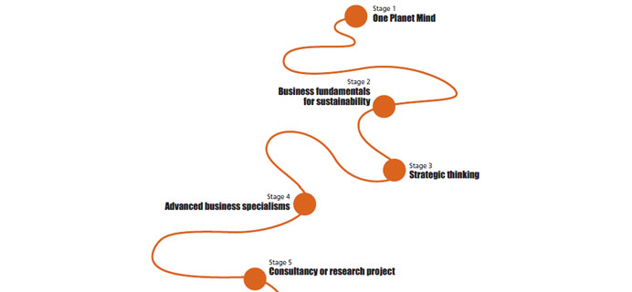
Clearly, it is too early to draw definitive conclusions, however the model is suggestive of moving away from the functional-specialization model towards an open systems perspective providing an alternative design model (and values) for business education.
Broader Implications for Business Program Design:
The primary conclusion to be offered here is that an animated discussion of the business model underpinning design of the current business curricula deserves more attention. As stated by PRME, it is “a timely global call for business schools and universities worldwide to gradually adapt their curricula, research, teaching methodologies and institutional strategies to the new business challenges and opportunities.” (“PRME: Principles,” n.d.) The purpose of this review, has been to open up this conversation beyond the existing critiques that conclude changes should be focused on integrative models but leaving the fundamental functional/disciplinary based model intact. (Datar et al., 2010) As a summary there are two points to be emphasized. These are a) that an open systems paradigm would better serve to educate critical, thinking business students to the complexity, nonlinearity and unpredictability of the current institutional environment where they will become decision makers and b) that the value discussion extends beyond increasing the “ethics” component. This last point has not been pursued here but there is evidence that even among mainstream business leaders there is a growing sentiment to critically explore the profit maximization/ shareholder value proposition. (“Conscious Capitalism,” n.d.) It is the responsibility of those of us who carry out research and provide instruction to take seriously the critique of the body of knowledge and expertise that we collectively impart. It remains the responsibility of professors and researchers who actively engage in developing courses, programs and content to support the critical thinking of our business students. There is discussion whether business students should take an oath similar to other professionals in medicine and law. (Morgan, 2011) Although this may remain controversial for some time, students, at the very least, should be made more cognizant of the institutional and individual frameworks in which they act--- and also live.

References
Aspen Institute Center for Businss Education. (n.d.). Retrieved from http://www.aspencbe.org/
Bertalanffy, L. V. (1972). The History and Status of General Systems Theory. Academy of Management Journal, 15(4), 407-426.
Bradshaw, D. (2008, June 23). Green Guide to Business Schools. Financial Times, business education.
Bradshaw, D. (2009, June 8). Deans fight crisis fires with MBA overhaul :Opinions differ on the culpability of business schools in the global economic meltdown. Financial Times, p. 12. doi:1742048651
Conscious Capitalism Alliance. (n.d.). Retrieved from http://www.consciouscapitalism.org/
Datar, S., Garvin, D., & Cullen, P. (2010). Rethinking the MBA: Business Education at a Crossroads. Boston, MA: Harvard Business Press.
DeAngelo, H., DeAngelo, L., & Zimmerman, J. (2005, July). What’s Really Wrong with U.S. Business Schools? Retrieved from Available at SSRN: http://ssrn.com/‌abstract=766404
Fleischer, D. (2001). Profit with a Conscience: Can Business be Good? (Unpublished master’s thesis). The London School of Economics and Political Science, London, U.K.
Friedman, M. (1970, September 13). The Social Responsibility of Business is to Increase its Profits. New York Times Magazine, 32-33.122.124.126.
Gentile, M. (2009, February 5). Business Schools: A Failing Grade on Ethics. Bloomberg Business Week, viewpoint. Retrieved from http://www.businessweek.com/‌bschools/‌content/‌feb2009/‌bs2009025_129477.htm
Ghoshal, S. (2005, March/‌April). Bad Management Theories are destroying good Management Practices. Academy of Management Learning & Education, 4(1), 75-91.
Graduate Management Admission Council: Graduate Management News. (n.d.). Retrieved from http://www.gmac.com/‌gmac/‌newsandevents/‌gmnews/
Gray, W. (1072, December). In memoriam: Ludwig Von Bertalanffy (1901-1972). Academy of Management Journal, 15(4), 403-404.
Guillen, M. (2001). Globalization Civilizing, Destructive or Feeble? A Critique of Five Key Debates in the Social Science Literature. Annual Review of Sociology, 27(1), 235-60.
Harvard: Year 1, Fall: Student Life. (n.d.). Retrieved from Harvard Business School website: http://www.hbs.edu/‌mba/‌studentlife/‌year1-fall.html
Hickman, S. (2010, August 16). A New Trajectory for Management Education. The European Financial Review, management. Retrieved from http://www.europeanfinancialreview.com/‌?p=1488
Mackey, J., Friedman, M., & Rodgers, T. (2005, October). Rethinking the Social Responsibility of Business: A Reason debate featuring Milton Friedman, Whole Foods’ John Mackey, and Cypress Semiconductor’s T.J. Rodgers. Reason.
Mintzberg, H. (2004). Managers not MBA’s: A Hard Look at the Soft Practice of Managing and management Development. San Francisco, CA: Berrett-Koehler .
Mitchell, M. (2009). Complexity: A Guided Tour. Oxford, U.K.: Oxford University Press.
MIT: Sloan School of Management, First Semester Core MBA Program. (n.d.). Retrieved from MIT Sloan School of Management website: http://mitsloan.mit.edu/‌mba/‌program/‌firstsem.php
Morgan, B. (2011, February 7). MBA Oath Provides an Ethical Foundation. Financial Times.
Pfeffer, J., & Fong, C. (2004, May). The Business School “Business”: Some Lessons from the US Experience (Rep. Research Paper Series.Stanford University No. 1885). Retrieved from http://https://gsbapps.stanford.edu/‌researchpapers/‌library/‌RP1855.pdf
PRME:Principles for Responsible Management Education. (n.d.). Retrieved from http://www.unprme.org/‌the-6-principles/‌engagement-model.php
Scott, R., & Davis, G. (2007). Organizations and Organizing: Rational, Natural and Open System Perspectives. Upper Saddle River, NJ: Pearson Prentice Hall.
Senge, P., Smith, B., Kruschwitz, N., Laur, J., & Schley, S. (2008). The Necessary Revolution: How Individuals and Organizations are Working Together to Create a Sustainable World. New York, NY: Doubleday.
Shapinker, M. (2011, January 25). Why Business Still Ignores Business Schools. Financial Times, p. 13.
Stanford MBA: Description of Curriculum. (n.d.). Retrieved from Stanford, Graduate School of Business website: http://www.gsb.stanford.edu/‌mba/‌academics/‌year1_detailed-p.html
Steger, M. (2009). Globalization: A Very Short Introduction. Oxford, U.K.: Oxford University Press.
University of Exeter Business School: The One Planet MBA. (n.d.). Retrieved from University of Exeter Business School website: http://business-school.exeter.ac.uk/‌mba/
U.S. News & World Report: Best Business School Rankings. (2011). Retrieved from http://grad-schools.usnews.rankingsandreviews.com/‌best-graduate-schools/‌top-business-schools/‌mba-rankings

