Assessment of Genome Annotation part of BIOL 241 Introductory Genetics Course

Core Competencies utilized in the genome annotation project:

Competency 2. Apply Quantitative analysis and mathematical reasoning to draw conclusions (use the data collected to annotate genes based on mathematical evidence)

Competency 3. Model the collection and critical analysis of data to draw conclusions about biological phenomena (use the data collected to draw conclusions about the structure and function of genes/proteins).

Competency 5. Explore the interdisciplinary nature within biology and with other liberal
arts disciplines (within biology- bioinformatics & computational biology used to annotate genes).

The integration of genomics research into the undergraduate biology curriculum provides students with the opportunity to become familiar with bioinformatics tools and answer original research questions. My purpose with this research project was to upscale the research experience through integration with classroom experience giving more students access to research projects. Students annotated predicted ABC genes of Methanothermobacter thermautotrophicus and were required to present a research poster to demonstrate their understanding of the project. Genome annotation is the process of identifying and attaching biological information to genome sequences. In the last few years many genomes have been sequenced but only a small percentage of them have been manually annotated to reveal important information. In this project genome annotation was integrated into the curriculum as a means of introducing original scientific research into the undergraduate curriculum. This approach led me to create an introductory genetics course to teach genetics/genomics integrated with genome annotation to create an exciting research program catering to underrepresented students. This approach to research has been used at Trinity with great success in the inaugural year (2013). During this research project a number of tests and surveys were conducted to assess if the project increased student interest in scientific research as depicted in figures 1 through 3 and in table 1.

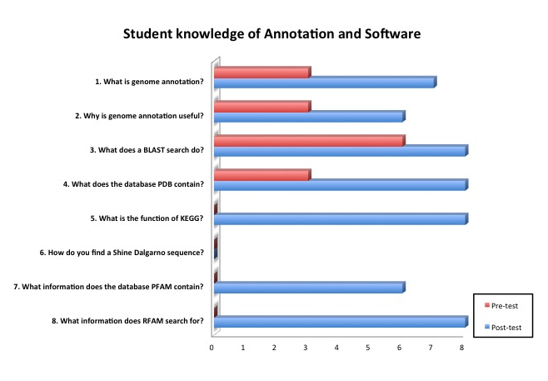

Figure 1. Student knowledge of genome annotation and annotation software, pre-course and post course. The bar graph depicts the answers to 8 questions pre and post course. The pre-course test scores are depicted in red and the post course in blue. It is clear that the students did much better on the post-course test than the pre-course test.
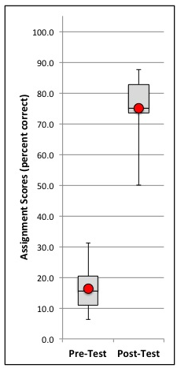

Figure 2. Box and whisker plot depicting pre-course and post-course analysis of the two genome annotation tests. The class average on the pre-test was 16.4% ± 6.1% (mean ± 95% confidence interval). The class average on the post-test was 75% ± 8.3% (mean ± 95% confidence interval). The students did much better on the post-test.

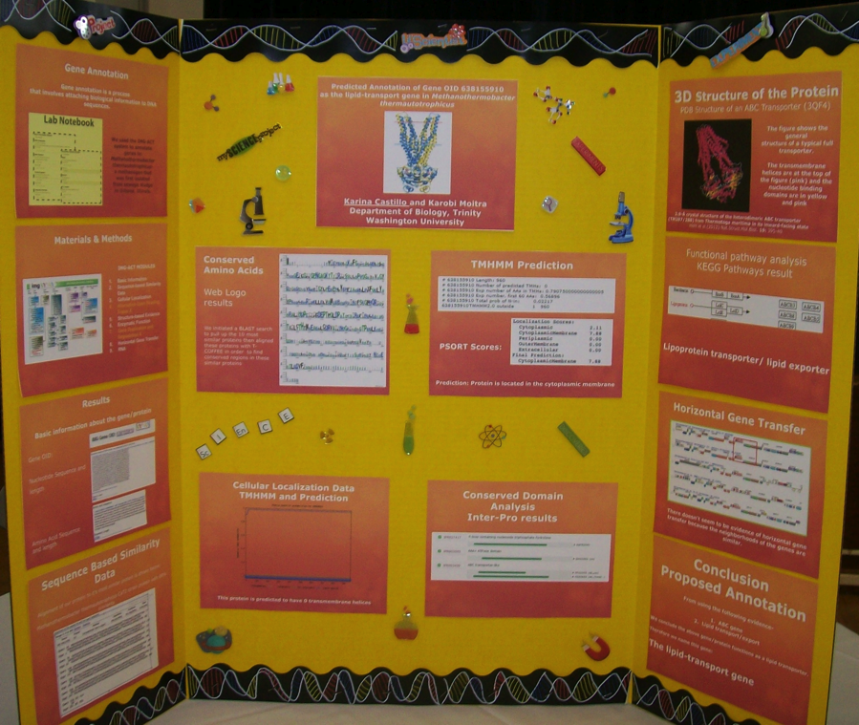

Figure 3. A sample poster prepared by a student for the genome annotation poster conference. The poster depicts one annotated gene and results from 6 of the 9 modules.

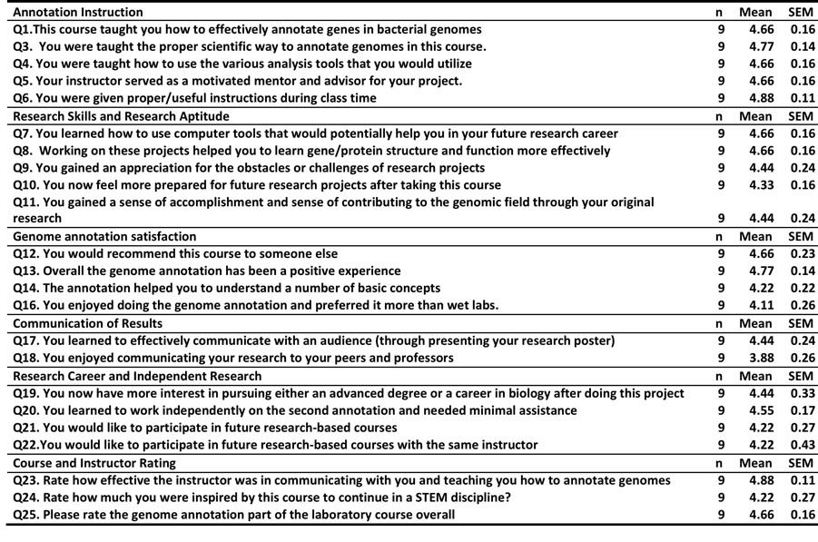

Table 2. Post-course student survey results for genome annotation. The table shows the questions, the number of students (n), the mean of each scored question and the standard error of the mean (SEM).

Survey results in detail:

The survey results are depicted in Table 2. Students were asked their opinion on their experiences in the genome annotation part of the Introductory Genetics course. The subject matter of the questions were grouped into different categories such as: Annotation Instruction, Research Skills and Research Aptitude, Genome annotation satisfaction, Communication of Results, Research Career and Independent Research, Course and Instructor Rating. The survey questions are available on request and also incorporated into Table 1.

Each category is discussed separately below:

Annotation Instruction: Students responded well to this section, all the questions under this section head received an average score over 4.5 out of a maximum of 5. The survey indicated that the annotation instructions that the students received was very good (mean score: 4.88/5), that they were taught the proper scientific way to annotate genomes (4.77/5), they were also taught how to use the various genome analysis tools (4.66/5) and the course as a whole effectively taught them how to annotate genomes (4.66/5). Finally the students agreed that their instructor served as a motivated mentor and advisor for their project (4.66/5) suggesting overall that the instruction and mentoring that they received was more than adequate for all of the students without exception to learn genome annotation.

Research Skills and Research Aptitude: Students agreed that they learned to use computational tools that would be helpful in future research career (4.66/5), working on the annotation project helped them to learn gene/protein structure and function more effectively (4.66/5), they gained an appreciation for the challenges of research projects (4.44/5) and felt more prepared to face any future research projects (4.33/5). Most importantly students did gain a sense of accomplishment and a sense of contributing to the field of genomics (4.11/5) through the annotation project, which was very encouraging since the students did realize that they were contributing original data to the research project.

Genome Annotation Satisfaction: Questions in this section were tailored to gauge if the students were satisfied with the new genome annotation curriculum. Students agreed that they would recommend the course to another student (4.66/5), that genome annotation help them to understand basic concepts in genetics (4.22/5) and that overall genome annotation had been a positive experience for the students (4.77/5). The one question that was scored lower was if the students enjoyed genome annotation and preferred doing it over wet labs (4.11/5) suggesting that although the students did enjoy doing the annotations some of the students did not strongly agree that they enjoyed doing them more than wet labs. From this we can conclude that there is a place in the curriculum for wet labs but also room for addition of computational laboratory assignments.

Communication of results: Students were required to communicate their results by preparing a poster and presenting it in an open poster session to their peers, professors and invited guests (including faculty from other universities and student interns from the non-profit advocacy group Genetic Alliance). Students were asked if they learned to effectively communicate with an audience (through presenting their research posters) which they were in overall agreement with (4.44/5). Surprisingly the only answer where the mean fell below a 4 (out of a possible 5) was the answer to the question asking if students enjoyed communicating their research to their peers and professors, where the mean was 3.88 suggesting that at least a few of the students were not comfortable speaking about their research and needed to develop more confidence and practice their communication skills. Research Career and Independent Research: Students agreed that they had more interest I pursuing and advanced degree or having a career in Biology based on their experience in genome annotation (4.44/5), they also learned to work independently (4.55/5) and would like to pursue future research based courses (4.22/5). This data indicates that as a result of their research experience students were motivated to pursue research and continue on to an advanced degree. This is very encouraging because sometimes it is very difficult for female students to pursue an advanced degree due to family and other obligations.

Course and instructor rating: The final part of the survey assessed the course and the instructor. Students rated the communications skills of the instructor very highly (4.88/5) most students strongly agreeing that the instructor was a very effective communicator. The rating of the genome annotation part of the course was also high (4.66/5) suggesting that students liked doing the annotations. On the whole most students did agree that genome annotation had inspired them to continue in a STEM (Science, Technology, Engineering and Math) discipline.
Overall the student reception to the new addition of genome annotation to the genetics curriculum was very positive. Working on the annotation project helped the students to learn gene/protein structure more efficiently, students effectively learned to communicate their research results and finally the students rated the genome annotation portion of the course as a 4.66/5, suggesting that students were on the whole very receptive to genome annotation being a part of the genetics curriculum and were inspired to continue on a STEM path.

Student comments on Genome Annotation:

“ I learned how to do genome annotation and present it to people. The presentation skills and research skills will help me to communicate and do research effectively in the workplace.”

“I learned how to use the different databases and a whole other side of science. I enjoyed it so much that I want to pursue my future career not only in medicine but also in research. This course prepared me for future classes and internships. It will definitely help me understand Biology better.”

“The gene annotation was a different and interesting research project. I learned about different online resources to help with gene annotation. Having the professor help during lab time was something I found to be effective.”

“I learned more on how to be more skilled in a research project and how to use different websites in order to annotate the gene. I still need a bit more practice but overall I enjoyed it.”

“This course gave me a better understanding of how research is performed. The course made me feel more confident in myself and it made me feel more comfortable about applying for future internships in the summer.”

