Strategies to Improve Academic Performance in BIOL 121 and BIOL 130

Anatomy and Physiology I or BIOL 121 is the most common first science course taken by students in the College of Arts and Sciences (CAS) Undecided-Nursing (UND-N) curriculum at Trinity University. The majority of the CAS UND-N students are enrolled in BIOL 121 within their first two semesters at Trinity; however, due to the rigorous content and fast pace of the course compacted by many student’s poor science preparation, the students often struggle in the course resulting in a high rate of BIOL course attrition.

The low academic performance in BIOL 121 by first-time CAS UND-N students is demonstrated in the following analysis. The average grade earned in BIOL 121 at first enrollment is 1.94 ± 1.15 or a “C” grade; however, this value does not include students who withdrew from the course. Thirteen of the 135 students were enrolled in BIOL 121 during the semester this statistical data was collected and, thus, their grades are not available for analysis in this report. This is almost an additional 10% attrition rate, which is not factored in to the final statistics.

Earned grades of the remaining 122 students show that 40.98% (50 of 122 students) withdrew from the course, 9.02% (11 of 122 students) received an “F”, 9.02% (11 of 122 students) received a “D”, 6.56% (8 of 122 students) received a “C-“, 13.93% (17 of 122 students) received a “C” or “C+”, 13.93% (17 of 122 students) received a “B-“, “B”, or a “B+” grade, and 6.56% (8 of 122 students) received an “A-“ or “A” grade at the first attempt in BIOL 121 (Figure 1A). Based on the passing grade of “C”, set by the criteria of the nursing program, 65.57% (80 of 122 students) did not pass (received below a “C” or withdrew from the BIOL 121 course), and 34.43% (42 of 122 students) passed BIOL 121 at the first attempt (Figure 1B).

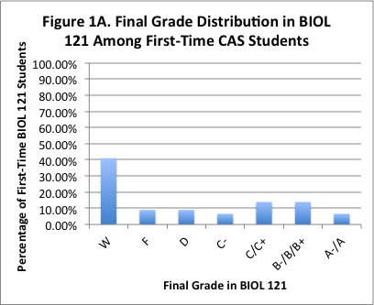
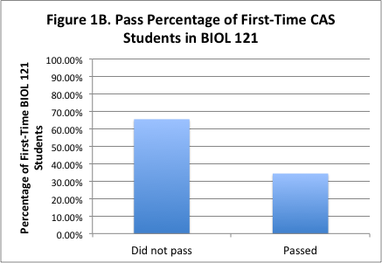

A 34.43% pass rate in BIOL 121 by first-time CAS UND-N students at their first attempt in BIOL 121 is staggeringly low. Therefore, determining the best strategies to improve performance in BIOL 121 will provide great assistance to students attracted to the UND-N curriculum at Trinity, and may improve the attrition rate associated with the UND-N students in BIOL 121, and overall in the UND-N curriculum.

Similar analysis has been performed for BIOL 130 course for the 2009-2012 period.

Based on the above information, the passing rate for the course was 77.2% with an attrition rate of 22.8%. The most frequently earned grade for the course is a B. This statistic is much more positive compared to BIOL 121 and is mostly due to the fact that the students taking Microbiology for Health Care Professions have taken at least one Anatomy and Physiology course before signing up, and thus have a more adequate preparation level. There is a concern however, that if a placement test is introduced for the BIO 121 course only, then the students who fail the test will take BIOL 130 first and it will severely affect the passing rate for the course.

Potential Strategies to Improve Academic Performance in BIOL 121 and BIOL 130

Anatomy and Physiology Placement Test
Grades | Spring 2009 | Fall 2009 | Spring 2010 | Fall 2010 | Spring 2011 | Fall 2011 | Spring 2012 | Fall 2012 | Sum
A | 3 | 2 | 4 | 7 | 1 | 5 | 4 | 2 | 28
B | 3 | 9 | 4 | 8 | 6 | 5 | 6 | 3 | 44
C | 7 | 5 | 3 | 2 | 1 | 1 | 1 | 2 | 22
D | 3 | 1 | 3 | 1 | 0 | 0 | 0 | 0 | 8
F | 0 | 0 | 7 | 0 | 0 | 2 | 1 | 0 | 10
W | 2 | 1 | 0 | 0 | 2 | 2 | 3 | 3 | 13
Attrition rate | 28 | 11 | 29 | 11 | 20 | 26 | 27 | 30 | 182

An anatomy and physiology placement test can be implemented prior to the enrollment of BIOL 121. This placement test would include content in math, as well as an introductory level of biology and chemistry materials that should have been learned at the high school educational level.

A potential placement exam with science-based questions has been drafted and tested in 3 courses. Questions are based on the material currently covered by the BIOL 101 course with the addition of fundamental algebraic questions. Students that do not pass this exam, will be required to pass BIOL 101 prior to taking BIOL 121.

The same procedure is recommended for students prior to enrollment in BIOL 130 (but this is not the focus of the current study).

It will be beneficial to collect and analyze similar data within a two year time frame to assess the impact of the placement test “intervention” on the passing rate for the BIOL 121 course.

A proposal has been made to require students to achieve a specified score on a biology placement test or pass BIOL 101 with a C or better before taking BIOL 121. Assessment data was collected during the Fall of 2013 to determine whether student performance on a biology placement test would (1.) correlate with student performance in BIOL 121 or (2.) improve after taking BIOL 101.

Assessment data was collected from 2 courses for BIOL 121 with different instructors from a total of 24 students. In both classes, students took the placement test at the beginning of the course and scores from the test for each student were compared to final course performance. The R value was 0.79 and 0.73 for the two courses, suggesting a strong positive correlation between performance on the placement test and performance in the course.

Additionally, students who took BIOL 101 took the assessment test at the beginning of the semester and at the end of the semester. The average percent improvement was 48%. Only 5% of the students scored above 50% on the exam at the beginning of the semester while 50% of the students scored above 50% at the end of the semester.

These data collectively suggest that there is a strong positive correlation between performance on the placement exam and performance in BIOL 121, and that students that take BIOL 101 improve performance on the placement exam. Based on these data it is therefore recommended that a requirement be implemented such that students must earn a 40% on the placement exam before they may take BIOL 121. If students earn less than a 40% on the placement exam, students will be required to earn a C or better in BIOL 101 prior to taking BIOL 121.

