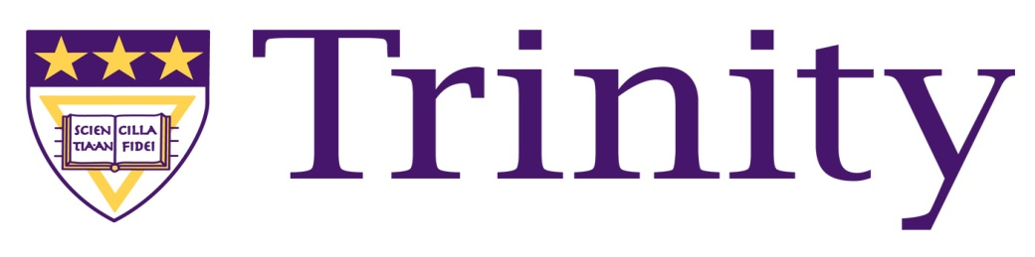
Trinity Washington University
College of Arts and Sciences
Staff Semester Report (Math 101S, Math 102, Math 108 and Math 123)
Fall Semester 2012

Executive Summary

Pass Rates Continue to Climb
One final adjustment incorporated into the Math 101S pedagogy – holding students to a higher standard on each test (and not just overall average) saw the pass rates climb from 39% to 53% For students that complete the course (they do not quit attending or withdraw) the pass rate is an astounding 87%.

Diagnostic Results Continue to Show Significant Progress
The use of differentiated instructional methods continues to show that 99% of all students made significant progress in their mathematical abilities regardless of their entry point into the course. Monday Mathematics, daily quizzes, individualized instructional strategies and tier grouping assignments led to the average for all students rising over 32% on the standardized diagnostic exam.

66% of the Freshman Red Class Placed into Math 101S
Math 101S had a significant impact on the success of an incoming class, and 84% of these students were enrolled for the Spring 2013 semester.

Replication of Pedagogy
Trinity’s pedagogical model for Math 101S can be replicated with similar success across different instructors. Our pass rates include three sections taught by two adjuncts and five sections taught by full time mathematics specialists.

Monday Mathematics
The Monday Mathematics program with its permanent home located in the Library Seminar room continues to soar with student participation and hence student success. The turn-outs have been so great that two additional Monday Mathematics sessions were held on Wednesday evening.

National Comparisons
Nationally, the pass rates hover between 35-45% depending on the article that you may be reading. NCAT (National Center for Academic Transformation) puts the national pass rate at 42%. Currently our pass rates are higher than any other school that is teaching a similar course – regardless of demographics and/or placement scores.

