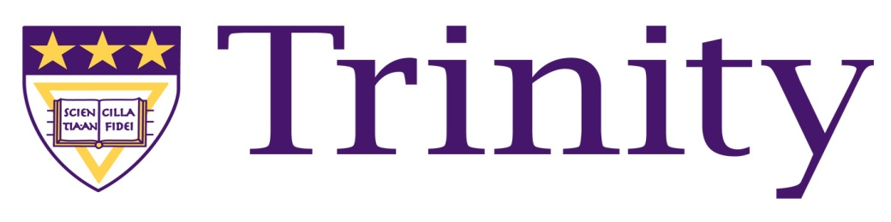
Trinity Washington University
College of Arts and Sciences
Staff Semester Report (Math 101S, Math 102 and Math 123) – Fall Semester 2011

Executive Summary

Pass Rates Remain the Same
The overall pass rate (for all students that registered for Math 101S) remained relatively the same as the Fall 2010 rate (39% - 40%).

Diagnostic Results Continue to Show Significant Progress
The use of differentiated instructional methods continues to show that 97% of all students made significant progress in their mathematical abilities regardless of their entry point into the course. Monday Mathematics, daily quizzes, individualized instructional strategies and tier grouping assignments led to the average for all students rising over 26% ( a 5% increase from last semester)on the standardized diagnostic exam.

65% of the Incoming Freshman Class Placed into Math 101S
Math 101S had a significant impact on the success of the incoming class, and 83% of these students have registered for the Spring 2012 semester.

Monday Mathematics
The Monday Mathematics program has a permanent home located in the Library Seminar room. Additional white boards were purchased to accommodate the program and attendance continues to rise with this valuable student resource.

Attrition in Math 101S and Math 102 continues to be a concern
Only 62% (60% in the Spring) of all those registering for Math 101S and 73% (77% in the Spring) for Math 102 completed the course and took the final.

Prerequisites
One factor that contributes to success in a math course is the grade received in the precursor course. Those students who meet the pre-requisites for Math 102 and 123 are passing at a greater than 90% rate. The highest grade that a student without the proper prerequisites has received is D+.

