AAC&U RUBRICS ASSESSMENT REPORT
SCHOOL OF PROFESSIONAL STUDIES

Fall 2012 to Fall 2013

AAC&U rubrics ASSESSMENT report
January 28, 2014

fall 2012-fall 2013

summary
In Fall 2012, Trinity Washington University School of Professional Studies implemented an Assessment project that utilized standard rubrics designed by the Association of American Colleges and Universities. These rubrics were implemented after a one year period of research and review on the effectiveness of the AAC&U assessments.
The purpose of the project is to assess the degree to which that the SPS general education core program, as well select major courses, teach and effectively measure specific outcomes that are key to the mission of the university and the academic unit. Information derived from these assessments will be utilized to improve the quality of the education provided in these important areas.
Every semester, faculty that are teaching courses that have been identified for assessment are expected to assess at least one assignment with each rubric assigned to his or her class. Faculty are asked to circle the ranking on the rubric that corresponds to the quality of work that the student has demonstrated. Rubrics are due at the end of the semester. To date, a total of twenty faculty members have participated in the rubrics project, representing 26% of faculty required to participate.

More on the AAC&U Rubrics
Through its ground-breaking national initiative, VALUE (Valid Assessment of Learning in Undergraduate Education), AAC&U has worked with faculty and assessment expert teams across the country to develop a set of 15 rubrics through which institutions can evaluate cross-cutting capacities students develop across courses and programs. More than 2000 institutions are currently using VALUE rubrics as part of their assessment plans. See the attachment for more information about the successful implementation results for the use of VALUE rubrics at campuses across the nation. (AAC&U, 2012)

ASSESSMENT results
To date, completed rubrics have been received for 23% of all courses designated for general education and selected major course assessment for the School of Professional Studies.
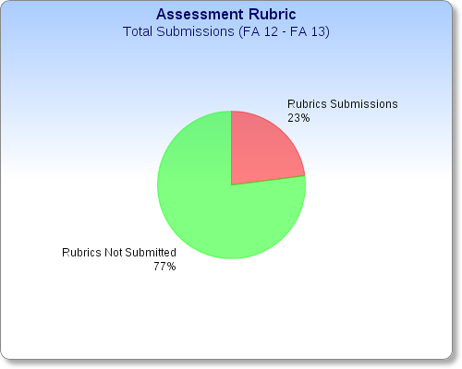

ASSESSMENT results BY SEMESTER
The graph below illustrates the number of course rubrics submitted per semester:

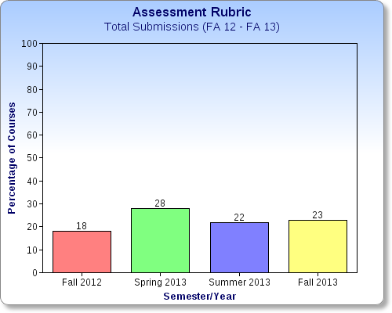

Rubrics have been received for the following SPS courses:

Fall 2102

Course | Instructor  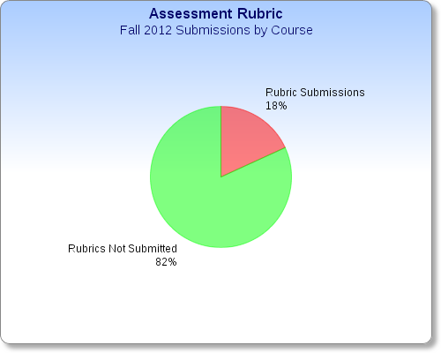
BIOL 101 | Christmas, John
ENVS 101 | Christmas, John
INT 109 | Price, Scheryl
INT 109 | Price, Scheryl
COM 290 | Washington, Sherron
MATH 109 | Jones, Andy
MATH 110 | Seck, Papa
MATH 110 | Seck, Papa

Spring 2013
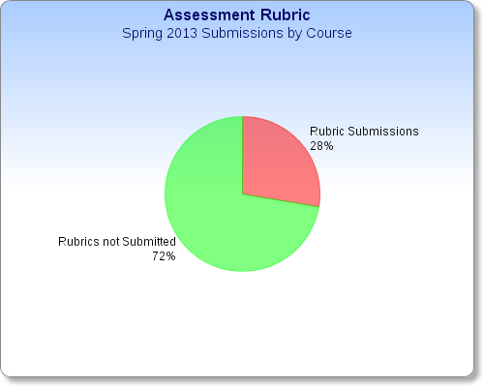

Course | Instructor
ENVS 101 | Christmas, John
INT 109 | Bryant, Bertie
INT 109 | Bryant, Bertie
INT 109 | Price, Scheryl
INT 117 | Nash, Angel
INT 117 | Nash, Angel
HUMR/SOCY 311 | Malloy, Daniel
HUMR/SOCY 499 | Thorne, Daryl
MATH 108 | Nyamekye, Farhaana
MATH 110 | Seck, Papa
MATH 110 | Seck, Papa
PHIL 251 | Marquez, Janice
PHIL 253 | Staggers, Maria

Summer 2013
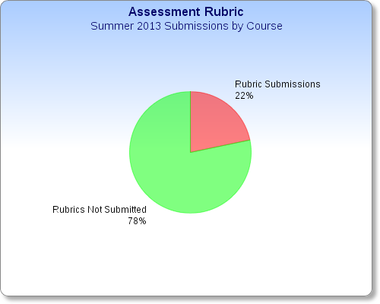

Course | Instructor
ENVS 101 | Christmas, John
INT 109 | Orlando, Benjamin
INT 109 | Orlando, Benjamin
MATH 108 | Bryan, Horace
MATH 110 | Seck, Papa

Fall 2013
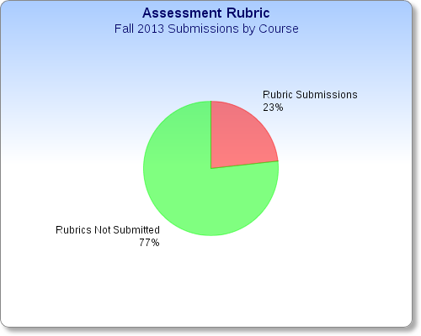

Course | Instructor
ENGL 107 | Miller, Kari
ENGL 107 | Lucas, Beverly
INT 117 | Nash, Angel
HUMR/SOCY 311 | Malloy, Daniel
COM 101 | Cork, Marceia
COM 225 | Washington, Sherron
COM 290 | Puma, Daniel
MATH 108 | Nyamekye, Farhaana
MATH 110 | Phulara, Dev
MATH 110 | Seck, Papa

ASSESSMENT results BY program
The graph below illustrates the number of course rubrics submitted by academic program:

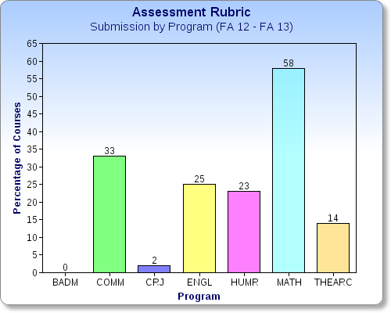

assessment results by rubric category
The rubrics listed below have been selected from the Association of American Colleges and Universities to assess general education, and selected major courses in the School of Professional Studies.
CT- Critical Thinking IK- Intercultural Knowledge
ER- Ethical Reasoning OC- Oral Communication
IL- Information Literacy PS- Problem Solving
QL- Quantitative Literacy

The graph below demonstrates the average level of student proficiency for each of the rubrics categories:

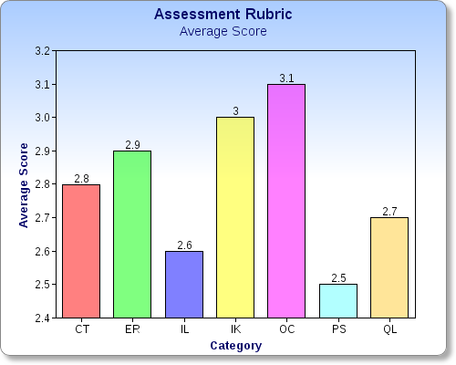

CRITICAL THINKING rubric

To date, Critical Thinking rubrics have been received for the following courses:

BIOL 101 Introduction to Biology
ENVS 101 Discovering Planet Earth
INT 109 Information Literacy
INT 117 Introduction to Information Literacy (THEARC)
ENGL 107 College Composition

Core expectations for the Critical Thinking rubric included Explanation of Issues, Evidence, Influence of Context and Assumption, Student's Position, and Conclusion and Related Outcomes.

The average scores for each of the Critical Thinking core expectations were as follows:

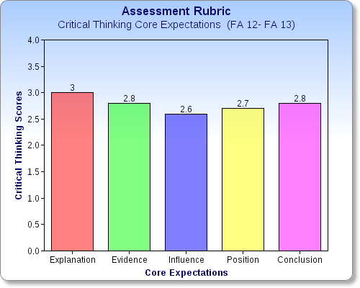

Students enrolled in ENGL 107 and INT 117 demonstrated the highest level of competency on the Critical Thinking rubric (3.2 out of 4), particularly in the core expectation, Explanation of Issues.

Alternatively, students enrolled in ENVS 101 Discovering Planet Earth scored the lowest on the Critical Thinking rubric (1.9 out of 4), in the areas of Influence of Context and Assumptions and Student’s Position.

Notably, there has been a slight increase in faculty evaluation of the core expectations for Critical Thinking over the last four semesters.

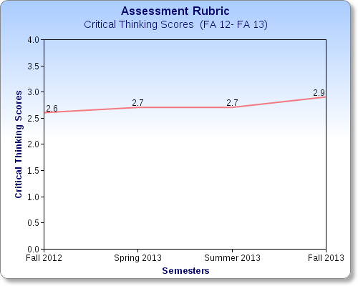

ethical reasoning rubric

To date, Ethical Reasoning rubrics have been received for the following courses:

PHIL 251 Bioethics Health Professions
PHIL 251 Business Ethics

Core expectations for the Critical Thinking rubric included Ethical Self-Awareness, Understanding Different Ethical Perspectives, Ethical Issue Recognition, Application of Ethical Perspectives, and Evaluation of Different Ethical Perspectives.

The average scores for each of the Critical Thinking core expectations are as follows:

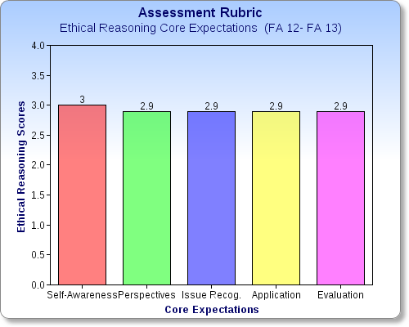

Very little data is available for this category, due to faculty participation of just 13%. Due to low faculty participation, it is difficult to form conclusions about achievement trends.

information literacy rubric

To date, Information Literacy rubrics have been received for the following courses:

BIOL 101 Introduction to Biology
ENVS 101 Discovering Planet Earth
INT 109 Information Literacy
HUMR/SOCY 311 Research Methods for Human Relations

Core expectations for the Critical Thinking rubric include Determine the Extent of Information Needed, Access the Information Needed, Evaluate Information and its Sources Critically, Use Information Effectively to Accomplish a Specific Purpose, and Access and Use Information Ethically and Legally.

The average scores for each of the Critical Thinking core expectations are as follows:

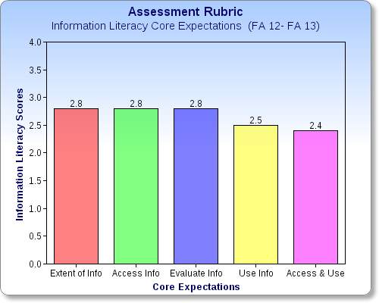

Students enrolled in INT 109, ENVS 101, and HUMR/SOCY 311 displayed the highest levels of competency on the Information Literacy rubric (3.3 out of 4), particularly in the core expectation, Access the Information Needed.

Alternatively, students enrolled in BIOL 101 Introduction to Biology and ENVS 101 Discovering Planet Earth scored the lowest on the Critical Thinking rubric (1.6 out of 4), in the areas of Evaluate Information and its Sources Critically and Use Information Effectively to Accomplish a Specific Purpose.

There was a surge in student scores for Critical Thinking in Summer 2013; however, student scores continue to show improvement since Fall 2012.

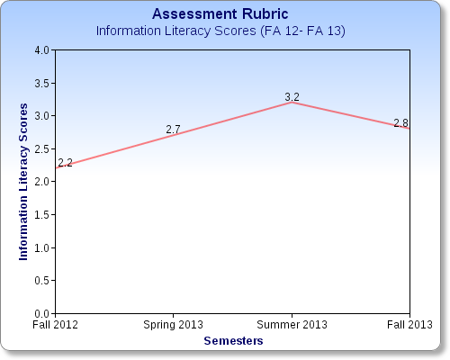

intercultural knowledge rubric

To date, Information Literacy rubrics were received for the following courses:

COM 101 Introduction to Comm. & Public Speaking (THEARC)
COM 225 Intercultural Communication
COM 290 Public Speaking

Core expectations for the Intercultural Knowledge rubric include Knowledge: Cultural Self-Awareness, Knowledge: Knowledge of Cultural Worldview Framework, Skills: Empathy, Attitudes: Curiosity, and Attitudes: Openness.

The average scores for each of the Critical Thinking core expectations are as follows:

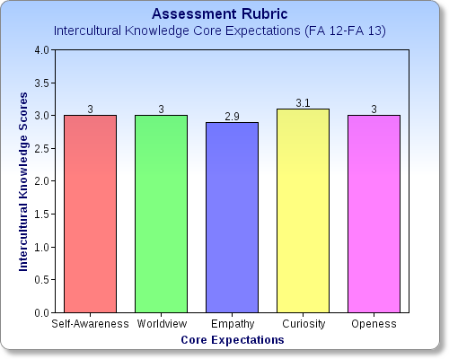

Students enrolled in COM 101, COM 225, and COM 290 demonstrated the highest level of competency on the Information Literacy rubric (3.3 out of 4). Students had slightly higher achievement rates in the area of Intercultural Curiosity.

Remarkably, there were no classes that scored, on average, in the lowest—or Benchmark category (1 out of 4) for this rubric, which suggests that students may have an ever increasing competency for Intercultural Knowledge.

Due to lack of faculty participation in Spring and Summer 2013, it is difficult to form conclusions about achievement trends; however, it should be noted that overall scores in Fall 2012 stood at 2.4 and in Fall 2013, they were ranked at 3.2.

oral communication rubric

Oral Communication rubrics were received for the following courses:

COM 101 Introduction to Comm. & Public Speaking (THEARC)
COM 290 Public Speaking
SOCY/HUMR 499 Senior Seminar.

Core expectations for the Intercultural Knowledge rubric include Organization, Language, Delivery, Supporting Material, and Central Message.

The average scores for each of the Oral Communication core expectations are as follows:

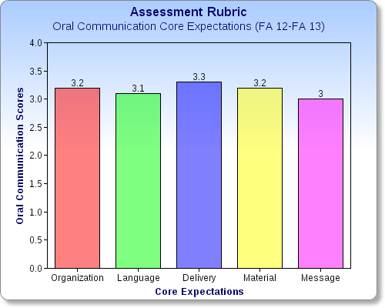

Students enrolled in COM 101 and COM 290 demonstrated highest level of competency on the Oral Communication rubric (3.2 out of 4). Students had slightly higher achievement rates in the area of Delivery.

Remarkably, there were no classes that scored, on average, in the lowest—or Benchmark category for this rubric (1), which suggests that students may have an ever increasing competency Oral Communication.

Due to no faculty participation in Summer 2013, it is difficult to form conclusions about achievement trends.

problem solving rubric

Problem Solving rubrics were received for the following courses:
BIOL 101 Introduction to Biology
ENVS 101 Discovering Planet Earth
HUMR/SOCY 311 Research Methods for Human Relations
MATH 108 Finite Math
MATH 109 Foundations of Mathematics
MATH 110 Introduction to Statistics

Core expectations for the Problem Solving rubric include Define Problems, Identify Strategies, Propose Solutions/Hypotheses, Evaluate Potential Solutions, Implement Solutions, and Evaluate Outcomes.
The average scores for each of the Problem Solving core expectations are as follows:

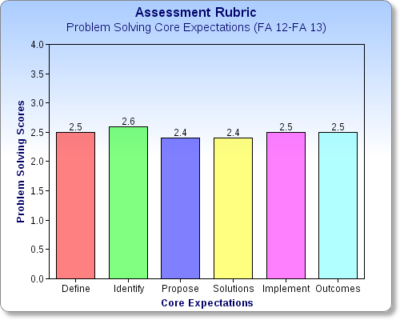

Students enrolled in ENVS 101 demonstrated both the highest and lowest levels of competency on the Problem Solving rubric, in the core expectations of defining problems (3.6 out of 4) and in the area of evaluating outcomes (1.3 out of 4).

Student competency peaked in Spring and Summer 2013 (2.7 out of 4) and fell in Fall 2013.

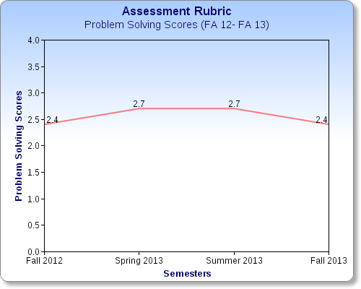

quantitative literacy rubric

Quantitative Literacy rubrics were received for the following courses:

MATH 108 Finite Math
MATH 109 Foundations of Mathematics
MATH 110 Introduction to Statistics
HUMR/SOCY 311 Research Methods for Human Relations.

Core expectations for the Problem Solving rubric include Interpretation, Representation, Calculation, Application/Analysis, Assumptions, and Communication.

The average scores for each of the Problem Solving core expectations were as follows:

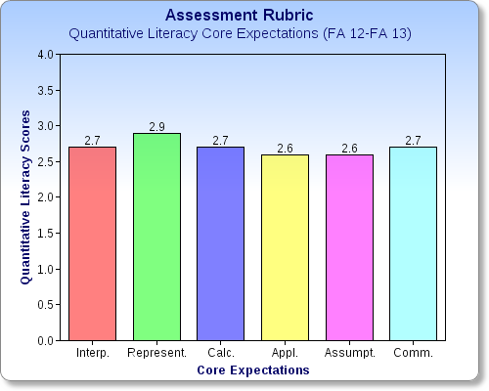

Students enrolled in ENVS 101 demonstrated both the highest and lowest levels of competency on the Problem Solving rubric, in the core expectations of defining problems (3.6 out of 4) and in the area of evaluating outcomes (1.3 out of 4).

Student competency peaked in Spring and Summer 2013 (2.7 out of 4) and fell in Fall 2013.

