

School of Professional Studies
Writing Specialist Report
August 2, 2012
Submitted by Beverly S. Lucas
2011-2012 Academic Year

Table of Contents
EXECUTIVE SUMMARY 3
OVERVIEW OF FINDINGS: 4
RECOMMENDATIONS: 4
Course Outcome Snapshot 6
OVERALL GRADE DISTRIBUTION 7
Classroom Structure 8
COURSE PROGRESSION 8
ACCUPLACER WritePlacer SCORES 8
ENGL 105 and ENGL 105/S Comparison 10
Town Hall Education and Recreation Center (THEARC) 10
INDIVIDUAL CLASS DETAILS 12
ENGL 107 Summer 2011 12
ENGL 103/1 Fall 2011 13
ENGL 103/2 Fall 2011 14
ENGL 105/1 Fall 2011 15
ENGL 105/S Fall 2011 16
ENGL 103/1 Spring 2012 17
ENGL 105/S Spring 2012 18
ENGL 107/2 Spring 2012 19
MY WRITING LAB (MWL) 21
MY WRITING LAB PRE AND POST SCORES 22
Writing Workshop Series 27
Individual Appointments 28
INT501Transition Seminar for Graduate Students 28
APPENDIX A COURSE SYLLABI 29
APPENDIX B ASSIGNMENTS 48
APPENDIX C ASSIGNMENT RUBRIC ENGL 103, 060, 105, and 105S 55
APPENDIX D ASSIGNMENT RUBRIC ENGL 106 and 107 58
APPENDIX E GRADUATE WRITING ASSESSMENT PROMPT 59

EXECUTIVE SUMMARY
The School of Professional Studies offers six levels of writing courses: ENGL030 Fundamental Writing Skills, ENGL 103 Grammar and Writing Workshop; ENGL105 Introduction to Writing; ENGL 105/S Introduction to Writing with Supplemental Instruction; ENGL 106 Writing for Academic and Professional Success; and ENGL 107 College Composition. This report is an analysis of the following course offerings:

Summer 2011: ENGL107/1 College Composition
Fall 2011: ENGL105/1 Introduction to Writing
ENGL105S/Introduction to Writing with Supplemental Instruction
ENGL 103/1; and ENGL103/2 Grammar and Writing Workshop
Spring 2012: ENG 103/1; ENGL 105S/1, ENGL 060; and ENGL 107/2

ENGL 103 Grammar and Writing is designed to help students acquire skills necessary to write effective paragraphs. The focus is on the construction of sentences and paragraphs, the writing process, grammar usage, and mechanics. This is 3-credit bearing course. ENGL105 Introduction to College Writing and ENG105S Introduction to College Writing with Supplementary Instruction are courses designed to increase fluency in college-level written communication with an emphasis on organizational skills and language structure. The goals of the course are for students to develop skills in academic writing and to give students a set of concepts to help structure their thinking and work toward writing clear, persuasive, stylish prose. This is accomplished by engaging various rhetorical strategies in response to a variety of interactions between writer, reader, text, topic and moment. ENGL105 is a 3-credit bearing course, whereas ENGL105S is a 4-credit bearing course which includes a weekly, 120 minute lab for supplemental instruction. ENGL 107 College Composition helps students to develop the skills necessary for effective writing of thesis-centered essays at the college level, including analytical, critical, and argumentative essays. Research and documentation techniques are included. This is a 3-credit bearing course.
The courses offered at the Town Hall Education and Recreation Center (THEARC) for students pursuing an Associate’s degree include: ENGL 060 and ENGL 106. ENGL 060 Composition Skills focuses on writing clear, effective compositions. Students learn how to construct paragraphs, state topics, and to develop narratives and analysis; and ENGL 106 Writing for Academic and Professional Success focuses on planning, writing, and revising compositions for academic and professional purposes including informational, analytical, evaluative and persuasive compositions. Students develop skills in accessing, evaluating, using, and documentation informational sources and introduce students to professional writing applications including memos, resumes, and reports. For each of the English courses, the instructional modes and strategies include: lecture, discussion, readings, quizzes, and collaborative learning activities.

Also, contained in this report is an analysis of the writing portion of INT 501 Transition Seminar for Graduate and the various activities and projects performed throughout the Summer 2011, Fall 2012, and Spring 2012 academic terms.

OVERVIEW OF FINDINGS:
- The average passing rate for the pre-foundational courses (103, 105, 105/S and 060) is 49%.

- The passing rate for students registered in ENGL105/S was 58% whereas the passage rate for students in 105 averaged at 36%.

- Out of the 81 students registered, 14 were repeat students. 5 of these students successfully passed.

- Out of the 81 students, 2 students officially withdrew from the course. 18 (22%) students abandoned the course, defined as not attending class or responding to e-mail communication. The abandoned students who did not officially withdraw from the course received a grade of “D” or “F.”

- Of the 81 students taught, 57 (70%) were registered for the pre-foundational courses.

- 10 students showed a progression in English course enrollment.

- Students who self disclosed English as a Second Language in ENGL 103 and ENGL 107 were challenged with basic sentence structure. These student required assistance above the expertise of the instructor. Of the 7 students, only two successfully earned a passing grade.

- Out of a total of 81 students, 60 students successfully completed the pre and post testing administered through My Writing Lab. The average gain for each student in all courses was 11.50%.

- Although ESL students scored the lowest on the My Writing Lab pretest, each demonstrated the most gain on the post test.

- A score of 70% or higher is considered mastery for MWL. Each class scored below mastery on the pre test, but averaged mastery on the post test.

RECOMMENDATIONS:

- Recommendation #1 Standardization – Standardized syllabi, assignments and policies should be adhered to for ENGL 030, 103, 105, 105/S, 106 and 107. As the number of students repeating ENGL105 is high, for continuity purposes, course goals, objectives and assignments should be standardized. ENGL105 should focus on multiple short paragraph assignments giving each instructor the latitude to utilize individual creativity in their pedagogical approach. . Standardization will also set the benchmarks for student assessment as it relates to students knowledge and competency upon completion of the foundational course.
- Recommendation #2 Implement 103 Grammar and Writing Workshop with Supplemental Instruction – Students who place in ENGL 103 have the lowest Accuplacer scores and are in need of the most instruction. Of the 12 students registered for the course, only 6 successfully passed with the required grade of “C.”The average failure rate for the three sections is 50%. The students would benefit from participating in an extra 2 hour lab each week.
- Recommendation # 3My Writing Lab - MWL should be adopted as a requirement for all English 105, 105/S and ENGL107. This will take full advantage of the year subscription of MWL of which each student is registered and will reinforce the principles and foundations of ENGL105. It will also give a baseline of assessment data to measure outcomes.
- Recommendation# 4 Writing Center Evening Hours - The Writing center should expand its hours on evenings and Saturdays to accommodate the schedules of working adult students. Evening appointment availability was confined on average between 5:00-6:30 PM. This was difficult for students and specialist because classes (for students and specialist) began at 6:30 PM.
- Recommendation #5 Mandatory Attendance Policy – Attendance requirement is crucial for students to successfully pass the course. SPS should adopt CAS’s current policy of 80% class attendance for English foundational courses. This policy will help the student to experience the value of consistently attending class. The higher the attendance rate, the higher the final grade.

- Recommendation #6 Upper Level Writing Course beyond College Composition (i.e. College Composition II) as well as other English literature courses to give students a wider variety of electives and courses to improve and sharpen their writing ability.

- Recommendation #7 English as a Second Language Course and/or Workshop Series – Students (7) who self reported English as a Second Language, scored low (C or below) for their final grade.

- Recommendation #8 Writing Support As the School of Professional Studies continues to increase in enrollment size for students requiring pre-foundational English courses, more writing support will be needed. SPS should begin to explore the idea of a second writing specialist.

- Recommendation #9 Academic Support Outreach – A representative from the Academic Success Center should implement outreach activities by visiting the developmental courses at least once per semester.

The recommendations extended within this report are based on classroom instruction, My Writing Lab results, final grades, student performance and observation.

Course Outcome Snapshot

 | NUMBER OF STUDENTS | PASS | PASS  %  Rate | FAIL | REPEAT | STUDENT  WITHDRAWL | ABANDONMENT
ENGL107/1 | 16 | 11 | 69 | 05 | 06 | 0 | 05
ENGL 103/1 | 03 | 02 | 67 | 02 | 0 | 0 | 0
ENGL 103/2 | 06 | 03 | 50 | 02 | 01 | 01 | 02
ENGL 105 | 14 | 05 | 36 | 09 | 02 | 0 | 05
ENGL 105/S/1 | 10 | 06 | 60 | 04 | 01 | 0 | 0
ENGL 103/1 | 03 | 02 | 67 | 2 | 0 | 0 | 0
ENGL 105S/1 | 07 | 04 | 57 | 03 | 01 | 0 | 0
ENGL 060/AR | 10 | 04 | 40 | 05 | 02 | 01 | 04
ENGL 107/2 | 12 | 11 | 92 | 01 | 01 | 0 | 01
TOTAL | 81 | 48 | 59% | 31 | 14 | 02 | 17
Table1: Overall Course Outcome Snapshot

Findings
- During the Summer 2011, Fall 2011 and Spring 2012, nine courses were taught by the writing specialist. The average number of students per class was 9. The average passing rate was 59%.

- A total of 14 (17%) students were “repeat” students. Of the 14 repeaters, 7 students successfully earned a passing grade.

- The course the most likely to be “abandoned” by students was ENGL 105.

- There was a very low withdrawal rate.

REPEATED
COURSES | B | C | C- | D | D+ | F | Grand Total
ENGL 060 |  |  |  | 1 |  | 1 | 2
ENGL 103 |  |  |  | 1 |  |  | 1
ENGL 105 | 1 |  |  |  |  | 1 | 2
ENGL 105S |  | 1 | 1 |  |  |  | 2
ENGL 107 | 1 |  | 1 | 1 | 1 | 3 | 7
Grand Total | 2 | 1 | 2 | 3 | 1 | 5 | 14
Table 2: Repeat Students

OVERALL GRADE DISTRIBUTION

Term/Course | A | A- | B | B+ | C | C- | C+ | D | D+ | F | W | Grand Total
2011 | 7 | 3 | 4 |  | 6 | 8 | 1 | 7 | 1 | 10 | 1 | 49
FALL | 5 | 2 | 3 |  | 6 | 6 | 1 | 4 |  | 5 | 1 | 33
ENGL 103 | 1 |  | 1 |  | 3 | 1 |  | 2 |  |  | 1 | 9
ENGL 105 | 2 |  | 2 |  | 1 | 1 | 1 | 2 |  | 5 |  | 14
ENGL 105S | 2 | 2 |  |  | 2 | 4 |  |  |  |  |  | 10
SUMMER | 2 | 1 | 1 |  |  | 2 |  | 3 | 1 | 5 |  | 16
ENGL 107 | 2 | 1 | 1 |  |  | 2 |  | 3 | 1 | 5 |  | 16
2012 | 7 |  | 1 | 1 | 5 | 5 |  | 6 |  | 6 | 1 | 32
SPRING | 7 |  | 1 | 1 | 5 | 5 |  | 6 |  | 6 | 1 | 32
ENGL 060 | 2 |  |  | 1 | 1 |  |  | 3 |  | 2 | 1 | 10
ENGL 103 | 1 |  |  |  |  |  |  | 2 |  |  |  | 3
ENGL 105S |  |  |  |  | 2 | 2 |  |  |  | 3 |  | 7
ENGL 107 | 4 |  | 1 |  | 2 | 3 |  | 1 |  | 1 |  | 12
Grand Total | 14 | 3 | 5 | 1 | 11 | 13 | 1 | 13 | 1 | 16 | 2 | 81
Table 3: Grade Distribution

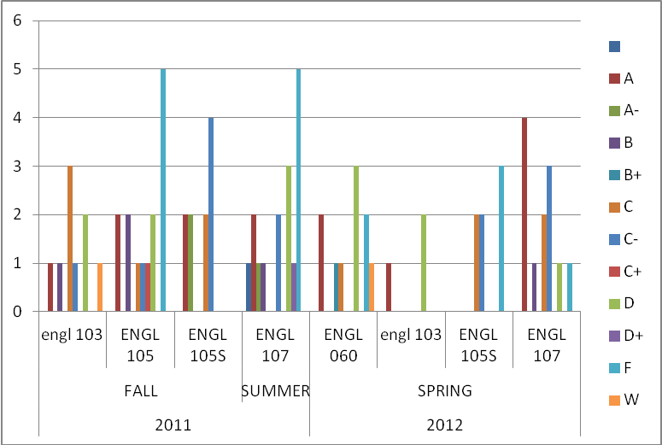
Figure 1 Grade Distribution

Classroom Structure
- All students were required to attend two, one-on-one sessions to discuss individual writing progress and specific areas of deficiency.

- Each class was given the same assignment for each pattern of organization. Assignments were taken from Successful College Writing by Kathleen T. McWhorter.

- All students were given the opportunity to makeup classes missed by attending another section (only) on the day of the absence from their registered class. Six students took advantage of this option during the course of the semester.

COURSE PROGRESSION
Findings:
- 10 students showed a progression in English course enrollment:
(3) 105 to 107: all 3 earned passing grades
(2) 105 to 105S: student A: pass/fail; student B: fail/fail
(1) 103 to 107: student earned passing grades
(1) 103 to 105S: pass/fail
(3) 105S to 107: all 2 earned passing grades

ACCUPLACER WritePlacer SCORES

ACCUPLACER - WritePlacer automatically evaluates students’ essays written responding to one of several prompts provided in the ACCUPLACER System. Students enter their essays into an onscreen textbox and submit for scoring. The system then returns a holistic score that ranges from 1 to 8, as well as feedback on six dimensions:
Purpose and Focus
- The extent to which the writer presents information in a unified and coherent manner clearly addressing the issue.
Organization and Structure
- The extent to which the writer orders and connects ideas.
Development and Support
- The extent to which the writer develops and supports ideas.
Sentence Variety and Style
- The extent to which the writer crafts sentences and paragraphs demonstrating control of vocabulary, voice, and structure. Specific elements to consider include
Mechanical Conventions
- The extent to which the writer expresses ideas using Standard English.
Critical Thinking
- The extent to which the writer communicates a point of view and demonstrates reasoned relationships among ideas.

Students who score 0, 1, 2, or 3, are placed in ENGL 103. Those who score 4, 5, and 6 are placed in ENG 105. Students are able to choose to register for the ENGL 105, 3-credit bearing course or ENGL 105/S with supplemental instruction which is a 4-credit bearing course. Students who score 7 and 8 are placed into ENGL 107.

Findings:
- There were placement scores recorded for only 46 (56%) students. Students Accuplacer scores ranged from 2-7.
- There is no clear correlation between the Accuplacer score and student’s final grade. This could be attributed to many factors: the sample of 46 is too small to make any comparison or the timing of the Accuplacer testing (Accuplacer changed its format and scoring in June 2009); thus students could have been misplaced in a higher level course than the results suggests.

ACCUPLACER SCORES | A | B | B+ | C | C- | C+ | D | D+ | F | W | Grand Total
2 | 1 |  |  |  |  |  | 2 |  |  | 1 | 4
3 | 2 |  |  | 3 |  |  | 3 |  |  | 1 | 9
4 |  |  | 1 | 2 | 2 | 1 | 4 |  | 4 |  | 14
5 | 5 | 1 |  | 1 | 4 |  | 2 |  | 3 |  | 17
7 |  |  |  |  | 1 |  |  | 1 |  |  | 2
Grand Total | 8 | 1 | 1 | 6 | 7 | 1 | 11 | 1 | 7 | 2 | 46
Table 4: Accuplacer Scores

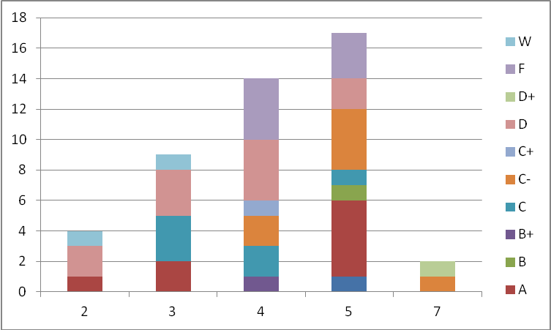
Figure 2 Accuplacer and Final Grades

ENGL 105 and ENGL 105/S Comparison
Findings:
- There were 31 students enrolled in ENGL 105 (14) and 105/S (17). Students enrolled in 105S show a significat increase in earning a higher grade. Although the passing rates were low for each section, the failure rate for 105 was an alarming 36% whereas the passage rate for 105/S averaged at 58%.
- Although ENGL 105/S is two days per week, the students who self chose this course are more likely to earn a higher grade.

 | Final Grade
Course ID | A | A- | B | C | C- | C+ | D | F | Grand Total
ENGL 105 | 2 |  | 2 | 1 | 1 | 1 | 2 | 5 | 14
ENGL 105S | 2 | 2 |  | 4 | 6 |  |  | 3 | 17
Grand Total | 4 | 2 | 2 | 5 | 7 | 1 | 2 | 8 | 31
Table5: ENGL 105 and ENGL 105/S Comparison

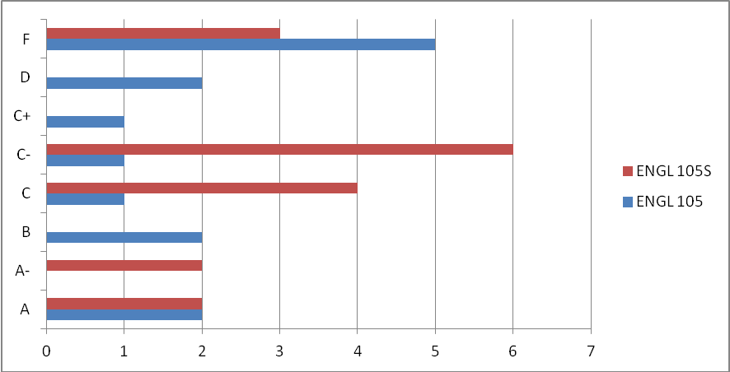
Figure 3 ENGL 105 and ENGL105/S

Town Hall Education and Recreation Center (THEARC)
Findings:
- The students at THEARC are pursuing an Associate’s Degree. Each of the classes is designed to be offered by semester in a cohort. The passing rate for ENGL 060 Composition Skills was 40%. This is alarmingly significant; the students who failed will need to wait until the next rotation of the course is offered. This can affect the student’s ability to graduate as scheduled. The student will also be challenged as they continue taking courses without having a strong writing foundation.
- Students at THEARC also had a high number of “abandonment” from the course, defined as not attending class and/or responding to e-mail or telephone communication.

ENGL 060/AR
Student | A | B+ | C | D | F | W | Grand Total
097063 |  |  |  |  | 1 |  | 1
101113 | 1 |  |  |  |  |  | 1
127686 |  |  |  |  | 1 |  | 1
131223 |  |  | 1 |  |  |  | 1
131815 |  |  |  | 1 |  |  | 1
132550 |  |  |  |  |  | 1 | 1
133928 |  |  |  | 1 |  |  | 1
135239 |  | 1 |  |  |  |  | 1
135405 |  |  |  | 1 |  |  | 1
136661 | 1 |  |  |  |  |  | 1
Grand Total | 2 | 1 | 1 | 3 | 2 | 1 | 10
Table 6: ENGL 060 Grade Distribution

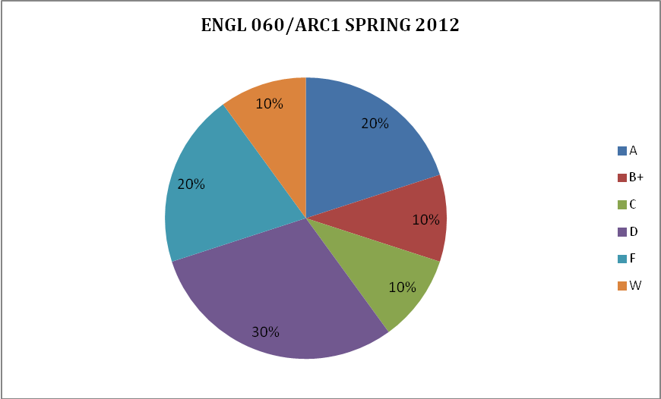
Figure 4 ENGL060 Grade Distribution

INDIVIDUAL CLASS DETAILS

ENGL 107 Summer 2011

 | NUMBER OF STUDENTS | PASS | PASS  %  Rate | FAIL | REPEAT | STUDENT  WITHDRAWL | ABANDONMENT
ENGL107/1 | 16 | 11 | 69 | 05 | 06 | 0 | 4

Findings:

- There were 6 student repeaters. Of the 6 students, 3 received a grade of “F.”
- Two students were referred to the Dean of Students for charges of plagiarism.

STUDENT | A | A- | B | C | C- | D | D+ | F | Grand Total
077618 |  |  |  |  |  |  |  | 1 | 1
077675 |  |  |  |  |  |  |  | 1 | 1
093596 | 1 |  |  |  |  |  |  |  | 1
098730 |  | 1 |  |  |  |  |  |  | 1
100535 |  |  |  |  |  |  | 1 |  | 1
101678 |  |  |  |  |  |  |  | 1 | 1
103518 |  |  |  |  |  |  |  | 1 | 1
106900 |  |  |  |  | 1 |  |  |  | 1
107159 |  |  |  |  |  | 1 |  |  | 1
111924 |  |  | 1 |  |  |  |  |  | 1
112431 |  |  |  |  |  | 1 |  |  | 1
118923 | 1 |  |  |  |  |  |  |  | 1
119387 |  |  |  | 1 |  |  |  |  | 1
119495 |  |  |  |  | 1 |  |  |  | 1
127827 |  |  |  |  |  |  |  | 1 | 1
128239 |  |  |  |  |  | 1 |  |  | 1
Grand Total | 2 | 1 | 1 | 1 | 2 | 3 | 1 | 5 | 16
Table 7: ENGL 107 Grade Distribution

ENGL 103/1 Fall 2011

 | NUMBER OF STUDENTS | PASS | PASS  %  Rate | FAIL | REPEAT | STUDENT  WITHDRAWL | ABANDONMENT
ENGL1 03/1 | 3 | 2 | 67 | 1 | 0 | 0 | 0

Findings:
- One of the 3 students enrolled in the course was an ESL student and did not pass the course.
STUDENT | B | C | D | Grand Total
119192 |  |  | 1 | 1
126814 | 1 |  |  | 1
130062 |  | 1 |  | 1
Grand Total | 1 | 1 | 1 | 3
Table 8: ENGL 103/1 Fall 2011 Grade Distribution
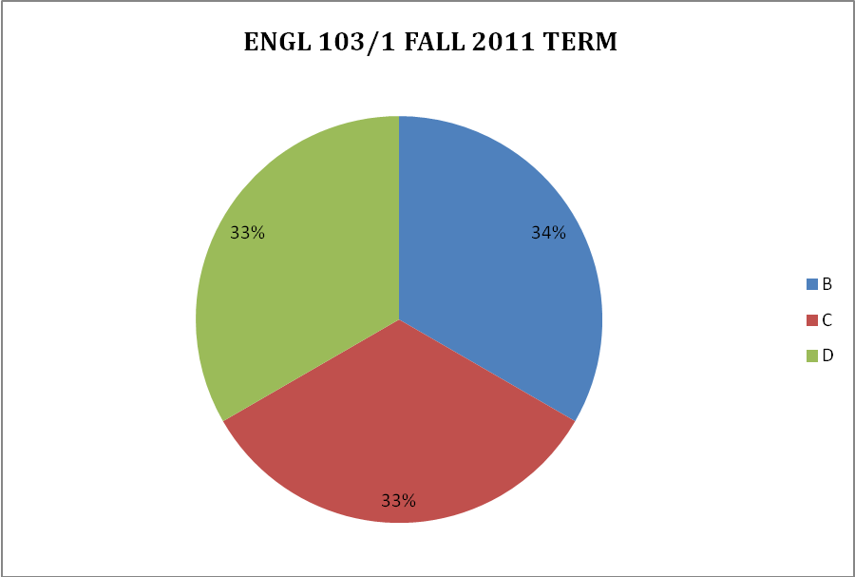
Figure 5 103 FALL GRADE PERCENTAGES

ENGL 103/2 Fall 2011
 | NUMBER OF STUDENTS | PASS | PASS  %  Rate | FAIL | REPEAT | STUDENT  WITHDRAWL | ABANDONMENT
ENGL1 03/2 | 6 | 3 | 50% | 2 |  | 1 | 2

Findings:
- Upon initial assessment, one student was referred to drop the course and register for ENGL 105. The student opted to remain in the class and received an A for the final grade. This student was referred to her advisor to skip ENGL 105 and register for ENGL 107.
- Two enrolled in the course were ESL students, 1 successfully passed the course.

 | A | C | D | W | Grand Total
128699 | 1
123942 |  |  | 1 |  | 1
129626 |  | 1 |  |  | 1
131603 |  |  |  | 1 | 1
132613 |  | 1 |  |  | 1
133529 |  |  | 1 |  | 1
Grand Total | 1 | 2 | 2 | 1 | 6
Table 9: ENGL 103/2 Fall 2011 Grade Distribution
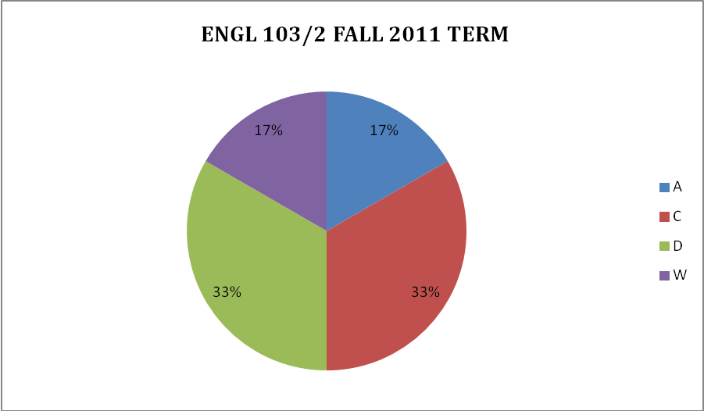
Figure 6 ENGL 103/2 FALL GRADE PERCENTAGES

ENGL 105/1 Fall 2011

 | NUMBER OF STUDENTS | PASS | PASS  %  Rate | FAIL | REPEAT | STUDENT  WITHDRAWL | ABANDONMENT
ENGL1 05/1 | 14 | 5 | 36% | 9 | 2 | 0 | 5

Findings:
- This course had the highest failure and abandonment rate. Perhaps this could be contributed to the day and time of the course (Saturday 1:00PM-4:00 PM).
- Of the two student repeaters, 1 passed and 1 failed the course.

Count of Final Grade
 | A | B | C | C- | C+ | D | F | Grand Total
083700 |  |  |  |  |  | 1 |  | 1
110561 |  |  |  |  |  |  | 1 | 1
119822 |  |  |  |  |  |  | 1 | 1
121155 |  | 1 |  |  |  |  |  | 1
123035 |  | 1 |  |  |  |  |  | 1
125279 |  |  |  |  |  | 1 |  | 1
127542 |  |  |  | 1 |  |  |  | 1
129416 |  |  |  |  |  |  | 1 | 1
129629 |  |  |  |  |  |  | 1 | 1
131472 |  |  |  |  | 1 |  |  | 1
132092 |  |  |  |  |  |  | 1 | 1
132451 | 1 |  |  |  |  |  |  | 1
133290 |  |  | 1 |  |  |  |  | 1
134098 | 1 |  |  |  |  |  |  | 1
Grand Total | 2 | 2 | 1 | 1 | 1 | 2 | 5 | 14
Table 10: ENGL 105 Fall 2011 Grade Distribution

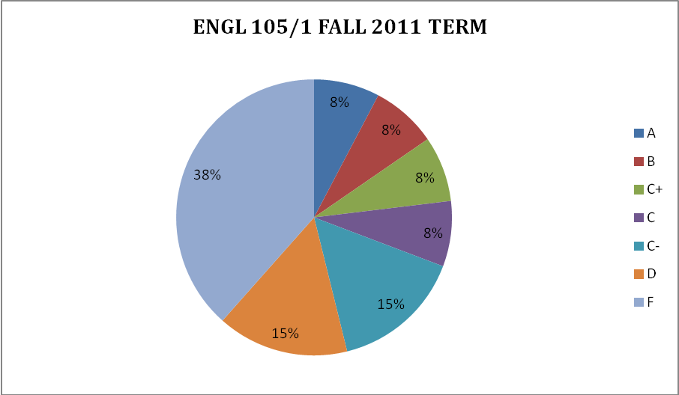
Figure 7 ENGL 105/1 FALL 2011 GRADE PERCENTAGES

ENGL 105/S Fall 2011

 | NUMBER OF STUDENTS | PASS | PASS  %  Rate | FAIL | REPEAT | STUDENT  WITHDRAWL | ABANDONMENT
ENGL1 05S/1 | 10 | 6 | 60% | 4 |  |  | 5

Count of Final Grade
 | A | A- | C | C- | Grand Total
ENGL 105S
048570 | 1 |  |  |  | 1
093584 |  |  | 1 |  | 1
116876 |  |  |  | 1 | 1
118200 |  | 1 |  |  | 1
124429 |  |  |  | 1 | 1
125692 |  |  |  | 1 | 1
129720 |  |  |  | 1 | 1
132884 |  | 1 |  |  | 1
133020 | 1 |  |  |  | 1
134087 |  |  | 1 |  | 1
Grand Total | 2 | 2 | 2 | 4 | 10
Table 11: ENGL 105S Fall 2011 Grade Distribution

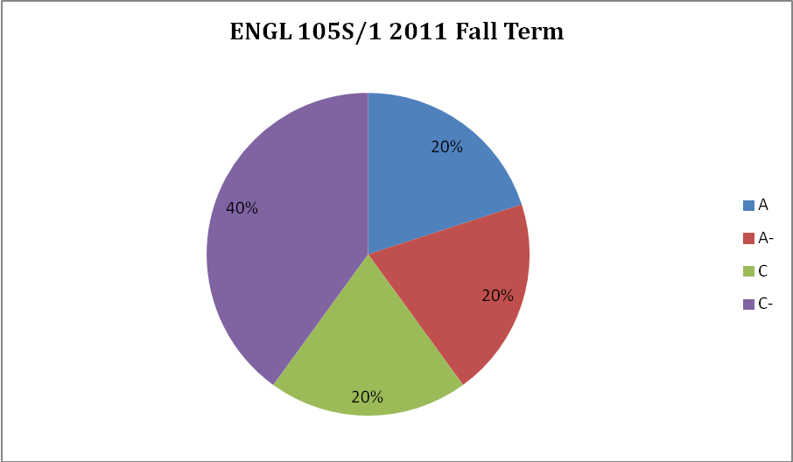
Figure 8 ENGL 105/S 2011 FALL GRADE PERCENTAGES

ENGL 103/1 Spring 2012

 | NUMBER OF STUDENTS | PASS | PASS  %  Rate | FAIL | REPEAT | STUDENT  WITHDRAWL | ABANDONMENT
ENGL1 03/1 | 3 | 1 | 33% | 2 |  |  | 0

Findings:
- Two of the 3 students enrolled in the course were ESL students and did not pass the course. Both students were referred to their advisors and was given information and references for additional resources.
STUDENT | A | D | Grand Total
104908 |  | 1 | 1
132291 |  | 1 | 1
134202 | 1 |  | 1
Grand Total | 1 | 2 | 3
Table 12: ENGL 103/1 Spring 2012 Grade Distribution

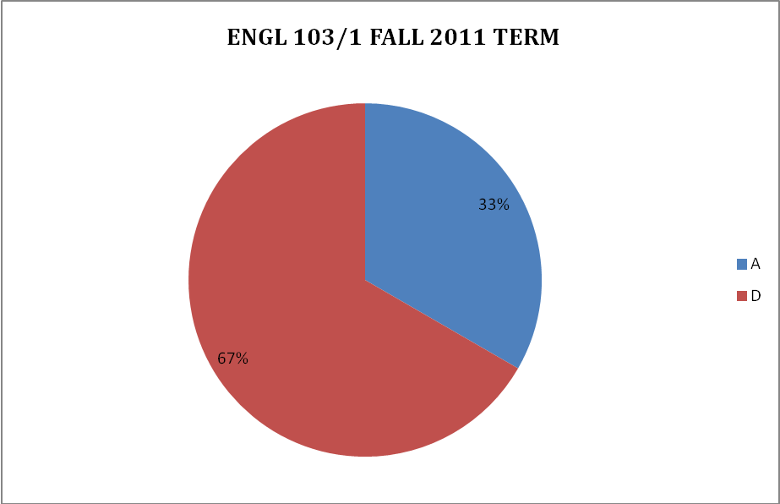
Figure 9 ENGL103/1 FALL GRADE PERCENTAGES

ENGL 105/S Spring 2012

 | NUMBER OF STUDENTS | PASS | PASS  %  Rate | FAIL | REPEAT | STUDENT  WITHDRAWL | ABANDONMENT
ENGL1 05S/1 | 7 | 4 | 57% | 3 |  |  | 0

STUDENT | C | C- | F | Grand Total
083700 |  |  | 1 | 1
094559 | 1 |  |  | 1
108654 |  |  | 1 | 1
121992 | 1 |  |  | 1
129629 |  | 1 |  | 1
130062 |  | 1 |  | 1
135029 |  |  | 1 | 1
Grand Total | 2 | 2 | 3 | 7
Table 13: ENGL 105S/1 Spring Grade Distribution

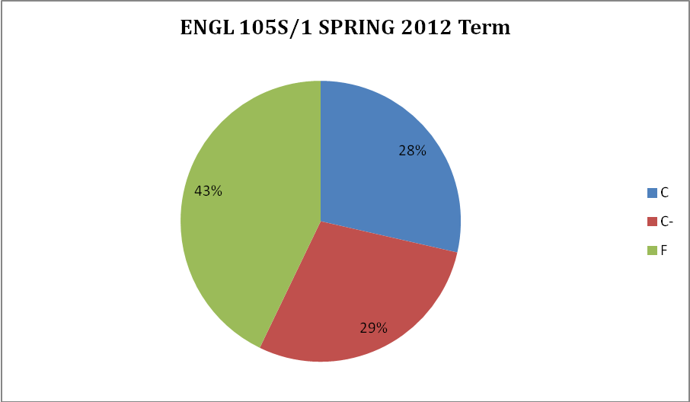
Figure 10 ENGL 105S/1 SPRING GRADE PERCENTAGES

ENGL 107/2 Spring 2012
STUDENT | A | B | C | C- | D | F | Grand Total
093584 |  |  |  | 1 |  |  | 1
121155 |  |  |  | 1 |  |  | 1
121716 |  |  |  |  | 1 |  | 1
123035 |  |  |  | 1 |  |  | 1
128699 | 1 |  |  |  |  |  | 1
130931 |  |  | 1 |  |  |  | 1
132451 | 1 |  |  |  |  |  | 1
132884 | 1 |  |  |  |  |  | 1
133020 | 1 |  |  |  |  |  | 1
133323 |  |  |  |  |  | 1 | 1
134714 |  | 1 |  |  |  |  | 1
136284 |  |  | 1 |  |  |  | 1
Grand Total | 4 | 1 | 2 | 3 | 1 | 1 | 12
Table 13: ENGL 107/2 Spring Grade Distribution

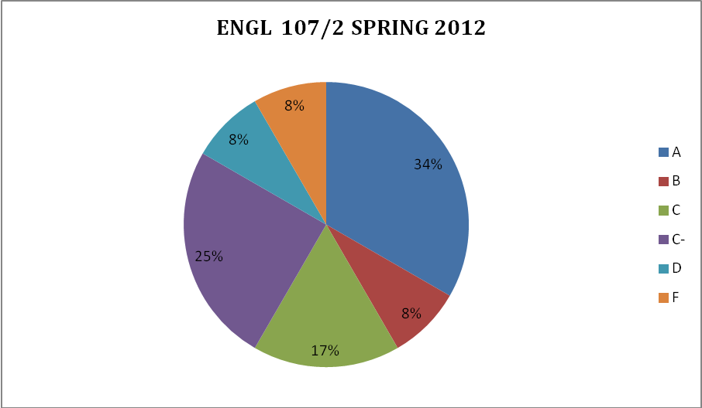
Figure 11 ENGL107/2 SPRING 2012 GRADE PERCENTAGES

MY WRITING LAB (MWL)

MWL is a complete online learning program which provides practices and exercises to help develop students writing. The site includes both pre and post diagnostic testing: The diagnostic test in MWL comprehensively assesses students' skills in grammar. MWL then creates an individualized learning path for students based on their diagnostic results, which identifies the areas of weakness. The online modules of study include:
- Sentence Grammar
- Punctuation and Mechanics
- Usage and Style
- Basic Grammar

The essence of MyWritingLab is the progressive learning that takes place as students complete the Recall, Apply, and Write exercises in each module. Students move from literal comprehension (Recall) to critical application (Apply) to demonstrating concepts in their own writing (Write). Although available, the students were not required to submit paragraph samples or writing. Only the recall and apply exercises were assigned for each student. All student work in MWL is recorded in the online grade book. Students are able monitor their own progress through reports detailing scores on all of the exercises in the course.

Students enrolled in ENGL105S with supplemental instruction were required to complete at least 50 minutes of MWL lab time per week. This was accomplished during the Friday session laboratory time. Students enrolled in ENGL105 were required to complete 50 minutes outside of the classroom per week.
Findings:
- Out of a total of 81 students, 60 students successfully completed the pre and post testing administered through MWL. The average gain for each student in all courses was 11.50%.
- The courses with the highest overall gain was ENGL 105/S and ENGL 060 at 15%.
- A score of 70% or higher is considered mastery for MWL. Each class scored below mastery on the pre test, but averaged mastery on the post test.

- Recommendation #4 My Writing Lab - MWL is adopted as a requirement for English 105, and 105/S. It should also be incorporated in ENGL107. This will not only take full advantage of the year subscription of MWL of which each student is registered, but will reinforce the principles and foundations of ENGL105.

MY WRITING LAB PRE AND POST SCORES

My Writing Lab Results ENGL107/1 Summer2011
Score on Diagnostic Pre Test: 69%
Overall Class Average: 84%
Score on Recall: 82%
Score on Apply: 86%
Score on Diagnostic Post Test: 80%
Overall Percentage Gain: 11%

Name | Sentence Grammar | Punctuation and Mechanics | Usage and Style | Basic Grammar | Overall  PRE  TEST | Sentence Grammar | Punctuation and Mechanics | Usage and Style | Basic Grammar | Overall  POST  TEST
Class Average | 51 | 74 | 78 | 72 | 68 | 69 | 79 | 89 | 84 | 80
Barbourl, | 44 | 55 | 67 | 52 | 55 | 64 | 68 | 80 | 72 | 71
Bush, | 76 | 95 | 80 | 92 | 86 | 91 | 90 | 87 | 96 | 91
Curtis, | 51 | 68 | 80 | 68 | 67
Hardin, | 45 | 73 | 87 | 72 | 69 | 65 | 75 | 100 | 76 | 79
Jefferson | 56 | 73 | 80 | 80 | 72 | 62 | 78 | 93 | 80 | 78
Jones | 53 | 68 | 80 | 56 | 64 | 53 |  |  |  | 53
Kitt | 38 | 73 | 80 | 68 | 65
Okeiy | 73 | 93 | 80 | 72 | 80 | 82 |  |  |  | 82
Opoku | 42 | 73 | 87 | 72 | 69 | 55 |  |  |  | 55
Robertson | 29 | 53 | 53 | 72 | 52
Schuck, | 55 | 88 | 87 | 76 | 77 | 89 | 90 | 87 | 96 | 91
Whitfield | 55 | 75 | 87 | 76 | 73 | 67 | 75 | 87 | 88 | 79
Wyatt, | 47 | 85 | 73 | 80 | 71

My Writing Lab Results ENGL 103/1 Fall, 2011
Score on Diagnostic Pre Test: 58%
Overall Class Average: 69%
Score on Recall: 79%
Score on Apply: 59%
Score on Diagnostic Post Test: 70%
Overall Percentage Gain: 12%

PRE TEST SCORES POST TEST SCORES
Name | Sentence Grammar | Punctuation and Mechanics | Usage and Style | Basic Grammar | Overall  PRE  TEST | Sentence Grammar | Punctuation and Mechanics | Usage and Style | Basic Grammar | Overall  POST  TEST
Class Average | 43 | 69 | 60 | 60 | 58 | 67 | 66 | 77 | 70 | 70
Bacon | 44 | 70 |  |  | 57 | 75 | 73 | 87 | 84 | 80
LEIVA | 42 | 68 | 60 | 60 | 58 | 60 | 60 | 67 | 56 | 61

My Writing Lab Results ENGL 103/2 Fall 2011
Score on Diagnostic Pre Test: 63%
Overall Class Average: 79%
Score on Recall: 73%
Score on Apply: 85%
Score on Diagnostic Post Test: 73%
Overall Percentage Gain: 10%

Name | Sentence Grammar | Punctuation and Mechanics | Usage and Style | Basic Grammar | Overall  PRE  TEST | Sentence Grammar | Punctuation and Mechanics | Usage and Style | Basic Grammar | Overall  POST  TEST
Class Average | 48 | 61 | 73 | 70 | 63 | 63 | 74 | 77 | 81 | 73
Coates | 84 | 88 | 80 | 100 | 88 | 89 | 95 | 100 | 100 | 96
Lynch | 58 | 70 | 87 | 76 | 73
Mason | 35 | 55 | 60 | 52 | 51 | 55 | 75 | 73 | 68 | 68
Mesfin | 40 | 45 | 73 | 52 | 53 | 53 | 53 | 60 | 76 | 61
Slay | 35 | 57 | 67 | 72 | 58
Webb | 40 | 53 | 73 | 68 | 59 | 58 |  |  |  | 58

My Writing Lab ENGL 105/1 Fall 2011
Score on Diagnostic Pre Test: 64%
Overall Class Average: 83%
Score on Recall: 83%
Score on Apply: 82%
Score on Diagnostic Post Test: 75%
Overall Percentage Gain: 11%
Name | Sentence Grammar | Punctuation and Mechanics | Usage and Style | Basic Grammar | Overall  PRE  TEST | Sentence Grammar | Punctuation and Mechanics | Usage and Style | Basic Grammar | Overall  POST  TEST
Class Average | 47 | 68 | 73 | 70 | 64 | 70 | 74 | 75 | 84 | 75
Harrigan | 45 | 70 | 67 | 72 | 64 | 73 | 75 | 73 | 84 | 76
Hughes | 47 | 68 | 67 | 76 | 65 | 62 | 75 | 80 |  | 72
Miller | 38 | 70 | 67 | 64 | 60 | 55 | 63 | 60 | 80 | 65
Miranda | 40 | 57 | 73 | 76 | 62 | 69 | 68 | 73 | 84 | 74
Muhammad, | 64 | 88 | 87 | 84 | 81 | 84 | 90 | 87 | 92 | 88
Rando, | 42 | 78 | 53 | 60 | 58
Stallings | 36 | 68 | 67 | 56 | 57 | 75 | 80 | 87 | 80 | 81
Waugh | 42 | 48 | 87 | 68 | 61 | 58 | 73 | 67 | 88 | 72
Woods | 76 | 68 | 93 | 76 | 78 | 84 |  |  |  | 84

My Writing Lab Results ENGL 105/S/1 Fall 2011

Score on Diagnostic Pre Test: 63%
Overall Class Average:
Score on Recall:
Score on Apply:
Score on Diagnostic Post Test: 78%
Overall Percentage Gain: 15%
Name | Sentence Grammar | Punctuation and Mechanics | Usage and Style | Basic Grammar | Overall  PRE  TEST | Sentence Grammar | Punctuation and Mechanics | Usage and Style | Basic Grammar | Overall  POST TEST
Class Average | 45 | 72 | 74 | 64 | 63 | 71 | 77 | 85 | 79 | 78
Advincula | 33 | 73 | 93 | 52 | 63 | 60 | 73 | 93 | 88 | 79
Brown | 49 | 68 | 80 | 56 | 63 | 84 | 88 | 87 | 84 | 86
Frazier | 38 | 73 | 80 | 60 | 63 | 62 | 68 | 80 | 80 | 73
James | 60 | 90 | 73 | 56 | 70 | 76 | 85 | 87 | 76 | 81
Lewis | 53 | 68 | 67 | 48 | 59 | 69 | 70 | 67 | 76 | 71
Mckoy | 44 | 70 | 60 | 80 | 64 | 76 | 83 | 93 | 72 | 81
Skinner | 53 | 73 | 60 | 72 | 65 | 82 | 78 | 93 | 84 | 84
Titus | 36 | 60 | 67 | 68 | 58 | 58 | 68 | 73 | 68 | 67
Watts | 47 | 78 | 87 | 84 | 74 | 73 | 80 | 93 | 84 | 83

My Writing Lab Results ENGL 107 Spring 2012
Score on Diagnostic Pre Test: 66%
Overall Class Average: 81%
Score on Recall: 83%
Score on Apply: 78%
Score on Diagnostic Post Test: 74%
Overall Percentage Gain: 8%
Name | Sentence Grammar | Punctuation and Mechanics | Usage and Style | Basic Grammar | Overall  PRE  TEST | Sentence Grammar | Punctuation and Mechanics | Usage and Style | Basic Grammar | Overall  POST TEST
Class | 57 | 69 | 71 | 68 | 66 | 63 | 73 | 82 | 79 | 74
Advincula | 51 | 53 | 80 | 68 | 63 | 71 | 70 | 93 | 72 | 77
Brown | 67 | 65 | 73 | 68 | 68 | 67 | 78 | 93 | 88 | 82
Bryan | 53 | 83 | 80 | 60 | 69 | 58 | 80 | 87 | 80 | 76
Coates | 91 | 85 | 93 | 100 | 92 | 93 | 95 | 100 | 92 | 95
CONTE | 33 | 68 | 67 | 60 | 57 | 45 | 70 | 80 | 64 | 65
Davis | 53 | 80 | 67 | 64 | 66 | 65 | 73 | 87 | 92 | 79
Douglas | 65 | 78 | 93 | 76 | 78 | 80 | 80 | 80 | 88 | 82
Harrigan | 64 | 73 | 60 | 76 | 68
Hughes | 44 | 75 | 67 | 64 | 63 | 56 | 83 | 80 | 88 | 77
Muhammad, | 60 | 18 | 7 | 24 | 27 | 24 | 18 | 40 | 40 | 31
ONYEJIUWA | 45 | 80 | 93 | 80 | 75
Watts | 64 | 78 | 73 | 80 | 74 | 73 | 90 | 80 | 92 | 84
My Writing Lab Results 103/1 Spring 2012
- Score on Diagnostic Pre Test: 61%
- Overall Class Average: 71%
- Score on Recall: 74%
- Score on Apply: 67%
- Score on Diagnostic Post Test: 72%
- Overall Percentage Gain: 11%
Name | Sentence Grammar | Punctuation and Mechanics | Usage and Style | Basic Grammar | Overall  PRE  TEST | Sentence Grammar | Punctuation and Mechanics | Usage and Style | Basic Grammar | Overall  POST  TEST
Class Average | 45 | 62 | 77 | 61 | 61 | 62 | 71 | 86 | 72 | 72
Benalla, | 40 | 60 | 73 | 52 | 56
Rodriguez | 47 | 48 | 73 | 80 | 62 | 62 | 60 | 80 | 56 | 65
Simms | 49 | 78 | 87 | 52 | 67 | 62 | 83 | 93 | 88 | 82
My Writing Lab Results ENGL 105/S/1 Spring 2012
Score on Diagnostic Pre Test: 64%
Overall Class Average: 82%
Score on Recall: 82%
Score on Apply: 82%
Score on Diagnostic Post Test: 72%
Overall Percentage Gain: 11%

Name | Sentence Grammar | Punctuation and Mechanics | Usage and Style | Basic Grammar | Overall  PRE  TEST | Sentence Grammar | Punctuation and Mechanics | Usage and Style | Basic Grammar | Overall  POST  TEST
Class Average | 40 | 67 | 66 | 63 | 59 | 65 | 73 | 75 | 78 | 72
Ball | 51 | 68 | 87 | 68 | 69 | 78 | 70 | 87 | 88 | 81
Chavis- | 51 | 75 | 80 | 76 | 71
Hernandez | 29 | 57 | 60 | 68 | 54
Mayberry, | 45 | 75 | 53 | 72 | 61
Monterosa | 38 | 85 | 47 | 64 | 59 | 58 | 70 | 73 | 68 | 67
Morris | 35 | 60 | 67 | 56 | 55 | 60 | 80 | 67 | 80 | 72
Shaw | 36 | 50 | 73 | 40 | 50

My Writing Lab Results ENGL 060 Spring 2012
- Score on Diagnostic Pre Test: 64%
- Overall Class Average: 86%
- Score on Recall: 85%
- Score on Apply: 87%
- Score on Diagnostic Post Test 79%
Overall Percentage Gain: 15%

Name | Sentence Grammar | Punctuation and Mechanics | Usage and Style | Basic Grammar | Overall | Sentence Grammar | Punctuation and Mechanics | Usage and Style | Basic Grammar | Overall
Class Average | 53 | 68 | 65 | 72 | 64 | 77 | 75 | 82 | 84 | 79
Dannah | 55 | 75 | 73 | 68 | 68 | 84 | 78 | 80 | 96 | 85
Gamble | 47 | 80 | 73 | 76 | 69 | 96 | 73 | 93 | 96 | 90
Jenkins | 45 | 68 | 53 | 72 | 60 | 58 | 63 |  |  | 61
Lewis | 55 | 60 | 53 | 76 | 61 | 76 | 78 | 80 | 60 | 74
McLeod
Norman | 69 | 70 | 80 | 80 | 75 | 95 | 88 | 87 | 84 | 89
Paylor | 47 | 55 | 60 | 64 | 57 | 58 | 70 | 73 | 88 | 72
Thomas

Writing Workshop Series

During Fall 2011 and Spring 2012, a writing workshop series was offered on various writing topics. These topics were chosen based on the overall theme of individual student meetings and input from various program directors. In addition to these workshops, there were four class presentations facilitated on APA Style Writing.

The Writing Process
6:30-8:30 PM
Number of participants: Fall 2011 (8) Spring 2012 (18)

This workshop will teach students the importance of approaching every writing assignment as a process. Students will be given strategies to help them effectively chose topics, focus, and prepare outlines. Topics covered will include: prewriting, drafting, revising, and proofreading.

APA Style Writing
6:30-8:30 PM
Number of participants: Fall 2011 (21) Spring 2012 (12)
This workshop will teach students the essential elements of APA Documentation Style writing. Topics covered will include: format, citation, reference list, and various style issues.

Research Strategies
6:30-8:30 PM
Number of participants: Fall 2011 (6) Spring 2012 (8)
In conjunction with Library Services, this workshop will cover services offered at the library. Topics covered will include: how to find scholarly articles using Trinity’ databases, books (catalog), and strategies to evaluate sources online, including those found via Google and other major search engines.

Resume Writing and Cover Letters
6:30-8:30 PM
Number of participants: Fall 2011 (15) Spring 2012 (12)
This workshop will teach students the basics of preparing a professional resume. Topics covered will include: skills and experience assessment, types of resumes, and cover letter guidelines. Students are encouraged to bring their current resume and will have the opportunity to participate in hands-on activities.

Individual Appointments

During the fall semester two hours a week were spent at the Writing Center. 19 students had individual appointments. During the spring semester specialist had 22 appointments during office hours. This included both graduate and undergraduate students.

INT501Transition Seminar for Graduate Students

As part of INT 501, students were introduced the importance and necessity of academic writing. The workshops, Graduate Writing Expectations and APA Writing Style were facilitated on separate dates and were one and a half hours in length. As part of the seminar, students were required to complete a Graduate Writing Assessment through Moodle. Students were allowed only one attempt to respond to one of four writing prompts and 45 minutes to complete the assessment.

Findings:
- Of the 54 students registered for the course, 28 completed the assignment online and 6 completed the assessment in person for a total of 34 (63% completion rate). The writing assessments were scored with a guide adapted from the Accuplacer, 2011 Scoring Rubric on a scale from 1-8.
- Results:

SCORE | NUMBER OF STUDENTS
3 | 3
4 | 1
5 | 2
6 | 7
7 | 7
8 | 14

- Students scoring 5 and below are required to take the new INT502 Writing Refresher Course in the Fall 2012 semester.

APPENDIX A COURSE SYLLABI
(Note: all Trinity syllabi template information and dates have been removed; only specific class information is included for the purposes of this report)

School of Professional Studies Course Information

ENGL103/LECT 1
Thursdays 6:30-9:00 pm, Main 251
Grammar and Writing
Credits: 3.0 Minimum Passing Grade: C Class Format: Lecture
What does this course fulfill? General Education Core
Methods of Instruction: Lecture, Discussion, Experiential Exercises, Quizzes
Syllabus Last Updated: 1.9.2012

Instructor: Beverly S. Lucas
Trinity Phone: (202) 884-9298
Trinity Email: lucasbe@trinitydc.edu Main Building Room #270
Office Hours: Wednesday Room 270 3:00-5:00 pm
Thursday Writing Center 3:00-5:00 pm

Weather Delays, Closings, and Emergencies: Information on school delays and closings will be available online and at the weather hotline, 202-884-9009. Trinity’s Department of Public Safety can be reached at 202-884-9111.

Course Description: This course is designed to help students acquire skills necessary to write effective paragraphs. The focus is on the construction of sentences and paragraphs, the writing process, grammar, usage, and mechanics.

Course Objectives:
Upon completion of this course you will be able to:
- employ different stages of writing—planning, drafting, revising and editing;
- identify verbs and their subjects in exercise and paragraph context;
- define, identify, and use prepositional phrases correctly;
- distinguish between phrases, dependent clauses, and independent clauses;
- define sentence fragments; identify and repair them in exercise context;
- define run-on sentences; identify and repair them in context;
- recognize correct and incorrect subject/verb agreement; repair in context;
- define a modifier; recognize misplaced modifiers; rewrite sentences in exercise and paragraph contexts to make reference clear;
- define clichés and wordiness; recognize and repair them in exercise context; and
- state and practice simple guidelines for punctuation usage.

These objectives will be measured through testing and practical application in class writing assignments. The writing component of the course presents an opportunity to practice personal and academic writing and to develop and display grammar and sentence formation skills in a real writing context.

“You gain strength, courage, and confidence by every experience in which you really stop
to look fear in the face…You must do the very thing which you think you cannot do.”
Eleanor Roosevelt

“A #2 pencil and a dream can take you anywhere.”
Joyce Meyers

Required Texts and Materials:
- Henry, D. J. Writing for Life: Sentences and Paragraphs. 2nd ed. Boston: Longman, 2010.
- MyWritingLab (Pearson online access code required)
- Regular access to a computer, printer, and the internet
- A black and white composition book for weekly journal writings

Additional Reading: Additional readings will be assigned in class.

Assignments and Contributions Towards Grade
Assignments | Percentage/Points towards grade
Narrative Assignment | 10%
Description Assignment | 10%
Definition Assignment | 10%
Comparison and Contrast Assignment | 10%
Persuasion Assignment | 20%
Participation/Attendance | 10%
Assigned homework, in-class exercises, journal writing, quizzes | 20%
My Writing Lab | 10%
Total Percentage/Points | 100%

All assignments must be typed, doubled spaced using a Times Roman (12 point) font with 1-inch margins on white 8 ½ by 11 inch paper. In the upper left-hand corner of the page, you must include:

Your Full Name
ENGL103 Grammar and Writing Workshop
Due Date
Assignment Name (i.e. “Description Paragraph”)

Begin your paragraph here…
Do not include a separate title page. Do not submit assignments in folders

Other Important Notes:
You must complete all paragraph and essay assignments in order to pass the course.

Homework assigned from the text book may be submitted hand written. You are not required to tear pages out of your textbook. Additional information on each assignment including length, assignment topics, and format requirements will be distributed in class.

ALL written assignments will be graded using a rubric which clearly outlines grading criteria based on a scale of 25 to 5 (25 =Exhibits mastery; 5=Fails to meet standards). You will be provided with a copy of the rubric score sheet.

In Class Assignments
The only way to improve your writing and become a better writer is to, “write.” Therefore, “free writing” will be an essential part of our class each week. You will receive constant, ongoing feedback on each of your weekly writing assignments. We will also work on various exercises from the text individually and in groups during the class session.

Presentations/Group Work
You will be required to present a 3-5 minute presentation on usage of punctuation or mechanics for your classmates. You will also have the opportunity to participate in at least one (but not limited to) peer review assignment. We will periodically work in groups for in-class exercises.

My Writing Lab
As a part of the lab requirement of this course, we will be working online through MyWritingLab.com. You are required to complete at least 30 minutes a week on lab exercises. Your online participation will be monitored and tracked. Our sessions will be structured individually and as a group.
MyWritingLab Website:
- Creates an individualized study plan so you can study just what you need, when you need it.
- Offers thousands of exercises with immediate feedback.
- Provides access to live tutors.
- Features video tutorials to help you understand writing concepts.
- Allows you to track your progress and see your grades improve

Quizzes
There will be two quizzes administered throughout the semester. One will be announced, the other unannounced.

Course Schedule
ENGL 103 Writing and Grammar
 | Date |  | Topics Covered | Reading Assignments for Class | Assignments will  be announced in class
1 |  |  | Review: course, syllabus, policies, expectations; and strategies for success  LEARNING STYLES
2 |  |  | Chapter 1  Preparing to Learn About Writing  Chapter 2  Thinking Through the Writing Process | Chapters 1, 2
3 |  |  | Chapter 8  Subjects, Verbs and Simple Sentences | Chapters 8
4 |  |  | Chapter 19  Nouns and Pronouns | Chapter 19
5 |  |  | Chapter 3  Understanding the Paragraph  Chapter 16  Subject-Verb Agreement: Present Tense  Chapter 4  Patterns of Organization  The Narration Paragraph | Chapters 3, 4, 16
6 |  |  | Chapter 10  Sentence Variety  Chapter 11  Sentence Clarity | Chapters 12, 20 | Narrative Paragraph Due
7 |  |  | Chapter 12  Parallelism  Chapter 20  Adjectives and Verbs  The Description Paragraph | Chapters 10, 11
8 |  |  | SPRING BREAK NO CLASS!
9 |  |  | Chapter 13  Run-ons: Comma Splices and Fused Sentences  Chapter 14  Fragment Sentences | Chapters 13, 14 | Descriptive Paragraph Due
10 |  |  | Chapter 15  Misplaced and Dangling Modifiers  The Definition Paragraph | Chapters 1522
11 |  |  | Chapter 21  The Comma  Chapter 22  The Apostrophe  Chapter 23  Quotation Marks  Chapter 24  End Punctuation  Chapter 25  Capitalization | Chapters 21, 22, 23, 24, 25 | Definition Paragraph Due
12 |  |  | Chapter 26  Revising for Effective Expression  The Compare and Contrast Paragraph | Chapters 26
13 |  |  | Chapter 27  Improving Your Spelling | Chapters 27 | Compare and Contrast Paragraph Due
14 |  |  | Chapter 5  Understanding the Essay  Chapter 6  Titles, Introductions and Conclusions  The Persuasion Paragraph | Chapters 5, 6
15 |  |  | Chapter 27  Improving Your Spelling  Writing Review | Chapter 27 | Persuasion (Draft) Due
16 |  |  | Writing Review  Post Testing |  | Persuasion Paragraphs Due

Classroom Management Policies

Communication
If you have any questions or concerns, I encourage you to contact me via e-mail (lucasbe@trinitydc.edu ) or phone (884-9298). In addition, my office hours are:
Wednday Room 270 3:00-5:00 pm
Thursday Writing Center 3:00-5:00 pm

*If you would like to visit me at the Writing Center, please utilize the online appointment form to schedule a time:
http://www.trinitydc.edu/offices/writing/Appointment_Request_Form.html

E-Mail Messages
When sending e-mail correspondence, please type your class (ENGL103) in the subject field.

Late Assignments
Late assignments will not be accepted without prior approval. All late assignments will have a 10% deduction for each DAY it is late. After 4 days, you will receive an “F”( 0%) for the assignment.

Accommodations
If you have a disabling condition and require special arrangements to meet course requirements, contact me as soon as possible to make necessary arrangements.

Electronic Devices
Do not use cell phones except in emergencies. No texting. No ear buds or earphones are to be worn in class. If you bring a computer to class, you may use it only to take notes or conduct research.

Other
- Please do not leave the room during class unless absolutely necessary.
- No full meals are allowed in the classroom. Beverages, candy and snacks are allowed.
- You are expected to adhere to the general rules in classroom etiquette of respect and space.

School of Professional Studies Course Information

ENGL105 and ENGL105/S
Introduction to College Writing

Credits: 3.0 Minimum Passing Grade: C Class Format: Lecture
What does this course fulfill? General Education Core
Methods of Instruction: Lecture, Discussion, Experiential Exercises, Quizzes
Syllabus Last Updated: 8.1.2011

Instructor: Beverly S. Lucas
Trinity Phone: (202) 884-9298
Trinity Email: lucasbe@trinitydc.edu Main Building Room #270
Office Hours: Wednesday Room 270 4:00-6:00 pm
Thursday Writing Center 3:00-5:00 pm

Course Description:
This course is designed to increase fluency in college-level written communication with an emphasis on organizational skills and language structure. Students will have the opportunity to develop and/or improve the ability to analyze and critique texts in order to write about them.

Course Goals:
- To develop skills in academic writing.
- To give students a set of concepts to help structure their thinking and work toward writing clear, persuasive, stylish prose. This will be achieved by engaging various rhetorical strategies in response to a variety of interactions between writer, reader, text, topic, and moment.

Course Objectives:
- Upon completion of this course you will be able to:
- incorporate a variety of tactics for generating ideas about a topic;
- use systematic patterns of topic development and organization;
- meet the usage standards and sophistication level of the audience being addressed;
- understand word and sentence level stylistic options;
- integrate techniques for making writing more coherent;
- develop strategies for revision that will carry into other classes and contexts;
- use the academic conventions of incorporating and citing the words and ideas of others;
- develop the habit of thinking critically both about ideas and about sources of information; and
- edit writing for correct word choice, grammar usage, capitalization, punctuation, and spelling.
Introduction to College Writing
ENGL 105

“You gain strength, courage, and confidence by every experience in which you really stop
to look fear in the face…You must do the very thing which you think you cannot do.”
Eleanor Roosevelt

“A #2 pencil and a dream can take you anywhere.”
Joyce Meyers

Required Texts and Materials:
- Henry, D. J. Writing for Life: Paragraphs and Essays. 2nd ed. Boston: Longman, 2010. Print.
- MyWritingLab (Pearson online access code required)
- Regular access to a computer, printer, and the internet
- A black and white composition book for weekly journal writings

Additional Reading: Additional readings will be assigned in class.

Assignments and Contributions Towards Grade
Assignments | Percentage/Points towards grade
Narrative Assignments – (3) paragraphs | 10%
Description Assignments – (3) paragraphs | 10%
Definition Assignments – (5) paragraphs | 10%
Comparison and Contrast Assignments – (5) paragraphs | 15%
Persuasion Essays – (8-10) paragraphs | 20%
Participation/Attendance | 10%
Assigned homework, in-class exercises, journal writing, quizzes | 10%
My Writing Lab (EVERY FRIDAY) | 15%
Total Percentage/Points | 100%

All assignments must be typed, doubled spaced using a Times Roman (12 point) font with 1-inch margins on white 8 ½ by 11 inch paper. In the upper left-hand corner of the page, you must include:

Your Full Name
ENGL105S/ Introduction to College Writing
Due Date
Assignment Name (i.e. “Description Paragraph”)

Begin your paragraph here…
Do not include a separate title page. Do not submit assignments in folders

Other Important Notes:
You must complete all paragraph and essay assignments in order to pass the course. Late assignments will be penalized by one letter grade for each day the assignments is late.

Homework assigned from the text book may be submitted hand written. You are not required to tear pages out of your textbook. Additional information on each assignment including length, assignment topics, and format requirements will be distributed in class.

ALL written assignments will be graded using a rubric which clearly outlines grading criteria based on a scale of 25 to 5 (25 =Exhibits mastery; 5=Fails to meet standards). You will be provided with a copy of the rubric score sheet.

In Class Assignments
The only way to improve your writing and become a better writer is to, “write.” Therefore, “free writing” will be an essential part of our class each week. You will receive constant, ongoing feedback on each of your weekly writing assignments. We will also work on various exercises from the text individually and in groups during the class session.

Presentations/Group Work
You will be required to present a 3-5 minute presentation on usage of punctuation or mechanics for your classmates. You will also have the opportunity to participate in at least one (but not limited to) peer review assignment. We will periodically work in groups for in-class exercises.

My Writing Lab
As a part of the lab requirement of this course, we will be working online through MyWritingLab.com (FRIDAYS). Our sessions will be structured individually and as a group.
MyWritingLab Website:
- Creates an individualized study plan so you can study just what you need, when you need it.
- Offers thousands of exercises with immediate feedback.
- Provides access to live tutors.
- Features video tutorials to help you understand writing concepts.
- Allows you to track your progress and see your grades improve

Quizzes
There will be two quizzes administered throughout the semester. One will be announced, the other unannounced.

Course Schedule
ENGL 105S Introduction to College Writing
 | Date |  | Topics Covered | Reading Assignments for Class | Assignments Due*
1 |  |  | Review: course, syllabus, policies, expectations; and strategies for success  Pre-Writing Diagnostic Testing  LEARNING STYLES
2 |  |  | NO CLASS – LABOR DAY
3 |  |  | Chapter 1  Preparing to Learn About Writing  Chapter 2  Thinking Through the Writing Process | Chapters 1, 2 | My Writing Lab  Registration and Review
3 |  |  | Chapter 3  Understanding the Paragraph  Chapter 5  The Narration Paragraph  Chapter 27  Nouns and Pronouns | Chapter 3 | Review Questions  pp. 17
4 |  |  | Chapter 28  Adjectives and Adverbs  Chapter 16  Subjects, Verbs, and Simple Sentences  Chapter 21  Comma Splices/Fused Sentences  Chapter 22  Fragment Sentences | Chapter 5 | Review Questions  pp. 50  Narrative Paragraphs due
5 |  |  | Chapter 19  Sentence Clarity: Person, Point of View, Number and Tense  Chapter 4  The Description Paragraph  Chapter 30  Apostrophe | Chapters 19, 4
6 |  |  | NO CLASS – COLUMBUS DAY
7 |  |  | Chapter 31  Quotation Marks  Chapter 25  Past Tense Verbs  Chapter 32  End Punctuation | Chapter 22 | Description Paragraphs Due
8 |  |  | Chapter 10  Definition Paragraph  PEER REVIEW | Chapter 10
9 |  |  | Chapter 23 Modifiers  Chapter 33 Capitalization | Chapters 23 | Definition Essay Due
10 |  |  | Chapter 9  Comparison and Contrast Paragraph  Chapter 24  Subject/Verb Agreement | Chapter 9
11 |  |  | INDIVIDUAL CONFERENCES |  | Compare/Contrast  Essay Due
12 |  |  | Chapter 12  Persuasive Paragraph  Chapter 34  Revising for Effective Expression | Chapter 12 | Persuasion Essay Draft Due
13 |  |  | NO CLASS  THANKSGIVING BREAK
14 |  |  | Chapter 13  Understanding the Essay  Chapter 35  Improving Your Spelling | Chapter 13 | Final Persuasion Essay Due
15 |  |  | Post Diagnostic Testing  Writing Review

Important Dates
Add/Drop
Withdrawal
Holidays
Last Day of Class
Classroom Management Policies

Communication
If you have any questions or concerns, I encourage you to contact me via e-mail (lucasbe@trinitydc.edu) or phone (884-9298). In addition, my office hours are:
Monday Room 270 4:00-6:00 pm
Thursday Writing Center 4:00-6:00 pm

*If you would like to visit me at the Writing Center, please utilize the online appointment form to schedule a time:
http://www.trinitydc.edu/offices/writing/Appointment_Request_Form.html

E-Mail Messages
When sending e-mail correspondence, please type your class (ENGL105/S and Section) in the subject field.

Late Assignments
Late assignments will not be accepted without prior approval. All late assignments will have a 10% deduction for each week it is late.

Accommodations
If you have a disabling condition and require special arrangements to meet course requirements, contact me as soon as possible to make necessary arrangements.

Electronic Devices
Do not use cell phones except in emergencies. No texting. No ear buds or earphones are to be worn in class. If you bring a computer to class, you may use it only to take notes or conduct research.

Other
- Please do not leave the room during class unless absolutely necessary.
- No full meals are allowed in the classroom. Beverages, candy and snacks are allowed.
- You are expected to adhere to the general rules in classroom etiquette of respect and space.

Communication
If you have any questions or concerns, I encourage you to contact me via e-mail (lucasbe@trinitydc.edu) or phone (884-9298). In addition, my office hours are:
Wednesday Room 270 4:00-6:00 pm
Thursday Writing Center 2:00-4:00 pm

*If you would like to visit me at the Writing Center, please utilize the online appointment form to schedule a time:
http://www.trinitydc.edu/offices/writing/Appointment_Request_Form.html

E-Mail Messages
When sending e-mail correspondence, please type your class (ENGL105/S and Section) in the subject field.

Late Assignments
Late assignments will not be accepted without prior approval. All late assignments will have a 10% deduction for each week it is late.

Accommodations
If you have a disabling condition and require special arrangements to meet course requirements, contact me as soon as possible to make necessary arrangements.

Electronic Devices
Do not use cell phones except in emergencies. No texting. No ear buds or earphones are to be worn in class. If you bring a computer to class, you may use it only to take notes or conduct research.

Other
- Please do not leave the room during class unless absolutely necessary.
- No full meals are allowed in the classroom. Beverages, candy and snacks are allowed.
- You are expected to adhere to the general rules in classroom etiquette of respect and space.

Course Information
Engl 107/2 College Composition

Room and Meeting Day and Time:
Credits: 3 Minimum Passing Grade: D
Class Format: Blended
What does this course fulfill? Core
Methods of Instruction: Lecture, Discussion, Workshop, Quiz, Written Assessment
Syllabus Last Updated: 5.2012

Weather Delays, Closings, and Emergencies: Follow Trinity weather emergencies and closings by texting “follow trinitydcalerts” to 40404. Information on school delays and closings will be available online, at the Trinity Weather Hotline (202-884-9009), and on local radio and television.
Trinity’s Department of Public Safety may be reached at 202-884-9111.

Instructor: Beverly S. Lucas
Email: lucasbe@trinitydc.edu
Phone: 202.884.9298
Office: Main 270
Office Hours: Tuesday and Thursday 4:00pm until 6:00pm

Course Description: This course helps students to develop the skills necessary for effective writing of thesis-centered essays at the college level, including analytical, critical, and argumentative essays. Research and documentation techniques are included.

Course Objectives:
- Recognize and compose a thesis statement;
- Identify an audience and write for that audience;
- Develop and organize a topic;
- Critique arguments;
- Summarize and analyze an author’s work;
- Use research to back up an argument or position;
- Use the academic conventions of incorporating and citing the words and ideas of others;
- Apply strategies and techniques of revision; and
- Think critically about ideas.

“You gain strength, courage, and confidence by every experience in which you really stop
to look fear in the face…You must do the very thing which you think you cannot do.”
Eleanor Roosevelt

“A #2 pencil and a dream can take you anywhere.”
Joyce Meyers

Required Texts:
- Anderson, M. (2008). Keys to successful writing: Unlocking the writer within (4th ed.). New York, NY: Pearson Longman. 0205727824.
- American Psychological Association. (2010). Publication manual of the American psychological association (6th ed.). Washington, DC: APA. 1433805618.

Additional Reading: Additional readings will be assigned in class.

Grading Scale
 |  | A | 93-100% | A- | 90-92%
B+ | 88-89% | B | 83-87% | B- | 80-82%
C+ | 78-79% | C | 73-77% | C- | 70-72%
D+ | 71-68% | D | 67-65% | D- | 64%
F | 63 and below

Assignment and Contributions Towards Grade
Assignments | Percentage/Points towards grade
Narrative or Illustration Essay | 10%
Descriptive or Definition Essay | 10%
Compare/Contrast or Cause and Effect Essay ( research based) | 10%
Argument Essay (without research) | 10%
Argument Essay (research based) | 10%
Participation/Attendance | 10%
Assigned homework, in-class exercises and journal writing | 10%
In Class Writing assignments | 10%
My Writing Lab | 10%
Quizzes | 10%
Total Percentage/Points | 100%

Course Schedule
ENGL 107 College Composition
Date | Topics Covered | Reading Assignments | Assignments Due
 | Review: course, syllabus, policies, expectations; and strategies for success  Chapter 1  Reading, Thinking and Writing for College | Chapter 1
 | Chapter 2  Defining the Essay and Composing Process  Chapter 3  Discovering Through Prewriting | Chapters 2,3
 | Chapter 4  Finding a Thesis and Drafting  Chapter 5  Using Body Paragraphs to Develop Essays | Chapters 4,5
 | Chapter 6  Creating Effective Introductions and Conclusions  Chapter 9  Writing About Events: Narration and Illustration | Chapters 6,9 | Creative Writing Due
 | Chapter 8  APA Style Writing  Research Skills/Library Resources  Chapter 10  Observing the World: Description and Definition | Chapter 8,10 | Narration or Illustration Essay Due
 | Chapter 11  Making Connections: Process and Cause/Effect  Chapter 12  Showing Relationships: Comparison/Contrast and Division/Classification | Chapter 11,12 | Description or Definition  Due
 | Chapter 13  Taking a Stand: Argument  Argument Draft (in-class) | Chapter 13 | Process or Cause/Effect
 | Unit 2  Writing About Film and Literature |  | Argument Due

Important Dates
Add/Drop Deadline
Withdrawal Deadline
Holidays
Last Day of Class

College Composition
ENGL 107
Additional Course Information

Assignments
You will complete five essay assignments (60% of your total grade) which will include the following:
- Narration or Illustration (2 pages maximum)
- Description or Definition (2 pages maximum)
- Process or Cause and Effect (3 pages maximum)
- Argument (without research) (4-5 pages maximum)
- Argument (with individual research (5-6 pages maximum)

All assignments must be typed, doubled spaced using a Times Roman (12 point) font with 1-inch margins on white 8 ½ by 11 inch paper. In the upper left-hand corner of the page, you must include:
Your Full Name
ENGL107 College Composition
Due Date
Assignment Name (i.e. “Description Essay”)

Begin your paragraph here…

Do not include a separate title page. Papers not submitted in proper format will NOT be accepted!

Homework assigned from the text book may be submitted hand written. You are not required to tear pages out of your textbook. Additional information on each assignment including length, assignment topics, and format requirements will be distributed in class.

In Class Assignments
The only way to improve your writing and become a better writer is to, “write.” Therefore, “free writing” will be an essential part of our class each week. You will receive constant, ongoing feedback on each of your writing assignments. We will also work on various exercises from the text individually and in groups during the class session.

My Writing Lab
As a part of the lab requirement of this course, we will be working online through MyWritingLab.com. Our sessions will be structured individually and as a group.
MyWritingLab:
- Creates an individualized study plan so you can study just what you need, when you need it.
- Offers thousands of exercises with immediate feedback.
- Provides access to live tutors.
- Features video tutorials to help you understand writing concepts.
- Allows you to track your progress and see your grades improve

Classroom Management Policies

Class Participation
By registering for this course, you have made a commitment to participate in class discussion and activities. Plan to participate regularly. Participation for this course is defined as proactive dialogue in weekly class discussions. This requires you to actively reflect on weekly topics and textbook readings. You will note in the grading policy that your class room participation counts significantly toward your final grade.

Attendance
Regular attendance is an important component of this course. It is expected that you will arrive on time and stay for the entire class. If you miss a class, you are held responsible for the material covered for that date. You are expected to attend class regularly. Class begins at 1:00 PM. Any student who arrives after a 15 minute grace period, without prior notification will be marked as absent. Any student who leaves class after instruction has begun without prior permission, will be marked as absent.

Communication
If you have any questions or concerns, I encourage you to contact me via e-mail (lucasbe@trinity.edu) or phone (202) 884-9298.

*If you would like to visit me at the Writing Center, please utilize the online appointment form to schedule a time:
http://www.trinitydc.edu/offices/writing/Appointment_Request_Form.html

E-Mail Messages
When sending e-mail correspondence, please type your class (ENGL107/ Saturday) in the subject field.

Late Assignments
You are responsible for turning in all assignments in their required format(s) (hard copy and/or electronic) at the beginning of class on their respective due dates. Should you find yourself unable to do so, your earned grade will decline by one letter grade for each day the assignment is late.
Late assignments will not be accepted without prior approval. All late assignments will have a 10% deduction for each DAY it is late. After 4 days, you will receive an “F” for the assignment.

Accommodations
If you have a disabling condition and require special arrangements to meet course requirements, contact me as soon as possible to make necessary arrangements.

Electronic Devices
Do not use cell phones except in emergencies. No texting. No ear buds or earphones are to be worn in class. If you bring a computer to class, you may use it only to take notes or conduct research.

Other
- Please do not leave the room during class unless absolutely necessary.
- Do not eat in the classroom. Beverages and candy are allowed.
- You are expected to adhere to the general rules in classroom etiquette of respect and space.

APPENDIX B ASSIGNMENTS

Writing Assignment
Beverly S. Lucas, Professor

NARRATIVE

PURPOSE: Write a narrative essay about an experience in your life that had a significant effect on you or that changed your views in some important way. Your essay should include 5-6 paragraphs. Choose from the following topics:
- An experience that caused you to learn something about yourself
- An incident that revealed the true character of someone you knew
- An experience that helped you discover a principle to live by
- An experience that explains the personal significance of a particular object

AUDIENCE: Trinity students

- Chose a topic
- Include a title
- Include a focused thesis statement/main point
- Use adequate details and vivid verbs to support your paragraphs
- Chose a method of organization (refer to handout)

Due Date:
All assignments must be typed, doubled spaced using a Times Roman (12 point) font with 1-inch margins on white 8 ½ by 11 inch paper. In the upper left-hand corner of the page, you must include:

Your Full Name
ENGL105 Introduction to College Writing
Due Date
Assignment Name (i.e. “Narrative Essay”)

Begin your paragraph here…

Staple your paper. Do not include a separate title page. Do not use paperclips or submit your paper in a folder.

Writing Assignment

DESCPRIPTIVE

Write a (5-6 paragraphs) descriptive essay. Your audience consists of your classmates. Select one of the following topics:
- An adult toy, such as a camera, computer, or cooking gadget
- A hobby or sport that you enjoy either engaging in or observing others in your neighborhood or on television
- An annoying or obnoxious person or a pleasant, courteous one

Chose a topic
- Include a thesis statement
- Consider your purpose and point of view
- Chose an aspect of your subject to emphasize
- Include details that describe your subject
- Chose a method of organization
- Include your first draft (may be submitted hand written) and final essay

Due Date:
All assignments must be typed, doubled spaced using a Times Roman (12 point) font with 1-inch margins on white 8 ½ by 11 inch paper. In the upper left-hand corner of the page, you must include:

Your Full Name
ENGL105 Introduction to College Writing
Due Date
Assignment Name (i.e. “Descriptive Essay”)

Begin your paragraph here…

Staple your paper. Do not include a separate title page. Do not use paperclips or submit your paper in a folder.

Writing Assignment

DEFINITION

Assume you are a first-semester college student who is enrolled in a study skills class, and you have been assigned to write an essay that defines student success. Based on your experience and observations, write a definition of student success that addresses attitudes, behaviors and skills. Your essay should be 5-6 paragraphs.

Audience: High school seniors

Make sure to… (Refer to Chapter 10 pages 174-189 in text)
- Chose a title
- Include a thesis statement
- Use key words and transition words that signal definition
- Incorporate sound structure and vivid images
- Attach your definition conception chart (pp. 185)

Due Date:

All assignments must be typed, doubled spaced using a Times Roman (12 point) font with 1-inch margins on white 8 ½ by 11 inch paper. In the upper left-hand corner of the page, you must include:

Your Full Name
ENGL105/S
Due Date
Assignment Name (i.e. “Definition Essay”)

Begin your paragraph here…

Staple your paper. Do not include a separate title page. Do not use paperclips or submit your paper in a folder.

Writing Assignment

COMPARE AND CONTRAST

Write a (maximum 2-page) comparison or contrast essay on one of the following topic pairs. Your audience is your classmates.
- Two public figures
- Two forms of entertainment (movies, concerts, radio, or music video) or one form of entertainment as it is used today and as it was used ten or more years ago.
- Two styles of communication, dress, or teaching
- The right and wrong ways of doing something
- Two different cultures’ approaches to a rite of passage, such as birth, puberty, marriage or death

Make sure to… (Refer to Chapter 14 pages 339-373 in text)
- Narrow a topic
- Develop your thesis
- Chose a method of organization

Due Date:

All assignments must be typed, doubled spaced using a Times Roman (12 point) font with 1-inch margins (left, right, top, bottom) on white 8 ½ by 11 inch paper using black ink. In the upper left-hand corner of the page, you must include:

Your Full Name
ENGL105 Introduction to College Writing
Due Date
Assignment Name (i.e. “Compare/Contrast Essay”)

Begin your paragraph here…

Staple your paper. Do not include a separate title page. Do not use paperclips or submit your paper in a folder.

Writing Assignment

ARGUMENT/PERSAUSION

Write an argument/persuasive (5 to 6 paragraph) essay on one of the following issues:
- Racial quotas in college admission policies
- Professional athletes and/or celebrities as role models
- Community service as a college graduation requirement
- Providing a free college education to prisoners
Make a claim about the issue and develop and argument in support of your claim. For this assignment, you select an audience. Analyze your readers’ views on the issue and target your argument to the specific audience you choose to address.

Make sure to… (Refer to Chapter 12 page 206 in text)
- Chose a title
- Include a thesis statement
- Use key words and transition words that signal argument/persuasion
- Incorporate relevant details using chart on page 212 (attach to assignment)

Due Date:

All assignments must be typed, doubled spaced using a Times Roman (12 point) font with 1-inch margins on white 8 ½ by 11 inch paper. In the upper left-hand corner of the page, you must include:

Your Full Name
ENGL105/S
Due Date
Assignment Name (i.e. “Argument Essay”)

Begin your paragraph here…

Staple your paper. Do not include a separate title page. Do not use paperclips or submit your paper in a folder.

ENG107 Writing Assignment Research Essay– Beverly S. Lucas, Professor

Chapter 8 Guidelines for Writing Essays with Sources
Begin your investigation by posing a question about a subject chosen from the following list. This question about your subject will serve as a tentative thesis, which is likely to change as you research about your topic. Your choices are*:
- Sports utility vehicles
- Ethnic breakdown of universities in the United States
- Purchase of airline tickets through Internet sources
- Childcare facilities for working parents with sick children
- Investment in the stock market
An example of a question for the sports utility vehicles could be posed as: Has the purchase of sports utility vehicles decreased or increased since the repression, and if so, why?
Your assignment is due on
- Submit your investigation question typed in APA format. This includes a cover page and running head. Utilize your APA Manual for specific guidelines.
- Submit your reference list in APA format of (8) eight sources to support your research for the question you have posed. Bring each of your sources to class.
Be sure to review the Chapter 8 and view materials posted on Moodle before you begin your research.

RESEARCH ESSAY - PART II
First, chose your pattern of organization(s). Write your introductory paragraph. Be sure to include your thesis statement. Include your APA cover page.
Assignment due on

RESEARCH ESSAY – PART III
Now that you have researched your topic, developed your thesis, and completed your introduction, you are ready to move forward in writing your persuasion essay. Important points to remember:
- This is a persuasion research essay. Although you can chose to incorporate other patterns, your goal is to persuade your reader that your claim is correct.
- Refer to page 172 in the text to review, “Strategies for Using Sources and Avoiding Plagiarism.” Pay particular attention to the list of verbs provided to help you integrate the summaries and paraphrasing of your research.
- Refer to the Power Point on APA Style Writing posted in the Moodle classroom.
- Research Paper Requirements - 5 typed pages (approximately 1,250 -1,500 word count). You must have all the elements of a scholarly, academic research paper including: introduction, body, and conclusion; word usage should be vivid and effective; transition should be smooth; and tone, voice, and vocabulary should be appropriate.
- Lastly, any paper submitted which is not in the proper APA format will be returned with a grade of “0.”

This assignment due on . Hard copies must be submitted.

APPENDIX C ASSIGNMENT RUBRIC ENGL 103, 060, 105, and 105S
Points | Concept/Purpose | Connections and  Organization | Evidence and Content | Style | Mechanics
Exhibits  Mastery  5 | You address the topic with an insightful and well-developed central idea. Your paragraph demonstrates an in-depth understanding of the issue(s), presents positions very convincingly, and discusses other views where appropriate. | Your paragraph is organized so that all parts support the whole. You make skillful use of transitions. You make larger connections. You introduce your ideas with sophistication. You have an insightful conclusion. | You have selected specific, relevant, and accurate evidence to support your central idea. You analyze your evidence perceptively and creatively. You provide rich detail to develop your ideas. | Your writing has varied and effective sentence structure. You provide an appropriately broad vocabulary and a lively, interesting use of language. | Your writing is free of grammatical, spelling, and punctuation errors.
Exceeds Standards  4 | You address the topic with a clear central idea. Your paragraph demonstrates an understanding of the issues and presents position convincingly. | Your paragraph is organized so that most parts support the whole. You make effective use of transitions. You attempt to make larger connections. You introduce your ideas effectively and you have a convincing conclusion. | You have selected relevant and accurate evidence to support your central idea. You analyze your evidence effectively | Your writing uses sentence structures effectively. You provide a mostly appropriate and effective use of vocabulary. | You have a minimal number of grammatical, spelling, and punctuation errors
Meets  Standards  3 | You address the topic with a clear central idea. | You have given some thought to the paragraph’s structure. Connections of parts to the whole are sometimes made. You make adequate use of transitions. | You have provided sufficient evidence to support your central idea. You analyze most of your evidence. | Your writing has an adequate use of varied sentence structures. You provide a generally appropriate use of vocabulary. | You have some grammatical, spelling, and punctuation errors, but they do not interfere with meaning.
Needs More Work  2 | Your addressing of the topic is implied but is incomplete and/or not clearly stated. Your central idea is too narrow or too broad. Focus is inconsistent. | Your paragraph needs more attention to structure and/or transitions. | You have insufficient evidence and/or your evidence does not clearly support your central idea. You do not analyze your evidence enough. | Your sentence structures need variation. You sometimes use words incorrectly. | You have many grammatical, spelling, and punctuation errors, but they generally do not interfere with meaning.
Fails to Meet  Standards  1 | You do not address the topic and/or you do not have a central idea. | Your paragraph does not include or does not make adequate use of an introduction, conclusion, and/or transitions. | You have provided little or no evidence and/or provided little or no analysis for your evidence. | Your sentence structures and vocabulary use need development. | You have many grammatical, spelling, and punctuation errors that interfere with meaning.
TOTALS
A = 4/25 | A– = 23 | B+ = 1/22 | B = 19/20 | B– = 18 | C+ 16/17 | C = 14/15 | C– = 13 | D = 8 – 12 | F = 5 – 7

 | Concept/Purpose |  |  | Connection/ Organization |  |  | Evidence/Content |  |  | Style |  |  | Mechanics
Exhibits Mastery  5 | You address the topic with an insightful and well-developed central idea. Your essay demonstrates an in-depth understanding of the issue(s), presents positions very convincingly, and clearly discusses other views where appropriate. |  |  | Your essay is organized so that all parts support the whole. You make skillful use of transitions and paragraphs. You make larger connections. You introduce your ideas with sophistication. You have an insightful conclusion. |  |  | You have selected specific, relevant, and accurate evidence to support your main idea. You analyze your evidence perceptively and creatively. You provide rich detail to develop your ideas. |  |  | Your writing has varied and effective sentence structure. You provide an appropriately broad vocabulary and a lively, interesting use of language. |  |  | Your writing is free of grammatical, spelling, and punctuation errors.
Exceeds Standards  4 | You address the topic with a clear central idea. Your essay demonstrates an understanding of the issues and presents position convincingly. |  |  | Your essay is organized so that most parts support the whole. You make effective use of transitions and paragraphs. You attempt to make larger connections. You introduce your ideas effectively and you have a convincing conclusion. |  |  | You have selected relevant and accurate evidence to support your main idea. You analyze your evidence effectively. |  |  | Your writing uses sentence structures effectively. You provide a mostly appropriate and effective use of vocabulary. |  |  | You have a minimal number of grammatical, spelling, (APA), and punctuation errors.
Meets Standards  3 | You address the topic with a clear central idea. |  |  | You have given some thought to the essay’s structure. Connections of parts to the whole are sometimes made. You make adequate use of paragraphs and/or transitions. |  |  | You have provided sufficient evidence to support your main idea. You analyze most of your evidence. |  |  | Your writing has an adequate use of varied sentence structures. You provide a generally appropriate use of vocabulary. |  |  | You have some grammatical, spelling, (APA), and punctuation errors, but they do not interfere with meaning.
Needs More Work  2 | Your addressing of the topic is implied but is incomplete and/or not clearly stated. Your central idea is too narrow or too broad. Focus is inconsistent. |  |  | Your essay needs more attention to structure, paragraphs, and/or transitions. |  |  | You have insufficient evidence and/or your evidence does not clearly support your main idea. You do not analyze your evidence enough. |  |  | Your sentence structures need variation. You sometimes use words incorrectly. |  |  | You have many grammatical, spelling, (APA) and punctuation errors, but they generally do not interfere with meaning.
Fails to Meet Standard  1 | You do not address the topic and/or you do not have a central idea. |  |  | Your essay does not include or does not make adequate use of an introduction, conclusion, paragraphs, and/or transitions. |  |  | You have provided little or no evidence and/or provided little or no analysis of your evidence. |  |  | Your sentence structures and vocabulary use need development. |  |  | You have many grammatical, spelling, (APA), and punctuation errors that interfere with meaning.
 | __________________ |  |  | __________________ |  |  | __________________ |  |  | __________________ |  |  | __________________
Total | __________________
A = 4/25 |  | A– = 23 | B+ = 1/22 |  | B = 19/20 | B– = 18 |  | C+ 16/17 | C = 14/15 |  | C– = 13 | D = 8 – 12 |  | F = 5 – 7

APPENDIX D ASSIGNMENT RUBRIC ENGL 106 and 107

APPENDIX E GRADUATE WRITING ASSESSMENT PROMPT

Instructions:
In response to ONE of the statements below, write an essay that develops a thesis, uses a clear structure, and provides sufficient and relevant evidence. Discuss the extent to which you agree or disagree with the statement and explain your reasoning for the position you take. As you construct and defend your thesis, consider any long-term effects or larger consequences for the ideas that you discuss. Your purpose is to persuade Trinity’s academic community that your position is correct. You will have 45 minutes to complete this assessment.
CHOICE 1
Nations should suspend government funds for science and arts programs if there is an alarming high rate of poverty and unemployment.
CHOICE 2
All institutions of higher education should require their students to spend at least one semester performing community service.
CHOICE 3
US Citizens should be willing to relinquish liberal freedoms in order for the government to strengthen our national security.
CHOICE 4
As the use of technology is becoming more prevalent in our society, the need for human interaction is slowly diminishing.

College Board, (2011). Accuplacer Program Manual, page 39.

