

School of Professional Studies
Writing Specialist Report
August 2, 2012
Submitted by Beverly S. Lucas
Summer 2010
Fall 2010
Spring 2011
Summer 2011
Fall 2011
Spring 2012
Table of Contents

EXECUTIVE SUMMARY 3

Recommendations: 4

Course Descriptions 5

Overall Snap Shot 6

Findings By Course 7
English 030 Fundamental Writing Skills 7
ENGL 060 Composition Skills 9
ENGL 103 Grammar and Writing 11
ENGL 105 Introduction to Writing 13
ENGL 105S Introduction to College Writing with Supplemental Instruction 15
English 106 Composition Skills 16
ENG 107 College Composition 18

ACCUPLACER WritePlacer SCORES 20

Supplemental Instruction 23

Course Repeaters 24

Instructors 25

SPS Writing Course Goals and Objectives 28

Appendices 31
RAW DATA 31

EXECUTIVE SUMMARY

The School of Professional Studies (SPS) offers six levels of writing courses: ENGL030 Fundamental Writing Skills, ENGL 103 Grammar and Writing Workshop; ENGL105 Introduction to Writing; ENGL 105/S Introduction to Writing with Supplemental Instruction; ENGL 106 Writing for Academic and Professional Success; and ENGL 107 College Composition. This report is a compilation and analysis of all SPS English courses from Summer 2010, Fall 2010, Spring 2011, Summer 2011 and Spring 2012 semesters.

Highlights of Findings:

- A total of 458 students were registered for English courses under the School of Professional Studies.
- The average passing rate for the pre-foundational courses (ENGL 030, 103, 105, 105/S and 060) is 57% (excluding withdrawals).

- ENGL 060 (61%) and 105S (59%) have the highest passage rates (excluding withdrawals).

- Students registered in ENGL105/S attained higher final grades than students registered in 105.
.
- Data shows no correlation between Accuplacer scores and grade attainment.

- Accuplacer changed its scoring and platform system in June 2009 from a 1-12 scoring system to a 1-8 scoring system. Therefore, students who took the Accuplacer before 2009 were placed in courses according to the old scoring system. Therefore, their scores appeared higher and they were placed in higher level courses; thus a factor in the pass/fail rate.

- There is a wide grade variance among instructors for final grades.

- Within this two year analysis period, there were 13 instructors. Of the 13, two were full-time writing specialist, one was a full time staff from the Writing Center and the remaining 10 were adjunct.

- There was no electronic portal, database or central location in which to extract information needed for further analysis (i.e. reading comprehension scores).

Recommendations:

- Recommendation #1Standardization – Standardized syllabi, assignments and policies should be adhered to for ENGL 030, 103, 105, 105/S, 106 and 107. As the number of students repeating ENGL105 is high, for continuity purposes, course goals, objectives and assignments should be standardized. ENGL105 should focus on multiple short paragraph assignments giving each instructor the latitude to utilize individual creativity in their pedagogical approach. Standardization will also set the benchmarks for student assessment as it relates to students knowledge and competency upon completion of the foundational course.

- Recommendation #2 Implement 103 Grammar and Writing Workshop with Supplemental Instruction – Students who place in ENGL 103 has the lowest Accuplacer scores and are in need of the most instruction. The failure rate for the two sections is 49%. The students would benefit from participating in an extra 2 hour lab each week.

- Recommendation #3 My Writing Lab - MWL should be adopted as a requirement for all English 105, 105/S, 060, 106 and107courses. This will take full advantage of the year subscription of MWL of which each student is registered and will reinforce the principles and foundations of ENGL105. The pre and post test will also assist with an accurate assessment of students’ skill level.

- Recommendation #4 Accuplacer Assessment - Each student enrolled in ENGL 106 and 107 should be assessed at the end of the semester using Accuplacer as the post test. This will allow consistency and assist with an accurate assessment of students’ skills level. Although the data does not demonstrate a correlation between Accuplacer scores and earned grades, the system can be used to objectively measure whether the standardized course outcomes have been achieved. This information can be retrieved by specialist and assessed.

- Recommendation #5 Correct Placement - Advisors need to make sure they check the actual date of the Accuplacer test before registering a student for an English course.

- Recommendation #6 PowerCampus - PowerCampus should include student information for yearly reports to include a complete listing of Accuplacer Scores including reading comprehension.

- Recommendation #8 Writing Support As the School of Professional Studies continues to increase in enrollment size for students requiring pre-foundational English courses, more writing support will be needed. SPS should begin to explore the idea of a second writing specialist. This person could assist with establishing assessment procedures and with course standardization.

Course Descriptions

ENGL 103 Grammar and Writing is designed to help students acquire skills necessary to write effective paragraphs. The focus is on the construction of sentences and paragraphs, the writing process, grammar usage, and mechanics. This is 3-credit bearing course.

ENGL105 Introduction to College Writing and ENG105S Introduction to College Writing with Supplementary Instruction are courses designed to increase fluency in college-level written communication with an emphasis on organizational skills and language structure. The goals of the course are for students to develop skills in academic writing and to give students a set of concepts to help structure their thinking and work toward writing clear, persuasive, stylish prose. This is accomplished by engaging various rhetorical strategies in response to a variety of interactions between writer, reader, text, topic and moment. ENGL105 is a 3-credit bearing course, whereas ENGL105S is a 4-credit bearing course which includes a weekly, 120 minute lab for supplemental instruction.

ENGL 107 College Composition helps students to develop the skills necessary for effective writing of thesis-centered essays at the college level, including analytical, critical, and argumentative essays. Research and documentation techniques are included. This is a 3-credit hour bearing course.

The courses offered at the Town Hall Education and Recreation Center (THEARC) for students pursuing an Associate’s degree include: ENGL 030, ENGL 060 and ENGL 106. ENGL 030 Fundamental Writing Skills is the equivalent course of ENGL103 and has the same course description. ENGL 060 Composition Skills focuses on writing clear, effective compositions. Students learn how to construct paragraphs, state topics, and to develop narratives and analysis; and ENGL 106 Writing for Academic and Professional Success focuses on planning, writing, and revising compositions for academic and professional purposes including informational, analytical, evaluative and persuasive compositions. Students develop skills in accessing, evaluating, using, and documentation informational sources and introduce students to professional writing applications including memos, resumes, and reports. Each of these courses is 3-credit hours.

Overall Snap Shot

Findings:
- 458 students enrolled in an English course during the period of from Summer 2010, Fall 2010, Spring 2011, Summer 2011 and Spring 2012 semesters.
- There is no clear pattern of enrollment for particular courses.

 | Year | Academic Term
 | 2010 |  |  | 2010 Total | 2011 |  |  | 2011 Total | 2012 | 2012 Total | Grand Total
Course ID | FALL | SPRING | SUMMER |  | FALL | SPRING | SUMMER |  | SPRING
ENGL 030 |  |  |  |  | 8 |  |  | 8 | 17 | 17 | 25
ENGL 060 | 9 | 15 |  | 24 | 13 | 7 |  | 20 | 10 | 10 | 54
ENGL 103 | 5 | 4 | 8 | 17 | 9 | 12 |  | 21 | 3 | 3 | 41
ENGL 105 | 11 | 19 | 20 | 50 | 14 | 14 | 10 | 38 |  |  | 88
ENGL 105S | 7 |  |  | 7 | 10 | 4 |  | 14 | 7 | 7 | 28
ENGL 106 | 9 | 17 |  | 26 |  | 9 |  | 9 | 9 | 9 | 44
ENGL 107 | 14 | 31 | 17 | 62 | 26 | 36 | 25 | 87 | 29 | 29 | 178
Grand Total | 55 | 86 | 45 | 186 | 80 | 82 | 35 | 197 | 75 | 75 | 458
Table 1: Course Enrollment Snapshot

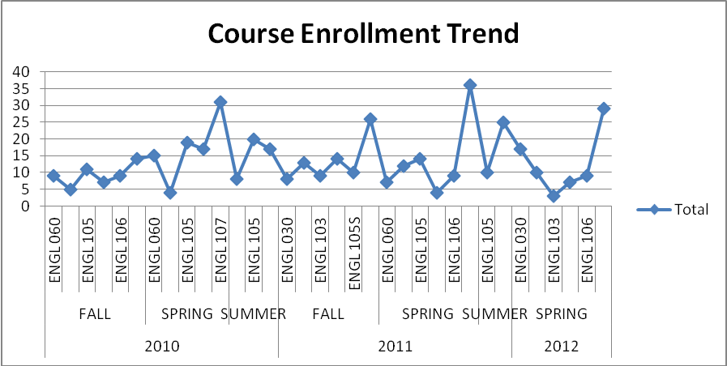
Figure 1 Course Enrollment Trend
Findings:
- Enrollment for English courses vacillate from term to term. There are no clear patterns.

Findings By Course

English 030 Fundamental Writing Skills

Findings:
- 13 students earned a grade of C or above. 11 students earned failing grades.
- The average passing rate for ENGL 030 is 52%. Excluding withdrawals the passing rate is 54%.
- The 030 was suspended from course offerings at THEARC and was reinstated during the Fall 2011 semester.
- There is a wide variance of the failure and passage rates between the two instructors during this period.
This can be contributed to the implementation of MyWritingLab in Spring 2012.
ENGL 030/ARC
Year | Academic Term | A- | B | B- | B+ | C | C- | C+ | D+ | F | W | Grand Total
2011 | FALL |  |  |  | 1 | 1 |  | 1 | 1 | 3 | 1 | 8
2011 Total |  |  |  |  | 1 | 1 |  | 1 | 1 | 3 | 1 | 8
2012 | SPRING | 3 | 2 | 4 | 2 |  | 2 |  |  | 4 |  | 17
2012 Total |  | 3 | 2 | 4 | 2 |  | 2 |  |  | 4 |  | 17
Grand Total |  | 3 | 2 | 4 | 3 | 1 | 2 | 1 | 1 | 7 | 1 | 25
Table 2: ENGL 103 Fundamental Writing Skills

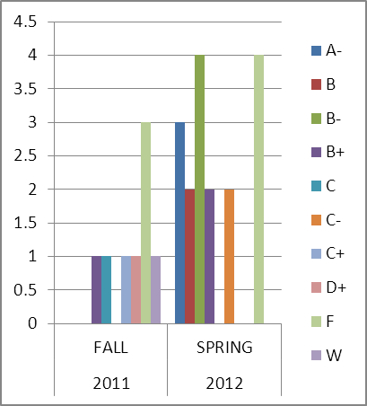
Figure 2 ENG 030

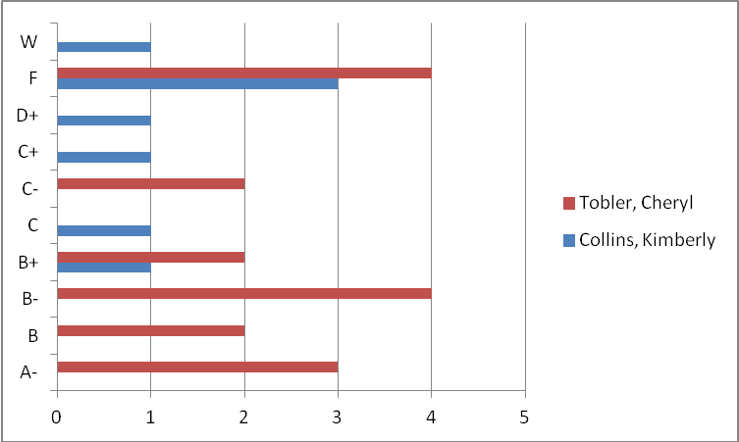
Figure 3 ENGL 030 GRADES BY INSTRUCTOR

ENGL 060 Composition Skills

Findings:
- Overall, students earn higher grades during the spring semesters.
- Of the 54 students, 31 earned a grade of C or above. 20 students earned failing grades.
- The average passing rate for ENGL 060 is 57%. Excluding withdrawals the passing rate is 61%.
- Data represents a wide variety of range of failing and passage rates by instructor. This can be contributed to a lack of course standardization.

 | ENGL 060
Year | Academic Term | A | A- | B | B- | B+ | C | C- | D | D+ | F | W | Grand Total
2010 | FALL |  |  |  | 1 |  | 3 | 2 | 1 | 2 |  |  | 9
 | SPRING | 8 | 3 | 1 |  | 2 |  |  |  |  | 1 |  | 15
2010 Total |  | 8 | 3 | 1 | 1 | 2 | 3 | 2 | 1 | 2 | 1 |  | 24
2011 | FALL | 2 | 1 | 1 |  | 1 | 1 |  |  |  | 7 |  | 13
 | SPRING | 1 |  |  | 1 | 1 |  |  |  |  | 2 | 2 | 7
2011 Total |  | 3 | 1 | 1 | 1 | 2 | 1 |  |  |  | 9 | 2 | 20
2012 | SPRING | 2 |  |  |  | 1 | 1 |  | 3 |  | 2 | 1 | 10
2012 Total |  | 2 |  |  |  | 1 | 1 |  | 3 |  | 2 | 1 | 10
Grand Total |  | 13 | 4 | 2 | 2 | 5 | 5 | 2 | 4 | 2 | 12 | 3 | 54
Table 3: ENG 060 Composition Skills

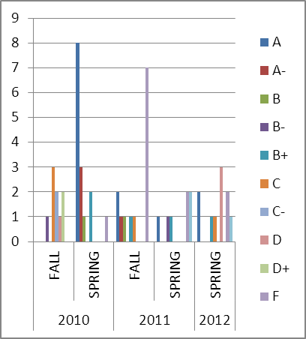
Figure 4 ENGL 060

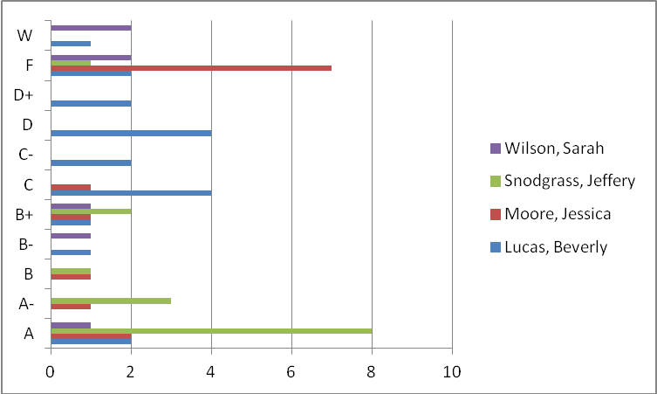
Figure 5 ENGL060 BY INSTRUCTOR

ENGL 103 Grammar and Writing

Findings:
- Out of a total of 41 students, 21 earned a passing grade of C or higher. 16 earned a failing grade and 4 withdrawals.
- The average passing rate for ENGL103 is 51%. Excluding withdrawals, the passing rate is 57%.
- The highest failure rate occurs during the summer and spring semesters.
- The grading by instructor is consistent in grades earn
ENGL 103
Year | Academic Term | A | A- | B | B- | B+ | C | C- | C+ | D | D+ | F | W | Grand Total
2010 | FALL |  |  |  | 1 |  | 2 |  |  |  | 1 | 1 |  | 5
 | SPRING |  | 1 | 1 |  |  |  |  |  |  |  | 2 |  | 4
 | SUMMER | 2 |  |  | 3 |  |  |  |  |  |  | 2 | 1 | 8
2010 Total |  | 2 | 1 | 1 | 4 |  | 2 |  |  |  | 1 | 5 | 1 | 17
2011 | FALL | 1 |  | 1 |  |  | 3 | 1 |  | 2 |  |  | 1 | 9
 | SPRING | 1 | 1 |  | 2 | 1 |  |  | 2 |  |  | 3 | 2 | 12
2011 Total |  | 2 | 1 | 1 | 2 | 1 | 3 | 1 | 2 | 2 |  | 3 | 3 | 21
2012 | SPRING | 1 |  |  |  |  |  |  |  | 2 |  |  |  | 3
2012 Total |  | 1 |  |  |  |  |  |  |  | 2 |  |  |  | 3
Grand Total |  | 5 | 2 | 2 | 6 | 1 | 5 | 1 | 2 | 4 | 1 | 8 | 4 | 41
Table 4: ENG 103 Grammar and Writing

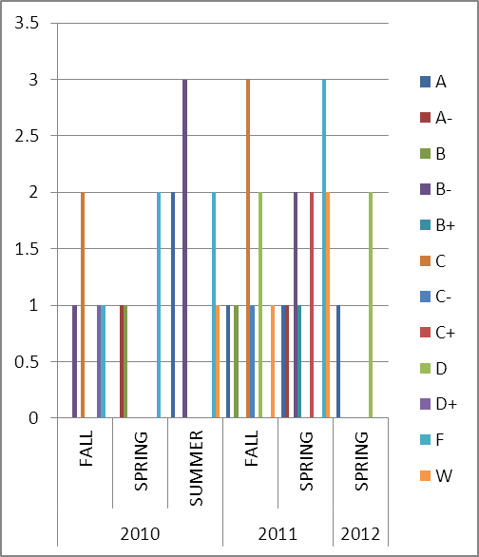
Figure 6 ENGL 103

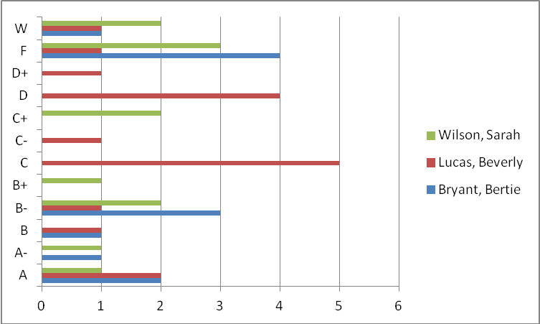
Figure 7 ENGL 103 GRADES BY INSTRUCTOR

ENGL 105 Introduction to Writing

- Out of 88 students, 44 students earned a passing grade of C or higher. 37 earned a failing grade and there were 7 withdrawals.
- The average passing rate for ENGL 105 is 50%. Excluding withdrawals, the passing rate is 54%.
- Data represents a wide variety of range of failing and passage rates by instructor. This can be contributed to a lack of course standardization.

ENGL 105
Year | Academic Term | A | A- | B | B- | B+ | C | C- | C+ | D | D+ | F | W | Grand Total
2010 | FALL |  |  | 1 | 2 |  |  | 2 |  | 1 | 1 | 3 | 1 | 11
 | SPRING | 1 | 3 | 2 | 1 | 2 | 2 |  | 1 | 3 |  | 2 | 2 | 19
 | SUMMER | 1 | 1 | 1 | 2 | 3 | 2 |  | 3 | 1 |  | 3 | 3 | 20
2010 Total |  | 2 | 4 | 4 | 5 | 5 | 4 | 2 | 4 | 5 | 1 | 8 | 6 | 50
2011 | FALL | 2 |  | 2 |  |  | 1 | 1 | 1 | 2 |  | 5 |  | 14
 | SPRING | 1 |  | 1 | 2 | 2 | 2 | 1 | 1 | 2 |  | 1 | 1 | 14
 | SUMMER | 7 |  |  |  |  |  |  |  |  |  | 3 |  | 10
2011 Total |  | 10 |  | 3 | 2 | 2 | 3 | 2 | 2 | 4 |  | 9 | 1 | 38
Grand Total |  | 12 | 4 | 7 | 7 | 7 | 7 | 4 | 6 | 9 | 1 | 17 | 7 | 88
Table 5: ENG 105 Introduction to College Writing

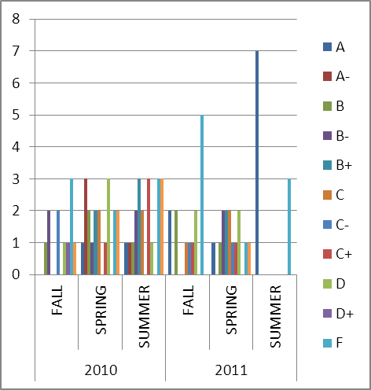
Figure 8 ENGL 105

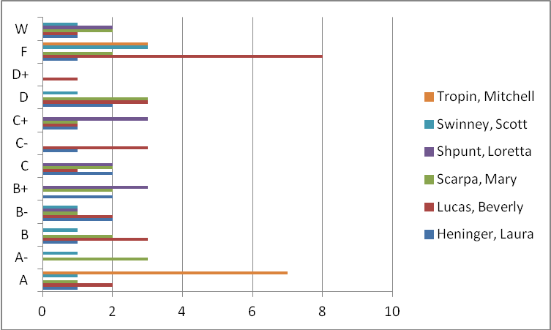
Figure 9 ENGL105 BY INSTRUCTOR

ENGL 105S Introduction to College Writing with Supplemental Instruction

Findings:
- Out of 28 students, 16 earned a passing grade of C or higher. 11 earned a failing grade and there was one withdrawal.
- The passage rate of ENGL 105S is 57%. Excluding withdrawals, the passage rate is 59%.
- Data represents a wide variety of range of failing and passage rates by instructor. This can be contributed to a lack of course standardization.

ENGL 105S
Year | Academic Term | A | A- | B | B+ | C | C- | F | W | Grand Total
2010 | FALL |  | 1 |  | 2 | 2 | 2 |  |  | 7
2010 Total |  |  | 1 |  | 2 | 2 | 2 |  |  | 7
2011 | FALL | 2 | 2 |  |  | 2 | 4 |  |  | 10
 | SPRING | 1 |  | 1 | 1 |  |  |  | 1 | 4
2011 Total |  | 3 | 2 | 1 | 1 | 2 | 4 |  | 1 | 14
2012 | SPRING |  |  |  |  | 2 | 2 | 3 |  | 7
2012 Total |  |  |  |  |  | 2 | 2 | 3 |  | 7
Grand Total |  | 3 | 3 | 1 | 3 | 6 | 8 | 3 | 1 | 28
Table 6: ENGL 105S Introduction to College Writing with Supplemental Instruction

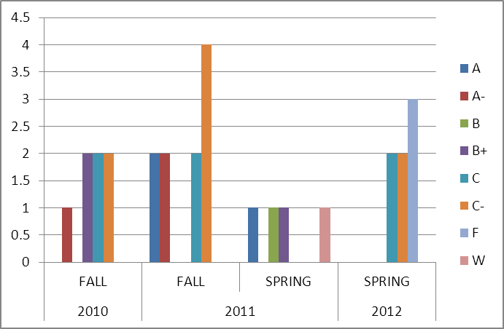
Figure 10 ENGL 105S

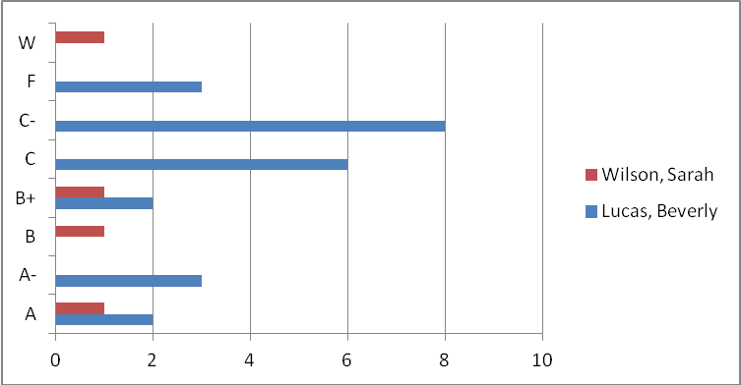
Figure 11 ENGL 105S BY INSTRUCTOR

English 106 Composition Skills

Findings
- Out of 44 students, 30 earned a passing grade of D or above. 14 students earned a failing grade and there were no student withdrawals.
- The average passing rate for ENGL 106 is 68%.

ENGL 106
Year | Academic Term | A | A- | B | B- | B+ | C | C- | C+ | D+ | F | Grand Total
2010 | FALL |  |  | 1 |  |  | 1 |  | 2 |  | 5 | 9
 | SPRING | 5 |  | 2 | 2 | 2 | 1 | 1 |  |  | 4 | 17
2010 Total |  | 5 |  | 3 | 2 | 2 | 2 | 1 | 2 |  | 9 | 26
2011 | SPRING |  | 1 | 3 |  |  |  |  | 1 |  | 4 | 9
2011 Total |  |  | 1 | 3 |  |  |  |  | 1 |  | 4 | 9
2012 | SPRING | 2 |  | 1 | 1 | 1 | 2 |  |  | 1 | 1 | 9
2012 Total |  | 2 |  | 1 | 1 | 1 | 2 |  |  | 1 | 1 | 9
Grand Total |  | 7 | 1 | 7 | 3 | 3 | 4 | 1 | 3 | 1 | 14 | 44
Table 7 ENGL 060 Composition Skills

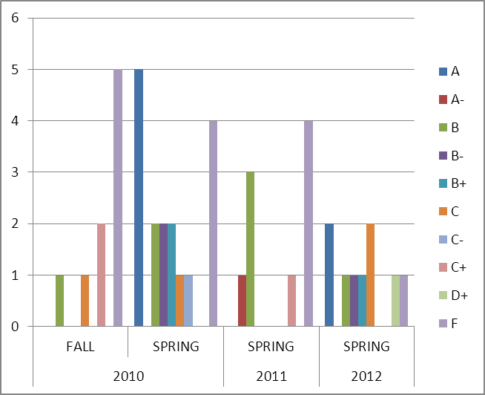
Figure 12 ENGL 106

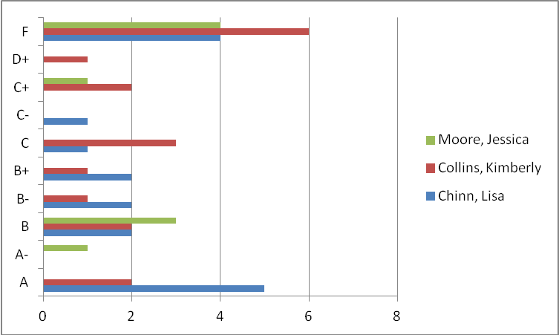
Figure 13 ENGL 106 GRADES BY INSTRUCTOR

ENG 107 College Composition
Findings:
- Out of 178 students, 142 earned a passing grade of D or higher. 36 earned a failing grade of F and there were 10 withdrawals.
- The average passing rate of ENGL 107 is 80%. Excluding withdrawals, the passing rate is 85%.
- Data represents a wide variety of range of failing and passage rates by instructor. This can be contributed to a lack of course standardization.

ENGL 107
Year | Academic Term | A | A- | B | B- | B+ | C | C- | C+ | D | D+ | F | W | Grand Total
2010 | FALL |  |  | 1 |  | 2 | 3 |  | 1 | 1 | 2 | 3 | 1 | 14
 | SPRING | 1 | 4 | 6 | 3 | 2 | 4 | 2 | 1 | 3 |  | 2 | 3 | 31
 | SUMMER |  | 2 | 1 | 1 | 2 |  | 3 | 1 | 1 |  | 6 |  | 17
2010 Total |  | 1 | 6 | 8 | 4 | 6 | 7 | 5 | 3 | 5 | 2 | 11 | 4 | 62
2011 | FALL | 1 | 3 | 4 | 5 |  |  | 4 | 2 |  |  | 5 | 2 | 26
 | SPRING | 1 | 8 | 6 | 6 | 3 | 3 | 1 |  |  |  | 5 | 3 | 36
 | SUMMER | 2 | 2 | 2 | 1 |  | 2 | 2 |  | 3 | 2 | 9 |  | 25
2011 Total |  | 4 | 13 | 12 | 12 | 3 | 5 | 7 | 2 | 3 | 2 | 19 | 5 | 87
2012 | SPRING | 4 | 1 | 4 | 1 | 1 | 4 | 3 | 2 | 1 | 1 | 6 | 1 | 29
2012 Total |  | 4 | 1 | 4 | 1 | 1 | 4 | 3 | 2 | 1 | 1 | 6 | 1 | 29
Grand Total |  | 9 | 20 | 24 | 17 | 10 | 16 | 15 | 7 | 9 | 5 | 36 | 10 | 178
Table 8: ENGL 107 College Composition

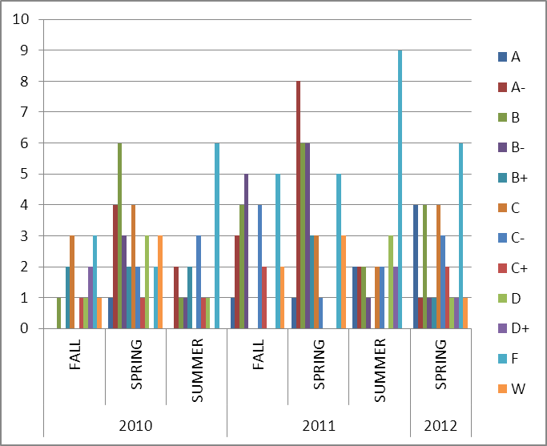
Figure 14 ENGL 107

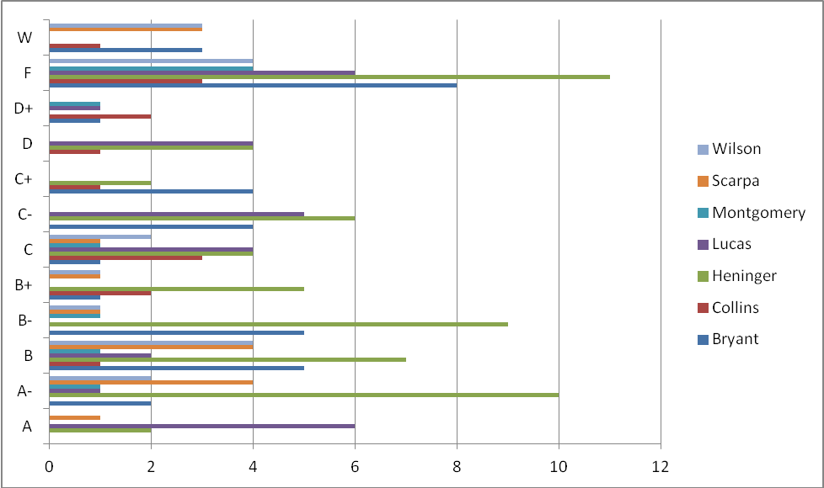
Figure 15 ENGL107 BY INSTRUCTOR

ACCUPLACER WritePlacer SCORES

ACCUPLACER - WritePlacer automatically evaluates students’ essays written responding to one of several prompts provided in the ACCUPLACER System. Students enter their essays into an onscreen textbox and submit for scoring. The system then returns a holistic score that ranges from 1 to 8, as well as feedback on six dimensions:
- Purpose and Focus - The extent to which the writer presents information in a unified and coherent manner clearly addressing the issue.
- Organization and Structure - The extent to which the writer orders and connects ideas.
- Development and Support - The extent to which the writer develops and supports ideas.
- Sentence Variety and Style - The extent to which the writer crafts sentences and paragraphs demonstrating control of vocabulary, voice, and structure. Specific elements to consider include
- Mechanical Conventions - The extent to which the writer expresses ideas using Standard English.
- Critical Thinking - The extent to which the writer communicates a point of view and demonstrates reasoned relationships among ideas.

Students who score 1, 2, or 3 on the Essay, are placed in ENGL103 (SPS) and ENGL 030 at THEARC.
Students who score 4, 5 are placed in ENGL105 or ENGL105/S (SPS) and ENGL 060 at THEARC.
Students who score 6, 7, or 8 are placed in ENGL 107 (SPS) and ENGL 106 at THEARC,

Findings:
- There were Accuplacer scores recorded for 249 students. The scores ranged from 0 to 8. There is no clear correlation between the Accuplacer score and grade outcome. In fact, the student who scored the highest on Accuplacer, received a “F” grade.
- Before 2009, Accuplacer scoring scale ranged between1-12. For students who took the test before this date, an equivalent formula was used to convert scores to reflect the 1-8 range. If students were placed in English course based on the 2009 scoring system, they were placed in a higher level course; thus this could contribute to the lack of correlation and be a factor in the overall pass/fail rate for each course.
- Note: In Fall 2010 it was discovered that students were being placed into ENGL105 regardless of their placement score. This could also be one of the factors of no correlation.

.
Accuplacer
Actual Score | A | A- | B | B- | B+ | C | C- | C+ | D | D+ | F | W | Grand Total
0 |  |  |  |  |  |  |  |  |  |  | 1 |  | 1
1 |  |  |  | 1 |  | 1 |  | 1 |  |  | 3 | 1 | 7
2 | 2 | 1 | 1 | 1 |  | 1 | 1 |  | 2 |  | 4 | 3 | 16
3 | 2 | 2 | 1 | 6 | 4 | 4 |  | 1 | 3 | 1 | 4 | 1 | 29
4 | 6 | 6 | 6 | 6 | 5 | 7 | 6 | 5 | 8 | 1 | 24 | 1 | 81
5 | 10 | 3 | 11 | 6 | 4 | 8 | 11 | 2 | 3 | 2 | 10 | 6 | 76
6 | 2 | 2 | 4 | 3 | 4 | 1 | 2 | 1 | 2 | 1 | 3 | 2 | 27
7 |  | 1 | 1 |  |  |  |  |  |  |  | 5 | 1 | 8
8 |  | 2 |  |  |  |  |  |  | 1 |  | 1 |  | 4
Grand Total | 22 | 17 | 24 | 23 | 17 | 22 | 20 | 10 | 19 | 5 | 55 | 15 | 249
Table 9: Accuplacer scores and grades

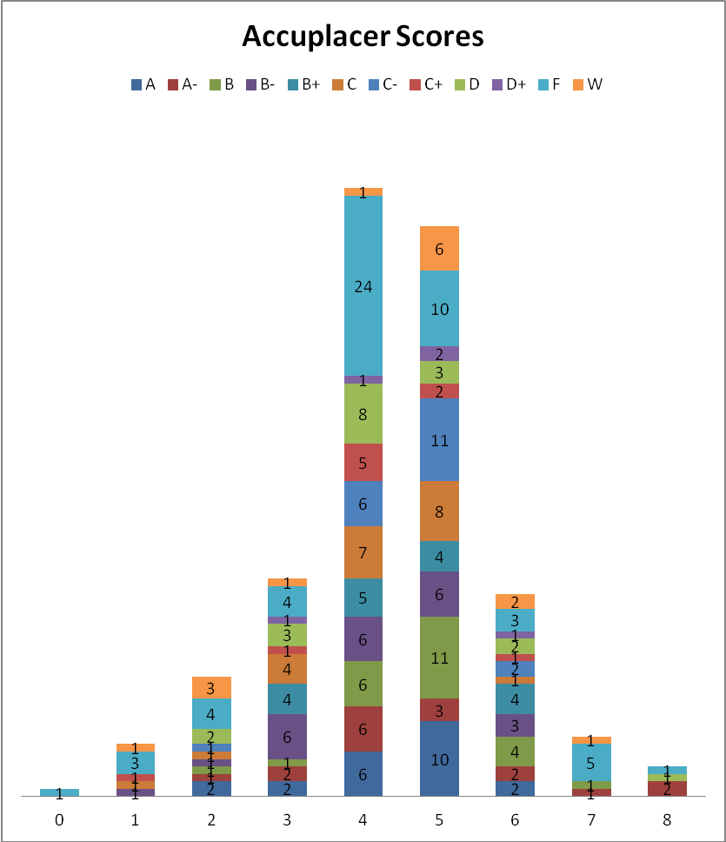
Figure 16 Accuplacer Scores

Supplemental Instruction
ENGL/105 and ENGL 105/S Correlation

Findings:
- 88 Students were registered in ENGL105 and 28 were registered in ENGL105S. Although more students were registered for ENGL105, the passage rate for ENGL105S (57%) is higher. The average passage rate for ENGL 105 is 50%.
 | Course ID
Final Grade | ENGL 105 | ENGL 105S | Grand Total
A | 12 | 3 | 15
A- | 4 | 3 | 7
B | 7 | 1 | 8
B- | 7 |  | 7
B+ | 7 | 3 | 10
C | 7 | 6 | 13
C- | 4 | 8 | 12
C+ | 6 |  | 6
D | 9 |  | 9
D+ | 1 |  | 1
F | 17 | 3 | 20
W | 7 | 1 | 8
Grand Total | 88 | 28 | 116
Table 10: ENGL 105 and 105/S

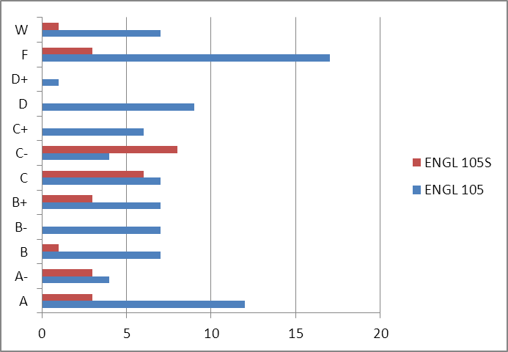
Figure 17 ENG 105/105S

Course Repeaters

Findings:
- 83 (18%) students repeated an English course
- ENGL 107 is the most repeated course and it also has the highest failure rate for repeaters.
- ENGL 103: 03 repeaters 2 pass, 1 fail
- ENGL 060: 10 repeaters 1 pass, 7 fail, and 2 withdrew
- ENGL103: 05 repeaters 1 pass, 4 fail
- ENGL105 13 repeaters 3 pass, 8 fail, and 2 withdrew
- ENGL 105S: 03 repeaters 2 pass, 1 fail
- ENGL 106: 10 repeaters 3 pass, 7 fail
- ENGL 107: 39 repeaters 21 pass, 13 fail and 5 withdrew

 | Course ID
Final Grade | ENGL 030 | ENGL 060 | ENGL 103 | ENGL 105 | ENGL 105S | ENGL 106 | ENGL 107 | Grand Total
A |  |  |  |  |  |  | 1 | 1
B | 1 |  |  | 1 | 1 | 1 | 4 | 8
B- |  |  |  |  |  | 1 | 1 | 2
B+ | 1 |  |  | 1 |  |  | 1 | 3
C |  | 1 | 1 |  | 1 |  | 5 | 8
C- | 1 | 1 |  |  | 1 |  | 5 | 8
C+ |  |  |  | 1 |  | 1 | 2 | 4
D |  | 1 | 1 | 2 |  |  | 1 | 5
D+ |  |  |  |  |  |  | 1 | 1
F |  | 5 | 3 | 6 |  | 7 | 13 | 34
W |  | 2 |  | 2 |  |  | 5 | 9
Grand Total | 3 | 10 | 5 | 13 | 3 | 10 | 39 | 83
Table 11: Course Repeaters

Instructors

Findings:
- 13 instructors have taught English courses over the analysis period. Of the 13, two were full-time writing specialist and one was a full-time staff member of the Writing Center.
- Note: Loretta Shpunt is not included in this count although she is listed on the report. It was discovered that Upward Bound courses have been coded in PowerCampus under “SEMSPS.” Therefore, her numbers (11 students) were included in the final count.
- Instructors who have taught the most students are Beverly Lucas (114), Laura Henninger (74) and Bertie Bryant (46).
- There are no instructors who have taught a section of every course offered.

 | Course ID
Instructor | ENGL 030 | ENGL 060 | ENGL 103 | ENGL 105 | ENGL 105S | ENGL 106 | ENGL 107 | Total
Bryant, Bertie |  |  | 12 |  |  |  | 34 | 46
Chinn, Lisa |  |  |  |  |  | 17 |  | 17
Collins, Kimberly | 8 |  |  |  |  | 18 | 14 | 40
Heninger, Laura |  |  |  | 14 |  |  | 60 | 74
Lucas, Beverly |  | 19 | 17 | 25 | 24 |  | 29 | 114
Montgomery, Shaunte' |  |  |  |  |  |  | 9 | 9
Moore, Jessica |  | 13 |  |  |  | 9 |  | 22
Scarpa, Mary |  |  |  | 19 |  |  | 15 | 34
Shpunt, Loretta |  |  |  | 11 |  |  |  | 11
Snodgrass, Jeffery |  | 15 |  |  |  |  |  | 15
Swinney, Scott |  |  |  | 9 |  |  |  | 9
Tobler, Cheryl | 17 |  |  |  |  |  |  | 17
Tropin, Mitchell |  |  |  | 10 |  |  |  | 10
Wilson, Sarah |  | 7 | 12 |  | 4 |  | 17 | 40
Total | 25 | 54 | 41 | 88 | 28 | 44 | 178 | 458
Table 12: Courses by Instructor
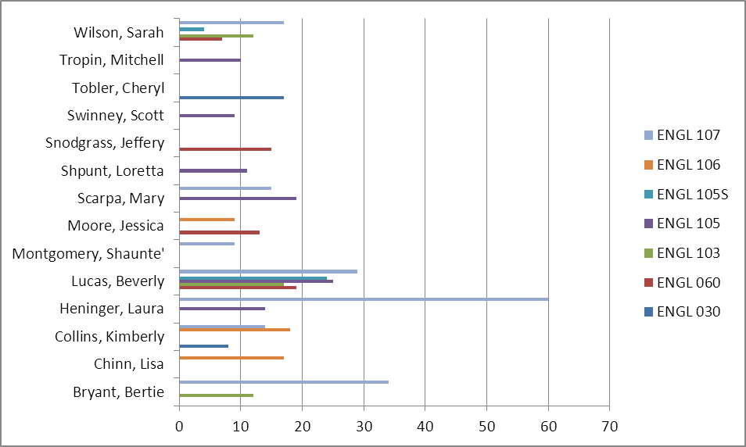
Figure 18 Courses by Instructor

Instructor | Course ID | A | A- | B | B- | B+ | C | C- | C+ | D | D+ | F | W | Total
Bryant, Bertie | ENGL 103 | 2 | 1 | 1 | 3 |  |  |  |  |  |  | 4 | 1 | 12
 | ENGL 107 |  | 2 | 5 | 5 | 1 | 1 | 4 | 4 |  | 1 | 8 | 3 | 34
Bryant, Bertie Total |  | 2 | 3 | 6 | 8 | 1 | 1 | 4 | 4 |  | 1 | 12 | 4 | 46
Chinn, Lisa | ENGL 106 | 5 |  | 2 | 2 | 2 | 1 | 1 |  |  |  | 4 |  | 17
Chinn, Lisa Total |  | 5 |  | 2 | 2 | 2 | 1 | 1 |  |  |  | 4 |  | 17
Collins, Kimberly | ENGL 030 |  |  |  |  | 1 | 1 |  | 1 |  | 1 | 3 | 1 | 8
 | ENGL 106 | 2 |  | 2 | 1 | 1 | 3 |  | 2 |  | 1 | 6 |  | 18
 | ENGL 107 |  |  | 1 |  | 2 | 3 |  | 1 | 1 | 2 | 3 | 1 | 14
Collins, Kimberly Total |  | 2 |  | 3 | 1 | 4 | 7 |  | 4 | 1 | 4 | 12 | 2 | 40
Heninger, Laura | ENGL 105 | 1 |  | 1 | 2 | 2 | 2 | 1 | 1 | 2 |  | 1 | 1 | 14
 | ENGL 107 | 2 | 10 | 7 | 9 | 5 | 4 | 6 | 2 | 4 |  | 11 |  | 60
Heninger, Laura Total |  | 3 | 10 | 8 | 11 | 7 | 6 | 7 | 3 | 6 |  | 12 | 1 | 74
Lucas, Beverly | ENGL 060 | 2 |  |  | 1 | 1 | 4 | 2 |  | 4 | 2 | 2 | 1 | 19
 | ENGL 103 | 2 |  | 1 | 1 |  | 5 | 1 |  | 4 | 1 | 1 | 1 | 17
 | ENGL 105 | 2 |  | 3 | 2 |  | 1 | 3 | 1 | 3 | 1 | 8 | 1 | 25
 | ENGL 105S | 2 | 3 |  |  | 2 | 6 | 8 |  |  |  | 3 |  | 24
 | ENGL 107 | 6 | 1 | 2 |  |  | 4 | 5 |  | 4 | 1 | 6 |  | 29
Lucas, Beverly Total |  | 14 | 4 | 6 | 4 | 3 | 20 | 19 | 1 | 15 | 5 | 20 | 3 | 114
Montgomery, Shaunte' | ENGL 107 |  | 1 | 1 | 1 |  | 1 |  |  |  | 1 | 4 |  | 9
Montgomery, Shaunte' Total |  |  | 1 | 1 | 1 |  | 1 |  |  |  | 1 | 4 |  | 9
Moore, Jessica | ENGL 060 | 2 | 1 | 1 |  | 1 | 1 |  |  |  |  | 7 |  | 13
 | ENGL 106 |  | 1 | 3 |  |  |  |  | 1 |  |  | 4 |  | 9
Moore, Jessica Total |  | 2 | 2 | 4 |  | 1 | 1 |  | 1 |  |  | 11 |  | 22
Scarpa, Mary | ENGL 105 | 1 | 3 | 2 | 1 | 2 | 2 |  | 1 | 3 |  | 2 | 2 | 19
 | ENGL 107 | 1 | 4 | 4 | 1 | 1 | 1 |  |  |  |  |  | 3 | 15
Scarpa, Mary Total |  | 2 | 7 | 6 | 2 | 3 | 3 |  | 1 | 3 |  | 2 | 5 | 34
Shpunt, Loretta | ENGL 105 |  |  |  | 1 | 3 | 2 |  | 3 |  |  |  | 2 | 11
Shpunt, Loretta Total |  |  |  |  | 1 | 3 | 2 |  | 3 |  |  |  | 2 | 11
Snodgrass, Jeffery | ENGL 060 | 8 | 3 | 1 |  | 2 |  |  |  |  |  | 1 |  | 15
Snodgrass, Jeffery Total |  | 8 | 3 | 1 |  | 2 |  |  |  |  |  | 1 |  | 15
Swinney, Scott | ENGL 105 | 1 | 1 | 1 | 1 |  |  |  |  | 1 |  | 3 | 1 | 9
Swinney, Scott Total |  | 1 | 1 | 1 | 1 |  |  |  |  | 1 |  | 3 | 1 | 9
Tobler, Cheryl | ENGL 030 |  | 3 | 2 | 4 | 2 |  | 2 |  |  |  | 4 |  | 17
Tobler, Cheryl Total |  |  | 3 | 2 | 4 | 2 |  | 2 |  |  |  | 4 |  | 17
Tropin, Mitchell | ENGL 105 | 7 |  |  |  |  |  |  |  |  |  | 3 |  | 10
Tropin, Mitchell Total |  | 7 |  |  |  |  |  |  |  |  |  | 3 |  | 10
Wilson, Sarah | ENGL 060 | 1 |  |  | 1 | 1 |  |  |  |  |  | 2 | 2 | 7
 | ENGL 103 | 1 | 1 |  | 2 | 1 |  |  | 2 |  |  | 3 | 2 | 12
 | ENGL 105S | 1 |  | 1 |  | 1 |  |  |  |  |  |  | 1 | 4
 | ENGL 107 |  | 2 | 4 | 1 | 1 | 2 |  |  |  |  | 4 | 3 | 17
Wilson, Sarah Total |  | 3 | 3 | 5 | 4 | 4 | 2 |  | 2 |  |  | 9 | 8 | 40
Grand Total |  | 49 | 37 | 45 | 39 | 32 | 44 | 33 | 19 | 26 | 11 | 97 | 26 | 458
Table 13: Instructor Grade Distribution

SPS Writing Course Goals and Objectives

The following proposed goals and objectives for English courses were developed by the writing specialist, Beverly Lucas and Sarah Wilson along with Professor Bill Beverly in the summer of 2010. These are the goals and objectives recommended to begin the implementation of My Writing Lab, standard syllabi, pre and post testing throughout each of the SPS English Courses.

English 107 College Composition

Course Description: This course helps students to develop the skills necessary for effective writing of thesis-centered essays at the college level, including analytical, critical, and argumentative essays. Research and documentation techniques are included.

English 106 Writing for Academic and Professional Success*

Course Description: This course focuses on planning, writing, and revising compositions for academic and professional purposes, including informational, analytical, evaluative, and persuasive compositions; develops skills in accessing, evaluating, using, and documenting informational sources and introduces students to professional writing applications, including memos, resumes, and reports. This course is only open to students in the Associate's Degree program.

Course Goals:
- To assist students in improving their academic writing. Improvement can only occur with practice and feedback. In this course, practice and feedback is gained through drafting, peer reviews, conferences, and the submission of several formal assignments.
- To help prepare students for the kinds of writing required at the university and in professional careers.

Course Objectives:
Upon completion of this course students will be able to:
- recognize and compose a thesis statement;
- identify an audience and write for that audience;
- develop and organize a topic;
- critique arguments;
- evaluate an author’s work;
- argue a position using research to back up a position;
- apply strategies and techniques of revision; and
- think critically about ideas.

English105 Introduction to College Writing
English 105S Introduction to College Writing with Supplemental Instruction

Course Description: This course is designed to increase fluency in college-level written communication with an emphasis on organizational skills and language structure. Students will have the opportunity to develop and/or improve the ability to analyze and critique texts in order to write about them.

English 060 Composition Skills*

Course Description: This course focuses on writing clear, effective compositions. Students will learn how to construct paragraphs, how to state topics, and how to develop narratives and analyses. This course is only open to students in the Associate's degree program.

Course Goals:
- To develop skills in academic writing.
- To give students a set of concepts to help structure their thinking and work toward writing clear, persuasive, stylish prose. This will be achieved by engaging various rhetorical strategies in response to a variety of interactions between writer, reader, text, topic, and moment.

Course Objectives:
Upon completion of this course students will be able to:
- understand and employ the fundamentals of expository and persuasive writing;
- incorporate a variety of tactics for generating ideas about a topic;
- use systematic patterns of topic development and organization;
- meet the usage standards and sophistication level of the audience being addressed;
- understand word and sentence level stylistic options;
- integrate techniques for making writing more coherent;
- develop strategies for revision that will carry into other classes and contexts;
- use the academic conventions of incorporating and citing the words and ideas of others;
- develop the habit of thinking critically both about ideas and about sources of information; and
- edit writing for correct word choice, grammar usage, capitalization, punctuation, and spelling.

English 103 Grammar and Writing

Course Description: This course is designed to help students acquire skills necessary to write effective paragraphs. The focus is on the construction of sentences and paragraphs, the writing process, grammar, usage, and mechanics.

English 030 Fundamental Writing Skills*

Course Description: This course is designed to help students acquire skills necessary to write effective paragraphs. The focus is on the construction of sentences and paragraphs, the writing process, grammar, usage, and mechanics. This course is only open to students in the Associate's degree program.

Course Objectives:
Upon completion of this course students will be able to:
- develop writing skills in association with skills of reading critically;
- employ different stages of writing—planning, drafting, revising and editing;
- organize and develop ideas logically, making clear connections between them;
- sustain a clear focus or thesis;
- use appropriate reasons, examples, and details to develop clearly and logically the ideas presented in the essay;
- demonstrate facility in the use of language and the ability to use a variety of structures and wide-ranging vocabulary;
- revise drafts in response to peer/ teacher feedback; and
- understand the use of rhetoric, including controlling tone and establishing and maintaining voice.

*Courses offered at THEARC (Town Hall Education and Recreation Center)

Appendices

RAW DATA
instructor | STUDENT ID | Year | Term | Course ID | Repeated | Grade | ACCUPLACER
Bryant, Bertie | P000113267 | 2010 | SPRING | ENGL 103 | N | A- | 5
Bryant, Bertie | P000113333 | 2010 | SPRING | ENGL 103 | Y | F
Bryant, Bertie | P000116876 | 2010 | SPRING | ENGL 103 | N | B
Bryant, Bertie | P000118109 | 2010 | SPRING | ENGL 103 | N | F | 4
Bryant, Bertie | P000004607 | 2010 | SUMMER | ENGL 103 | N | F
Bryant, Bertie | P000022972 | 2010 | SUMMER | ENGL 103 | N | B-
Bryant, Bertie | P000088274 | 2010 | SUMMER | ENGL 103 | N | A
Bryant, Bertie | P000112431 | 2010 | SUMMER | ENGL 103 | N | B- | 3
Bryant, Bertie | P000113996 | 2010 | SUMMER | ENGL 103 | N | A | 4
Bryant, Bertie | P000114465 | 2010 | SUMMER | ENGL 103 | N | W
Bryant, Bertie | P000115422 | 2010 | SUMMER | ENGL 103 | N | F | 1
Bryant, Bertie | P000117149 | 2010 | SUMMER | ENGL 103 | N | B- | 4
Bryant, Bertie | P000008185 | 2011 | FALL | ENGL 107 | N | W
Bryant, Bertie | P000086585 | 2011 | FALL | ENGL 107 | Y | C+ | 3
Bryant, Bertie | P000103345 | 2011 | FALL | ENGL 107 | N | C-
Bryant, Bertie | P000103495 | 2011 | FALL | ENGL 107 | Y | F | 4
Bryant, Bertie | P000103518 | 2011 | FALL | ENGL 107 | Y | B-
Bryant, Bertie | P000108047 | 2011 | FALL | ENGL 107 | N | B- | 3
Bryant, Bertie | P000109820 | 2011 | FALL | ENGL 107 | N | B
Bryant, Bertie | P000117149 | 2011 | FALL | ENGL 107 | N | B- | 4
Bryant, Bertie | P000117669 | 2011 | FALL | ENGL 107 | N | F | 4
Bryant, Bertie | P000120832 | 2011 | FALL | ENGL 107 | N | B | 4
Bryant, Bertie | P000121227 | 2011 | FALL | ENGL 107 | N | C+
Bryant, Bertie | P000124292 | 2011 | FALL | ENGL 107 | N | C-
Bryant, Bertie | P000127354 | 2011 | FALL | ENGL 107 | N | C-
Bryant, Bertie | P000127403 | 2011 | FALL | ENGL 107 | N | A-
Bryant, Bertie | P000127827 | 2011 | FALL | ENGL 107 | Y | F
Bryant, Bertie | P000129809 | 2011 | FALL | ENGL 107 | N | C-
Bryant, Bertie | P000130022 | 2011 | FALL | ENGL 107 | N | W | 6
Bryant, Bertie | P000130396 | 2011 | FALL | ENGL 107 | N | B-
Bryant, Bertie | P000015093 | 2012 | SPRING | ENGL 107 | Y | B+ | 3
Bryant, Bertie | P000084121 | 2012 | SPRING | ENGL 107 | Y | C | 5
Bryant, Bertie | P000084125 | 2012 | SPRING | ENGL 107 | N | F
Bryant, Bertie | P000088074 | 2012 | SPRING | ENGL 107 | N | B
Bryant, Bertie | P000114496 | 2012 | SPRING | ENGL 107 | N | A- | 5
Bryant, Bertie | P000116923 | 2012 | SPRING | ENGL 107 | N | D+
Bryant, Bertie | P000118988 | 2012 | SPRING | ENGL 107 | Y | W | 7
Bryant, Bertie | P000123328 | 2012 | SPRING | ENGL 107 | N | C+ | 5
Bryant, Bertie | P000125096 | 2012 | SPRING | ENGL 107 | Y | F | 6
Bryant, Bertie | P000131017 | 2012 | SPRING | ENGL 107 | N | F | 5
Bryant, Bertie | P000131472 | 2012 | SPRING | ENGL 107 | N | F | 4
Bryant, Bertie | P000132395 | 2012 | SPRING | ENGL 107 | N | B | 2
Bryant, Bertie | P000132818 | 2012 | SPRING | ENGL 107 | N | B- | 6
Bryant, Bertie | P000132943 | 2012 | SPRING | ENGL 107 | N | B
Bryant, Bertie | P000133791 | 2012 | SPRING | ENGL 107 | N | C+ | 4
Bryant, Bertie | P000135928 | 2012 | SPRING | ENGL 107 | N | F
Chinn, Lisa | P000009074 | 2010 | SPRING | ENGL 106 | N | C
Chinn, Lisa | P000053783 | 2010 | SPRING | ENGL 106 | N | A
Chinn, Lisa | P000075910 | 2010 | SPRING | ENGL 106 | N | A
Chinn, Lisa | P000078915 | 2010 | SPRING | ENGL 106 | Y | B-
Chinn, Lisa | P000093914 | 2010 | SPRING | ENGL 106 | Y | F
Chinn, Lisa | P000107486 | 2010 | SPRING | ENGL 106 | N | B+
Chinn, Lisa | P000109176 | 2010 | SPRING | ENGL 106 | N | B+
Chinn, Lisa | P000110526 | 2010 | SPRING | ENGL 106 | N | A
Chinn, Lisa | P000111149 | 2010 | SPRING | ENGL 106 | N | F
Chinn, Lisa | P000111371 | 2010 | SPRING | ENGL 106 | N | F
Chinn, Lisa | P000112236 | 2010 | SPRING | ENGL 106 | N | F | 3
Chinn, Lisa | P000112705 | 2010 | SPRING | ENGL 106 | N | A
Chinn, Lisa | P000112896 | 2010 | SPRING | ENGL 106 | N | B-
Chinn, Lisa | P000113639 | 2010 | SPRING | ENGL 106 | N | A
Chinn, Lisa | P000114344 | 2010 | SPRING | ENGL 106 | N | B
Chinn, Lisa | P000117872 | 2010 | SPRING | ENGL 106 | N | C- | 6
Chinn, Lisa | P000118007 | 2010 | SPRING | ENGL 106 | N | B | 7
Collins, Kimberly | P000107287 | 2011 | FALL | ENGL 030 | N | F | 2
Collins, Kimberly | P000119727 | 2011 | FALL | ENGL 030 | N | F
Collins, Kimberly | P000130319 | 2011 | FALL | ENGL 030 | N | C+ | 1
Collins, Kimberly | P000131221 | 2011 | FALL | ENGL 030 | N | W
Collins, Kimberly | P000131223 | 2011 | FALL | ENGL 030 | N | B+
Collins, Kimberly | P000132250 | 2011 | FALL | ENGL 030 | N | F
Collins, Kimberly | P000132550 | 2011 | FALL | ENGL 030 | N | C | 2
Collins, Kimberly | P000133022 | 2011 | FALL | ENGL 030 | N | D+ | 3
Collins, Kimberly | P000081013 | 2010 | FALL | ENGL 106 | N | F
Collins, Kimberly | P000083361 | 2010 | FALL | ENGL 106 | N | B | 5
Collins, Kimberly | P000110648 | 2010 | FALL | ENGL 106 | Y | F
Collins, Kimberly | P000111149 | 2010 | FALL | ENGL 106 | Y | F
Collins, Kimberly | P000112549 | 2010 | FALL | ENGL 106 | N | C
Collins, Kimberly | P000117321 | 2010 | FALL | ENGL 106 | Y | F | 3
Collins, Kimberly | P000118880 | 2010 | FALL | ENGL 106 | N | C+
Collins, Kimberly | P000121535 | 2010 | FALL | ENGL 106 | N | C+ | 5
Collins, Kimberly | P000123788 | 2010 | FALL | ENGL 106 | N | F | 7
Collins, Kimberly | P000116658 | 2012 | SPRING | ENGL 106 | N | A
Collins, Kimberly | P000129905 | 2012 | SPRING | ENGL 106 | N | C
Collins, Kimberly | P000131220 | 2012 | SPRING | ENGL 106 | N | C | 5
Collins, Kimberly | P000132618 | 2012 | SPRING | ENGL 106 | N | A | 4
Collins, Kimberly | P000133068 | 2012 | SPRING | ENGL 106 | N | B | 5
Collins, Kimberly | P000133219 | 2012 | SPRING | ENGL 106 | N | D+
Collins, Kimberly | P000133660 | 2012 | SPRING | ENGL 106 | N | B+ | 4
Collins, Kimberly | P000134899 | 2012 | SPRING | ENGL 106 | N | F | 5
Collins, Kimberly | P000136969 | 2012 | SPRING | ENGL 106 | N | B-
Collins, Kimberly | P000083434 | 2010 | FALL | ENGL 107 | N | B
Collins, Kimberly | P000086783 | 2010 | FALL | ENGL 107 | N | F
Collins, Kimberly | P000100486 | 2010 | FALL | ENGL 107 | Y | F | 4
Collins, Kimberly | P000100522 | 2010 | FALL | ENGL 107 | Y | C | 6
Collins, Kimberly | P000100693 | 2010 | FALL | ENGL 107 | N | F | 4
Collins, Kimberly | P000106900 | 2010 | FALL | ENGL 107 | Y | W | 5
Collins, Kimberly | P000108195 | 2010 | FALL | ENGL 107 | N | C
Collins, Kimberly | P000108308 | 2010 | FALL | ENGL 107 | N | D+
Collins, Kimberly | P000112681 | 2010 | FALL | ENGL 107 | N | C
Collins, Kimberly | P000113267 | 2010 | FALL | ENGL 107 | N | D | 5
Collins, Kimberly | P000114132 | 2010 | FALL | ENGL 107 | N | B+
Collins, Kimberly | P000114951 | 2010 | FALL | ENGL 107 | N | C+
Collins, Kimberly | P000117113 | 2010 | FALL | ENGL 107 | N | D+ | 5
Collins, Kimberly | P000118329 | 2010 | FALL | ENGL 107 | N | B+
Heninger, Laura | P000012638 | 2011 | SPRING | ENGL 105 | N | D
Heninger, Laura | P000084121 | 2011 | SPRING | ENGL 105 | N | B- | 5
Heninger, Laura | P000108154 | 2011 | SPRING | ENGL 105 | N | D | 4
Heninger, Laura | P000116295 | 2011 | SPRING | ENGL 105 | Y | F | 8
Heninger, Laura | P000117149 | 2011 | SPRING | ENGL 105 | N | B- | 4
Heninger, Laura | P000117669 | 2011 | SPRING | ENGL 105 | Y | C+ | 4
Heninger, Laura | P000119203 | 2011 | SPRING | ENGL 105 | N | C- | 5
Heninger, Laura | P000119495 | 2011 | SPRING | ENGL 105 | N | C | 5
Heninger, Laura | P000120515 | 2011 | SPRING | ENGL 105 | N | B+ | 5
Heninger, Laura | P000120832 | 2011 | SPRING | ENGL 105 | N | B+ | 4
Heninger, Laura | P000121716 | 2011 | SPRING | ENGL 105 | N | C | 4
Heninger, Laura | P000123035 | 2011 | SPRING | ENGL 105 | N | W | 5
Heninger, Laura | P000123229 | 2011 | SPRING | ENGL 105 | N | B | 5
Heninger, Laura | P000124102 | 2011 | SPRING | ENGL 105 | N | A
Heninger, Laura | P000048395 | 2010 | SPRING | ENGL 107 | N | B- | 5
Heninger, Laura | P000049066 | 2010 | SPRING | ENGL 107 | N | C-
Heninger, Laura | P000082894 | 2010 | SPRING | ENGL 107 | Y | B | 6
Heninger, Laura | P000092874 | 2010 | SPRING | ENGL 107 | N | C
Heninger, Laura | P000093165 | 2010 | SPRING | ENGL 107 | N | B-
Heninger, Laura | P000101559 | 2010 | SPRING | ENGL 107 | N | B
Heninger, Laura | P000101678 | 2010 | SPRING | ENGL 107 | N | F
Heninger, Laura | P000103070 | 2010 | SPRING | ENGL 107 | N | D | 6
Heninger, Laura | P000103495 | 2010 | SPRING | ENGL 107 | Y | F | 4
Heninger, Laura | P000104822 | 2010 | SPRING | ENGL 107 | N | D | 6
Heninger, Laura | P000107268 | 2010 | SPRING | ENGL 107 | Y | C-
Heninger, Laura | P000109726 | 2010 | SPRING | ENGL 107 | Y | C+ | 6
Heninger, Laura | P000110210 | 2010 | SPRING | ENGL 107 | N | D | 4
Heninger, Laura | P000110377 | 2010 | SPRING | ENGL 107 | N | C
Heninger, Laura | P000110688 | 2010 | SPRING | ENGL 107 | N | C
Heninger, Laura | P000113335 | 2010 | SPRING | ENGL 107 | N | B+
Heninger, Laura | P000077618 | 2010 | SUMMER | ENGL 107 | N | F | 2
Heninger, Laura | P000096134 | 2010 | SUMMER | ENGL 107 | N | C+ | 4
Heninger, Laura | P000100535 | 2010 | SUMMER | ENGL 107 | Y | C- | 5
Heninger, Laura | P000101216 | 2010 | SUMMER | ENGL 107 | N | B- | 6
Heninger, Laura | P000102356 | 2010 | SUMMER | ENGL 107 | N | F
Heninger, Laura | P000103102 | 2010 | SUMMER | ENGL 107 | Y | C-
Heninger, Laura | P000104971 | 2010 | SUMMER | ENGL 107 | Y | F | 4
Heninger, Laura | P000107506 | 2010 | SUMMER | ENGL 107 | N | F | 4
Heninger, Laura | P000108126 | 2010 | SUMMER | ENGL 107 | N | F
Heninger, Laura | P000109122 | 2010 | SUMMER | ENGL 107 | N | B | 6
Heninger, Laura | P000109829 | 2010 | SUMMER | ENGL 107 | Y | C- | 5
Heninger, Laura | P000110611 | 2010 | SUMMER | ENGL 107 | N | B+
Heninger, Laura | P000111924 | 2010 | SUMMER | ENGL 107 | N | F
Heninger, Laura | P000113338 | 2010 | SUMMER | ENGL 107 | N | D
Heninger, Laura | P000113466 | 2010 | SUMMER | ENGL 107 | N | B+
Heninger, Laura | P000115666 | 2010 | SUMMER | ENGL 107 | N | A- | 6
Heninger, Laura | P000116109 | 2010 | SUMMER | ENGL 107 | N | A-
Heninger, Laura | P000052649 | 2011 | FALL | ENGL 107 | N | B-
Heninger, Laura | P000077690 | 2011 | FALL | ENGL 107 | Y | A
Heninger, Laura | P000099836 | 2011 | FALL | ENGL 107 | N | B
Heninger, Laura | P000107506 | 2011 | FALL | ENGL 107 | Y | F | 4
Heninger, Laura | P000111213 | 2011 | FALL | ENGL 107 | N | A-
Heninger, Laura | P000117113 | 2011 | FALL | ENGL 107 | Y | B | 5
Heninger, Laura | P000124102 | 2011 | FALL | ENGL 107 | N | F | 5
Heninger, Laura | P000130167 | 2011 | FALL | ENGL 107 | N | A-
Heninger, Laura | P000009382 | 2011 | SPRING | ENGL 107 | N | A-
Heninger, Laura | P000020967 | 2011 | SPRING | ENGL 107 | N | A
Heninger, Laura | P000024556 | 2011 | SPRING | ENGL 107 | N | A-
Heninger, Laura | P000029405 | 2011 | SPRING | ENGL 107 | N | A- | 4
Heninger, Laura | P000048214 | 2011 | SPRING | ENGL 107 | N | B-
Heninger, Laura | P000081361 | 2011 | SPRING | ENGL 107 | N | B- | 6
Heninger, Laura | P000084482 | 2011 | SPRING | ENGL 107 | N | B-
Heninger, Laura | P000092431 | 2011 | SPRING | ENGL 107 | N | F | 0
Heninger, Laura | P000096244 | 2011 | SPRING | ENGL 107 | Y | C
Heninger, Laura | P000098552 | 2011 | SPRING | ENGL 107 | N | B-
Heninger, Laura | P000103067 | 2011 | SPRING | ENGL 107 | N | C- | 5
Heninger, Laura | P000113771 | 2011 | SPRING | ENGL 107 | N | B
Heninger, Laura | P000113996 | 2011 | SPRING | ENGL 107 | N | A- | 4
Heninger, Laura | P000119349 | 2011 | SPRING | ENGL 107 | N | B+
Heninger, Laura | P000121698 | 2011 | SPRING | ENGL 107 | N | B | 5
Heninger, Laura | P000122335 | 2011 | SPRING | ENGL 107 | N | A-
Heninger, Laura | P000122364 | 2011 | SPRING | ENGL 107 | N | B- | 5
Heninger, Laura | P000124521 | 2011 | SPRING | ENGL 107 | N | A- | 7
Heninger, Laura | P000125203 | 2011 | SPRING | ENGL 107 | N | B+ | 6
Lucas, Beverly | P000053033 | 2010 | FALL | ENGL 060 | N | D+
Lucas, Beverly | P000083362 | 2010 | FALL | ENGL 060 | N | C | 4
Lucas, Beverly | P000093914 | 2010 | FALL | ENGL 060 | Y | C-
Lucas, Beverly | P000116832 | 2010 | FALL | ENGL 060 | N | C-
Lucas, Beverly | P000116975 | 2010 | FALL | ENGL 060 | N | C
Lucas, Beverly | P000120311 | 2010 | FALL | ENGL 060 | Y | C
Lucas, Beverly | P000120979 | 2010 | FALL | ENGL 060 | N | B-
Lucas, Beverly | P000122673 | 2010 | FALL | ENGL 060 | N | D+
Lucas, Beverly | P000123514 | 2010 | FALL | ENGL 060 | N | D
Lucas, Beverly | P000097063 | 2012 | SPRING | ENGL 060 | Y | F | 5
Lucas, Beverly | P000101113 | 2012 | SPRING | ENGL 060 | N | A | 5
Lucas, Beverly | P000127686 | 2012 | SPRING | ENGL 060 | N | F | 5
Lucas, Beverly | P000131223 | 2012 | SPRING | ENGL 060 | N | C
Lucas, Beverly | P000131815 | 2012 | SPRING | ENGL 060 | Y | D | 4
Lucas, Beverly | P000132550 | 2012 | SPRING | ENGL 060 | N | W | 2
Lucas, Beverly | P000133928 | 2012 | SPRING | ENGL 060 | N | D | 5
Lucas, Beverly | P000135239 | 2012 | SPRING | ENGL 060 | N | B+ | 4
Lucas, Beverly | P000135405 | 2012 | SPRING | ENGL 060 | N | D | 3
Lucas, Beverly | P000136661 | 2012 | SPRING | ENGL 060 | N | A | 5
Lucas, Beverly | P000108707 | 2010 | FALL | ENGL 103 | N | D+
Lucas, Beverly | P000115422 | 2010 | FALL | ENGL 103 | Y | C | 1
Lucas, Beverly | P000119501 | 2010 | FALL | ENGL 103 | N | F
Lucas, Beverly | P000121992 | 2010 | FALL | ENGL 103 | N | B- | 3
Lucas, Beverly | P000123272 | 2010 | FALL | ENGL 103 | N | C
Lucas, Beverly | P000119192 | 2011 | FALL | engl 103 | N | C-
Lucas, Beverly | P000126814 | 2011 | FALL | ENGL 103 | N | B
Lucas, Beverly | P000130062 | 2011 | FALL | ENGL 103 | N | C | 4
Lucas, Beverly | P000123942 | 2011 | FALL | ENGL 103 | Y | D | 2
Lucas, Beverly | P000128699 | 2011 | FALL | ENGL 103 | N | A | 3
Lucas, Beverly | P000129626 | 2011 | FALL | ENGL 103 | N | C | 3
Lucas, Beverly | P000131603 | 2011 | FALL | ENGL 103 | N | W | 3
Lucas, Beverly | P000132613 | 2011 | FALL | ENGL 103 | N | C | 3
Lucas, Beverly | P000133529 | 2011 | FALL | ENGL 103 | N | D | 2
Lucas, Beverly | P000104908 | 2012 | SPRING | ENGL 103 | N | D
Lucas, Beverly | P000132291 | 2012 | SPRING | ENGL 103 | N | D | 3
Lucas, Beverly | P000134202 | 2012 | SPRING | ENGL 103 | N | A | 2
Lucas, Beverly | P000091671 | 2010 | FALL | ENGL 105 | Y | F
Lucas, Beverly | P000097042 | 2010 | FALL | ENGL 105 | N | W | 5
Lucas, Beverly | P000102632 | 2010 | FALL | ENGL 105 | N | D
Lucas, Beverly | P000105060 | 2010 | FALL | ENGL 105 | N | F | 5
Lucas, Beverly | P000108680 | 2010 | FALL | ENGL 105 | N | C- | 5
Lucas, Beverly | P000109868 | 2010 | FALL | ENGL 105 | N | D+ | 6
Lucas, Beverly | P000119043 | 2010 | FALL | ENGL 105 | N | B- | 4
Lucas, Beverly | P000121698 | 2010 | FALL | ENGL 105 | N | C- | 5
Lucas, Beverly | P000122364 | 2010 | FALL | ENGL 105 | N | B | 5
Lucas, Beverly | P000123162 | 2010 | FALL | ENGL 105 | N | B- | 5
Lucas, Beverly | P000123237 | 2010 | FALL | ENGL 105 | N | F | 4
Lucas, Beverly | P000083700 | 2011 | FALL | ENGL 105 | N | D | 4
Lucas, Beverly | P000110561 | 2011 | FALL | ENGL 105 | Y | F | 7
Lucas, Beverly | P000119822 | 2011 | FALL | ENGL 105 | N | F | 4
Lucas, Beverly | P000121155 | 2011 | FALL | engl 105 | N | B | 4
Lucas, Beverly | P000123035 | 2011 | FALL | ENGL 105 | Y | B | 5
Lucas, Beverly | P000125279 | 2011 | FALL | ENGL 105 | N | D | 5
Lucas, Beverly | P000127542 | 2011 | FALL | ENGL 105 | N | C- | 5
Lucas, Beverly | P000129416 | 2011 | FALL | ENGL 105 | N | F | 4
Lucas, Beverly | P000129629 | 2011 | FALL | ENGL 105 | N | F | 4
Lucas, Beverly | P000131472 | 2011 | FALL | ENGL 105 | N | C+ | 4
Lucas, Beverly | P000132092 | 2011 | FALL | ENGL 105 | N | F | 4
Lucas, Beverly | P000132451 | 2011 | FALL | ENGL 105 | N | A | 5
Lucas, Beverly | P000133290 | 2011 | FALL | ENGL 105 | N | C | 5
Lucas, Beverly | P000134098 | 2011 | FALL | ENGL 105 | N | A
Lucas, Beverly | P000046780 | 2010 | FALL | ENGL 105S | N | C | 4
Lucas, Beverly | P000103067 | 2010 | FALL | ENGL 105S | N | B+ | 5
Lucas, Beverly | P000106424 | 2010 | FALL | ENGL 105S | N | A-
Lucas, Beverly | P000108047 | 2010 | FALL | ENGL 105S | N | C | 3
Lucas, Beverly | P000113996 | 2010 | FALL | ENGL 105S | N | B+ | 4
Lucas, Beverly | P000119606 | 2010 | FALL | ENGL 105S | N | C- | 4
Lucas, Beverly | P000119667 | 2010 | FALL | ENGL 105S | N | C- | 6
Lucas, Beverly | P000048570 | 2011 | FALL | ENGL 105S | N | A | 5
Lucas, Beverly | P000093584 | 2011 | FALL | ENGL 105S | N | C | 4
Lucas, Beverly | P000116876 | 2011 | FALL | ENGL 105S | N | C-
Lucas, Beverly | P000118200 | 2011 | FALL | ENGL 105S | N | A- | 4
Lucas, Beverly | P000124429 | 2011 | FALL | ENGL 105S | Y | C- | 2
Lucas, Beverly | P000125692 | 2011 | FALL | ENGL 105S | N | C- | 5
Lucas, Beverly | P000129720 | 2011 | FALL | ENGL 105S | N | C- | 4
Lucas, Beverly | P000132884 | 2011 | FALL | ENGL 105S | N | A- | 4
Lucas, Beverly | P000133020 | 2011 | FALL | ENGL 105S | N | A | 5
Lucas, Beverly | P000134087 | 2011 | FALL | ENGL 105S | N | C | 4
Lucas, Beverly | P000083700 | 2012 | SPRING | ENGL 105S | N | F | 4
Lucas, Beverly | P000094559 | 2012 | SPRING | ENGL 105S | Y | C | 5
Lucas, Beverly | P000108654 | 2012 | SPRING | ENGL 105S | N | F | 5
Lucas, Beverly | P000121992 | 2012 | SPRING | ENGL 105S | N | C | 3
Lucas, Beverly | P000129629 | 2012 | SPRING | ENGL 105S | N | C- | 4
Lucas, Beverly | P000130062 | 2012 | SPRING | ENGL 105S | N | C- | 4
Lucas, Beverly | P000135029 | 2012 | SPRING | ENGL 105S | N | F
Lucas, Beverly | P000077618 | 2011 | SUMMER | ENGL 107 | Y | F | 2
Lucas, Beverly | P000077675 | 2011 | SUMMER | ENGL 107 | Y | F | 6
Lucas, Beverly | P000093596 | 2011 | SUMMER | ENGL 107 | N | A
Lucas, Beverly | P000098730 | 2011 | SUMMER | ENGL 107 | N | A-
Lucas, Beverly | P000100535 | 2011 | SUMMER | ENGL 107 | Y | D+ | 5
Lucas, Beverly | P000101678 | 2011 | SUMMER | ENGL 107 | Y | F
Lucas, Beverly | P000103518 | 2011 | SUMMER | ENGL 107 | N | F
Lucas, Beverly | P000106900 | 2011 | SUMMER | ENGL 107 | Y | C- | 5
Lucas, Beverly | P000107159 | 2011 | SUMMER | ENGL 107 | N | D | 4
Lucas, Beverly | P000111924 | 2011 | SUMMER | ENGL 107 | Y | B
Lucas, Beverly | P000112431 | 2011 | SUMMER | ENGL 107 | N | D | 3
Lucas, Beverly | P000118923 | 2011 | SUMMER | ENGL 107 | N | A | 6
Lucas, Beverly | P000119387 | 2011 | SUMMER | ENGL 107 | N | C | 5
Lucas, Beverly | P000119495 | 2011 | SUMMER | ENGL 107 | N | C- | 5
Lucas, Beverly | P000127827 | 2011 | SUMMER | ENGL 107 | N | F
Lucas, Beverly | P000128239 | 2011 | SUMMER | ENGL 107 | N | D | 4
Lucas, Beverly | P000093584 | 2012 | SPRING | ENGL 107 | N | C- | 4
Lucas, Beverly | P000121155 | 2012 | SPRING | ENGL 107 | N | C- | 4
Lucas, Beverly | P000121716 | 2012 | SPRING | ENGL 107 | Y | D | 4
Lucas, Beverly | P000123035 | 2012 | SPRING | ENGL 107 | N | C- | 5
Lucas, Beverly | P000128699 | 2012 | SPRING | ENGL 107 | N | A | 3
Lucas, Beverly | P000130931 | 2012 | SPRING | ENGL 107 | N | C | 5
Lucas, Beverly | P000130931 | 2012 | SPRING | ENGL 107 | N | C | 5
Lucas, Beverly | P000132451 | 2012 | SPRING | ENGL 107 | N | A | 5
Lucas, Beverly | P000132884 | 2012 | SPRING | ENGL 107 | N | A | 4
Lucas, Beverly | P000133020 | 2012 | SPRING | ENGL 107 | N | A | 5
Lucas, Beverly | P000133323 | 2012 | SPRING | ENGL 107 | N | F
Lucas, Beverly | P000134714 | 2012 | SPRING | ENGL 107 | N | B
Lucas, Beverly | P000136284 | 2012 | SPRING | ENGL 107 | N | C
Montgomery, Shaunte' | P000084121 | 2011 | SUMMER | ENGL 107 | N | F | 5
Montgomery, Shaunte' | P000096323 | 2011 | SUMMER | ENGL 107 | N | B | 4
Montgomery, Shaunte' | P000110979 | 2011 | SUMMER | ENGL 107 | N | F | 4
Montgomery, Shaunte' | P000115620 | 2011 | SUMMER | ENGL 107 | N | B-
Montgomery, Shaunte' | P000118988 | 2011 | SUMMER | ENGL 107 | Y | F | 7
Montgomery, Shaunte' | P000121716 | 2011 | SUMMER | ENGL 107 | N | D+ | 4
Montgomery, Shaunte' | P000124395 | 2011 | SUMMER | ENGL 107 | N | A-
Montgomery, Shaunte' | P000125096 | 2011 | SUMMER | ENGL 107 | N | F | 6
Montgomery, Shaunte' | P000125415 | 2011 | SUMMER | ENGL 107 | N | C | 4
Moore, Jessica | P000053033 | 2011 | FALL | ENGL 060 | Y | F
Moore, Jessica | P000097063 | 2011 | FALL | ENGL 060 | N | F | 5
Moore, Jessica | P000116658 | 2011 | FALL | ENGL 060 | N | A
Moore, Jessica | P000116832 | 2011 | FALL | ENGL 060 | Y | F
Moore, Jessica | P000123514 | 2011 | FALL | ENGL 060 | Y | F
Moore, Jessica | P000129905 | 2011 | FALL | ENGL 060 | N | B+
Moore, Jessica | P000131220 | 2011 | FALL | ENGL 060 | N | A | 5
Moore, Jessica | P000131815 | 2011 | FALL | ENGL 060 | N | F | 4
Moore, Jessica | P000132618 | 2011 | FALL | ENGL 060 | N | A- | 4
Moore, Jessica | P000133068 | 2011 | FALL | ENGL 060 | N | B | 5
Moore, Jessica | P000133219 | 2011 | FALL | ENGL 060 | N | C
Moore, Jessica | P000133351 | 2011 | FALL | ENGL 060 | N | F | 4
Moore, Jessica | P000133590 | 2011 | FALL | ENGL 060 | N | F | 4
Moore, Jessica | P000081013 | 2011 | SPRING | ENGL 106 | Y | C+
Moore, Jessica | P000110648 | 2011 | SPRING | ENGL 106 | Y | F
Moore, Jessica | P000114131 | 2011 | SPRING | ENGL 106 | Y | F
Moore, Jessica | P000116975 | 2011 | SPRING | ENGL 106 | N | B
Moore, Jessica | P000117321 | 2011 | SPRING | ENGL 106 | Y | B | 3
Moore, Jessica | P000120311 | 2011 | SPRING | ENGL 106 | N | F
Moore, Jessica | P000120327 | 2011 | SPRING | ENGL 106 | N | B
Moore, Jessica | P000120979 | 2011 | SPRING | ENGL 106 | N | A-
Moore, Jessica | P000123788 | 2011 | SPRING | ENGL 106 | Y | F | 7
Scarpa, Mary | P000096134 | 2010 | SPRING | ENGL 105 | N | A- | 4
Scarpa, Mary | P000098552 | 2010 | SPRING | ENGL 105 | N | C
Scarpa, Mary | P000100693 | 2010 | SPRING | ENGL 105 | N | C+ | 4
Scarpa, Mary | P000102020 | 2010 | SPRING | ENGL 105 | Y | D
Scarpa, Mary | P000103831 | 2010 | SPRING | ENGL 105 | Y | W | 5
Scarpa, Mary | P000104418 | 2010 | SPRING | ENGL 105 | N | B- | 4
Scarpa, Mary | P000104422 | 2010 | SPRING | ENGL 105 | Y | D
Scarpa, Mary | P000108903 | 2010 | SPRING | ENGL 105 | N | B+ | 6
Scarpa, Mary | P000110231 | 2010 | SPRING | ENGL 105 | N | W
Scarpa, Mary | P000110742 | 2010 | SPRING | ENGL 105 | N | A | 6
Scarpa, Mary | P000110814 | 2010 | SPRING | ENGL 105 | Y | F | 1
Scarpa, Mary | P000111075 | 2010 | SPRING | ENGL 105 | Y | B+ | 6
Scarpa, Mary | P000111213 | 2010 | SPRING | ENGL 105 | N | B | 4
Scarpa, Mary | P000111924 | 2010 | SPRING | ENGL 105 | N | B
Scarpa, Mary | P000113771 | 2010 | SPRING | ENGL 105 | N | C
Scarpa, Mary | P000114951 | 2010 | SPRING | ENGL 105 | N | A-
Scarpa, Mary | P000115881 | 2010 | SPRING | ENGL 105 | N | F | 3
Scarpa, Mary | P000116109 | 2010 | SPRING | ENGL 105 | N | A-
Scarpa, Mary | P000116295 | 2010 | SPRING | ENGL 105 | N | D | 8
Scarpa, Mary | P000008177 | 2010 | SPRING | ENGL 107 | N | B-
Scarpa, Mary | P000017662 | 2010 | SPRING | ENGL 107 | N | B+
Scarpa, Mary | P000049052 | 2010 | SPRING | ENGL 107 | N | B | 6
Scarpa, Mary | P000076682 | 2010 | SPRING | ENGL 107 | N | A- | 3
Scarpa, Mary | P000077253 | 2010 | SPRING | ENGL 107 | N | C
Scarpa, Mary | P000088075 | 2010 | SPRING | ENGL 107 | N | B | 5
Scarpa, Mary | P000096659 | 2010 | SPRING | ENGL 107 | N | B
Scarpa, Mary | P000103056 | 2010 | SPRING | ENGL 107 | N | A- | 6
Scarpa, Mary | P000103102 | 2010 | SPRING | ENGL 107 | Y | W
Scarpa, Mary | P000105950 | 2010 | SPRING | ENGL 107 | N | A
Scarpa, Mary | P000106900 | 2010 | SPRING | ENGL 107 | N | W | 5
Scarpa, Mary | P000110916 | 2010 | SPRING | ENGL 107 | N | A- | 8
Scarpa, Mary | P000111346 | 2010 | SPRING | ENGL 107 | N | B | 6
Scarpa, Mary | P000116985 | 2010 | SPRING | ENGL 107 | N | W
Scarpa, Mary | P000117492 | 2010 | SPRING | ENGL 107 | N | A- | 8
Shpunt, Loretta | P000092453 | 2010 | SUMMER | ENGL 105 | N | B+ | 5
Shpunt, Loretta | P000092454 | 2010 | SUMMER | ENGL 105 | N | B+
Shpunt, Loretta | P000123081 | 2010 | SUMMER | ENGL 105 | N | B+
Shpunt, Loretta | P000123188 | 2010 | SUMMER | ENGL 105 | N | C+
Shpunt, Loretta | P000123189 | 2010 | SUMMER | ENGL 105 | N | C
Shpunt, Loretta | P000123190 | 2010 | SUMMER | ENGL 105 | N | W
Shpunt, Loretta | P000123192 | 2010 | SUMMER | ENGL 105 | N | C+
Shpunt, Loretta | P000123193 | 2010 | SUMMER | ENGL 105 | N | B-
Shpunt, Loretta | P000123309 | 2010 | SUMMER | ENGL 105 | N | W
Shpunt, Loretta | P000123310 | 2010 | SUMMER | ENGL 105 | N | C
Shpunt, Loretta | P000123311 | 2010 | SUMMER | ENGL 105 | N | C+
Snodgrass, Jeffery | P000011740 | 2010 | SPRING | ENGL 060 | N | A | 5
Snodgrass, Jeffery | P000110648 | 2010 | SPRING | ENGL 060 | N | A-
Snodgrass, Jeffery | P000110908 | 2010 | SPRING | ENGL 060 | N | B+
Snodgrass, Jeffery | P000113960 | 2010 | SPRING | ENGL 060 | N | A
Snodgrass, Jeffery | P000114131 | 2010 | SPRING | ENGL 060 | N | A
Snodgrass, Jeffery | P000114372 | 2010 | SPRING | ENGL 060 | N | A | 2
Snodgrass, Jeffery | P000114698 | 2010 | SPRING | ENGL 060 | N | B
Snodgrass, Jeffery | P000115505 | 2010 | SPRING | ENGL 060 | N | A-
Snodgrass, Jeffery | P000116107 | 2010 | SPRING | ENGL 060 | N | A
Snodgrass, Jeffery | P000116706 | 2010 | SPRING | ENGL 060 | N | A | 4
Snodgrass, Jeffery | P000117321 | 2010 | SPRING | ENGL 060 | N | B+ | 3
Snodgrass, Jeffery | P000117431 | 2010 | SPRING | ENGL 060 | N | A | 4
Snodgrass, Jeffery | P000117842 | 2010 | SPRING | ENGL 060 | N | F | 4
Snodgrass, Jeffery | P000117981 | 2010 | SPRING | ENGL 060 | N | A | 5
Snodgrass, Jeffery | P000118103 | 2010 | SPRING | ENGL 060 | N | A- | 2
Swinney, Scott | P000102020 | 2010 | SUMMER | ENGL 105 | Y | F
Swinney, Scott | P000110814 | 2010 | SUMMER | ENGL 105 | Y | F | 1
Swinney, Scott | P000112980 | 2010 | SUMMER | ENGL 105 | Y | W
Swinney, Scott | P000113267 | 2010 | SUMMER | ENGL 105 | N | B | 5
Swinney, Scott | P000117113 | 2010 | SUMMER | ENGL 105 | N | B- | 5
Swinney, Scott | P000117669 | 2010 | SUMMER | ENGL 105 | N | D | 4
Swinney, Scott | P000118329 | 2010 | SUMMER | ENGL 105 | N | A
Swinney, Scott | P000118389 | 2010 | SUMMER | ENGL 105 | N | A- | 5
Swinney, Scott | P000121039 | 2010 | SUMMER | ENGL 105 | N | F
Tobler, Cheryl | P000108813 | 2012 | SPRING | ENGL 030 | N | F | 2
Tobler, Cheryl | P000117893 | 2012 | SPRING | ENGL 030 | N | A-
Tobler, Cheryl | P000119727 | 2012 | SPRING | ENGL 030 | Y | B
Tobler, Cheryl | P000123514 | 2012 | SPRING | ENGL 030 | N | C-
Tobler, Cheryl | P000125247 | 2012 | SPRING | ENGL 030 | N | F
Tobler, Cheryl | P000132147 | 2012 | SPRING | ENGL 030 | N | B- | 4
Tobler, Cheryl | P000132250 | 2012 | SPRING | ENGL 030 | Y | C-
Tobler, Cheryl | P000133022 | 2012 | SPRING | ENGL 030 | Y | B+ | 3
Tobler, Cheryl | P000133590 | 2012 | SPRING | ENGL 030 | N | F | 4
Tobler, Cheryl | P000134203 | 2012 | SPRING | ENGL 030 | N | B
Tobler, Cheryl | P000134503 | 2012 | SPRING | ENGL 030 | N | A-
Tobler, Cheryl | P000135241 | 2012 | SPRING | ENGL 030 | N | B- | 3
Tobler, Cheryl | P000135313 | 2012 | SPRING | ENGL 030 | N | B+ | 3
Tobler, Cheryl | P000136659 | 2012 | SPRING | ENGL 030 | N | B- | 3
Tobler, Cheryl | P000137468 | 2012 | SPRING | ENGL 030 | N | A-
Tobler, Cheryl | P000137998 | 2012 | SPRING | ENGL 030 | N | B-
Tobler, Cheryl | P000138163 | 2012 | SPRING | ENGL 030 | N | F | 3
Tropin, Mitchell | P000122307 | 2011 | SUMMER | ENGL 105 | N | A
Tropin, Mitchell | P000128550 | 2011 | SUMMER | ENGL 105 | N | F
Tropin, Mitchell | P000132681 | 2011 | SUMMER | ENGL 105 | N | A
Tropin, Mitchell | P000132682 | 2011 | SUMMER | ENGL 105 | N | A
Tropin, Mitchell | P000132683 | 2011 | SUMMER | ENGL 105 | N | A
Tropin, Mitchell | P000132684 | 2011 | SUMMER | ENGL 105 | N | F
Tropin, Mitchell | P000132685 | 2011 | SUMMER | ENGL 105 | N | A
Tropin, Mitchell | P000132734 | 2011 | SUMMER | ENGL 105 | N | A
Tropin, Mitchell | P000132735 | 2011 | SUMMER | ENGL 105 | N | F
Tropin, Mitchell | P000133195 | 2011 | SUMMER | ENGL 105 | N | A
Wilson, Sarah | P000053033 | 2011 | SPRING | ENGL 060 | Y | F
Wilson, Sarah | P000116832 | 2011 | SPRING | ENGL 060 | Y | W
Wilson, Sarah | P000123514 | 2011 | SPRING | ENGL 060 | Y | W
Wilson, Sarah | P000125106 | 2011 | SPRING | ENGL 060 | N | A
Wilson, Sarah | P000125995 | 2011 | SPRING | ENGL 060 | N | B- | 2
Wilson, Sarah | P000126436 | 2011 | SPRING | ENGL 060 | N | F
Wilson, Sarah | P000126742 | 2011 | SPRING | ENGL 060 | N | B+ | 5
Wilson, Sarah | P000015093 | 2011 | SPRING | ENGL 103 | N | A- | 3
Wilson, Sarah | P000052845 | 2011 | SPRING | ENGL 103 | N | F
Wilson, Sarah | P000085852 | 2011 | SPRING | ENGL 103 | N | B+
Wilson, Sarah | P000097386 | 2011 | SPRING | ENGL 103 | N | A
Wilson, Sarah | P000108707 | 2011 | SPRING | ENGL 103 | Y | F
Wilson, Sarah | P000114875 | 2011 | SPRING | ENGL 103 | N | W | 1
Wilson, Sarah | P000119501 | 2011 | SPRING | ENGL 103 | Y | F
Wilson, Sarah | P000119715 | 2011 | SPRING | ENGL 103 | N | C+
Wilson, Sarah | P000122615 | 2011 | SPRING | ENGL 103 | N | C+
Wilson, Sarah | P000123604 | 2011 | SPRING | ENGL 103 | N | B- | 1
Wilson, Sarah | P000123942 | 2011 | SPRING | ENGL 103 | N | W | 2
Wilson, Sarah | P000124501 | 2011 | SPRING | ENGL 103 | N | B- | 3
Wilson, Sarah | P000096323 | 2011 | SPRING | ENGL 105S | N | B+ | 4
Wilson, Sarah | P000110040 | 2011 | SPRING | ENGL 105S | N | W | 4
Wilson, Sarah | P000117248 | 2011 | SPRING | ENGL 105S | Y | B | 4
Wilson, Sarah | P000125415 | 2011 | SPRING | ENGL 105S | N | A | 4
Wilson, Sarah | P000002356 | 2011 | SPRING | ENGL 107 | N | A-
Wilson, Sarah | P000016928 | 2011 | SPRING | ENGL 107 | N | A-
Wilson, Sarah | P000025005 | 2011 | SPRING | ENGL 107 | N | B
Wilson, Sarah | P000047018 | 2011 | SPRING | ENGL 107 | Y | C
Wilson, Sarah | P000077618 | 2011 | SPRING | ENGL 107 | Y | W | 2
Wilson, Sarah | P000100486 | 2011 | SPRING | ENGL 107 | Y | F | 4
Wilson, Sarah | P000100817 | 2011 | SPRING | ENGL 107 | N | W | 6
Wilson, Sarah | P000104971 | 2011 | SPRING | ENGL 107 | Y | B | 4
Wilson, Sarah | P000106424 | 2011 | SPRING | ENGL 107 | N | B
Wilson, Sarah | P000106900 | 2011 | SPRING | ENGL 107 | Y | W | 5
Wilson, Sarah | P000108126 | 2011 | SPRING | ENGL 107 | Y | C
Wilson, Sarah | P000116793 | 2011 | SPRING | ENGL 107 | N | F | 4
Wilson, Sarah | P000117113 | 2011 | SPRING | ENGL 107 | Y | F | 5
Wilson, Sarah | P000118389 | 2011 | SPRING | ENGL 107 | N | B- | 5
Wilson, Sarah | P000118988 | 2011 | SPRING | ENGL 107 | N | F | 7
Wilson, Sarah | P000123162 | 2011 | SPRING | ENGL 107 | N | B | 5
Wilson, Sarah | P000123518 | 2011 | SPRING | ENGL 107 | N | B+ | 6

College Board, (2011). Accuplacer Program Manual, page 39.

