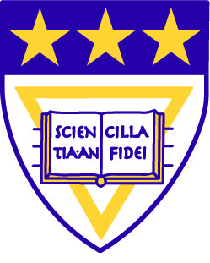

Remarks Accepting the Honorary Degree at the Howard University Commencement
May 11, 2013

President Patricia McGuire
Trinity Washington University

Thank you, President Ribeau. President Clinton, my sister honorees Marie Johns and Sheila Johnson, the family of Jack Kemp, Chairman Rand and members of the board, faculty, distinguished guests and families, and most of all, you, Howard’s Class of 2013: thank you for this amazing honor! I accept on behalf of everyone in the Trinity community whose hard work has ensured Trinity’s great mission. My colleagues and students really deserve this honor; I am humbled to be their public face. Thank you!

College president that I am, I cannot resist the opportunity to offer a few words during this “last class” for Howard’s Class of 2013.

Today is your crowning achievement: you join the elite 7% of the world’s citizens who are college graduates. Your Howard degrees bear relentless imperatives daring you to be outrageous in pursuing the causes of your lives: Freedom. Equality. Peace. Justice. You will face choices that these degrees expect you to make wisely and with integrity.

When faced with the chance to run away from crisis, be the ones who run toward the flames.

Be the outsiders that go inside to confront racism and oppression in all of their ugly forms.

When silence engulfs the assembly, be the ones who shout out for justice.

When the rage of the crowd demands vengeance, fly high the banners of peace and reconciliation.

When the schemers lure you to insane riches by leveraging the desperation of others, pick up your briefcases and walk away, very fast. When you become very rich on your own honorable merits, share your wealth broadly.

When doors open to serve in the public arena, walk through those doors with the conviction that you will make a great difference in shaping laws and public policy, ever more urgently seeking to rebalance the still-unequal playing fields for rising generations.

When people tell you that the revolutions in civil rights, women’s rights, human rights are over, remind them that the revolutions have yet to begin for the millions of God’s children on this small planet for whom poverty, violence and justice denied are daily tormenters. It’s been 50 years since Martin Luther King, Jr. wrote in his famous letter from a Birmingham Jail that “Injustice anywhere is a threat to justice everywhere.” Make that thought your central inspiration for action every day.

Honor Howard’s history by joining Howard’s long and distinguished line of passionate activists for justice, equality and freedom for all humanity.

Teach your children through the example of your lives, wearing proudly these values we extol today on each and every day. We would have no fear for the future if every child could be taught so well.

From your sisters and brothers across the reservoir at Trinity, so many thanks for this honor; congratulations, Howard Class of 2013, and may the Lord’s peace be with you.

